What teachers need to do to develop their pupils’ metacognition knowledge – recommendation 1.

Recommendation 1:
Teachers should acquire the professional understanding and skills to develop their pupils’ metacognitive knowledge.

Self-regulated learners are aware of their strengths and weaknesses, and can motivate themselves to engage in, and improve, their learning.
At the heart of this is metacognition. This term is increasingly well known in schools, but beyond a simple definition of ‘thinking about thinking’, teachers can quickly run out of classroom examples to describe it accurately.
Understanding what we mean is the first step in helping teachers to improve pupils’ metacognition.
We approach any learning task or opportunity with some metacognitive knowledge about:
- our own abilities and attitudes (knowledge of ourselves as a learner);
- what strategies are effective and available (knowledge of strategies); and
- this particular type of activity (knowledge of the task).
When undertaking a learning task, we start with this knowledge, then apply and adapt it. This is metacognitive regulation. It is about planning how to undertake a task, working on it while monitoring the strategy to check progress, then evaluating the overall success.
The diagram below represents the metacognitive regulation cycle:

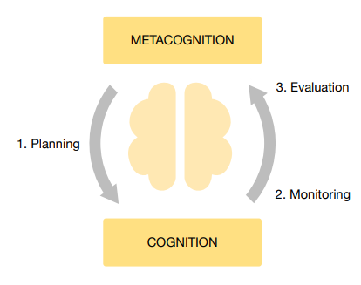
This is not a one-off process of discrete steps, but an ongoing cycle. As you progress through the task, applying your metacognitive and cognitive skills, you update your metacognitive knowledge (of yourself, strategies, and tasks), as well as updating your subject knowledge and skills.
The cycle of plan, monitor, evaluate and the different aspects of metacognitive knowledge (learner, strategies, task) are recurrent themes throughout this guidance.
Teachers should consider these when setting learning tasks and supporting pupils to complete them. In an expert learner, these processes are unconscious and automatic. In novice learners, however, it can be valuable to make them explicit.

Misconception 1: Metacognition is only developed in older pupils.
A common misconception is that metacognition is only developed effectively in mature young adults and not young children.
We know from research, however, that children as young as three have been able to engage in a wide range of metacognitive and selfregulatory behaviours, such as setting themselves goals and checking their understanding. [1] They also show greater accuracy on tasks they have chosen to accept than on tasks they would have preferred to opt out of. [2]
There is clear evidence that the level of security and self-knowledge remains rather inaccurate until about eight years of age, with children being over-optimistic about their levels of knowledge. [3]
However, although older children typically exhibit a broader repertoire of metacognitive strategies, the evidence suggests that younger children do typically develop metacognitive knowledge, even at a very early age.

To use an example to make the cycle more concrete, imagine a learner, John, is set a maths question to answer:

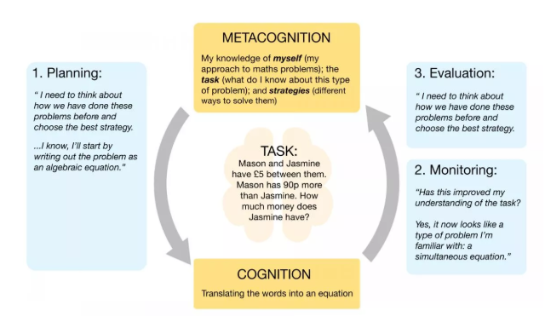

In this example, John starts with some knowledge of the task (word problems in maths are often solve by expressing them as equations) and of strategies (how to turn sentences into an equation).
His knowledge of the task then develops as it emerges from being a word problem into a simultaneous equation. He would then continue through this cycle if he has the strategies for solving simultaneous equations.
He could then evaluate his overall success by substituting his answers into the word problem and checking they are correct. If this was wrong, he could attempt other strategies and once more update his metacognitive knowledge.
Most learners will go through many of these thinking processes to some extent when trying to solve a problem or tackle a task in the classroom.
In this example, John starts with some knowledge of the task (word problems in maths are often solve by expressing them as equations) and of strategies (how to turn sentences into an equation).
His knowledge of the task then develops as it emerges from being a word problem into a simultaneous equation. He would then continue through this cycle if he has the strategies for solving simultaneous equations.
He could then evaluate his overall success by substituting his answers into the word problem and checking they are correct. If this was wrong, he could attempt other strategies and once more update his metacognitive knowledge.
Most learners will go through many of these thinking processes to some extent when trying to solve a problem or tackle a task in the classroom.
The most effective learners will have developed a repertoire of different cognitive and metacognitive strategies and be able to effectively use and apply these in a timely fashion. They will self-regulate and find ways to motivate themselves when they become more confident in undertaking new tasks and challenges.
As with other aspects of knowledge and skills, pupils will develop differently. The extent to which skills are acquired is in part dependent on the opportunities pupils receive to develop them outside of school and in the home, which is likely (though not necessarily) to be correlated with social background.
Metacognition is part of the fabric of successful learning, but it can prove both complex and subtle. It is ever-present in the classroom, but unless teachers have a strong understanding of the metacognitive demands of the topics they are teaching, they may miss opportunities to develop pupils’ knowledge and skills.
Various studies have shown that self-regulated learning—and in particular metacognition—has a significant impact on pupils’ academic performance, beyond that predicted by prior achievement. [4]
This recommendation introduces the key concepts teachers should be aware of; the rest of this email series focus on how teachers can improve pupils' learning by integrating these concepts into their teaching.

