OneNote Resources Links
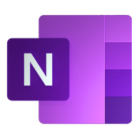
OneNote for Education - http://onenoteforteachers.com/en-US/students/

OneNote Teacher Tool kit - https://aka.ms/onenoteteachertoolkit

Getting Started with OneNote - https://www.education.microsoft.com/en-us/course/23b7f02f/overview

