Microsoft Teams
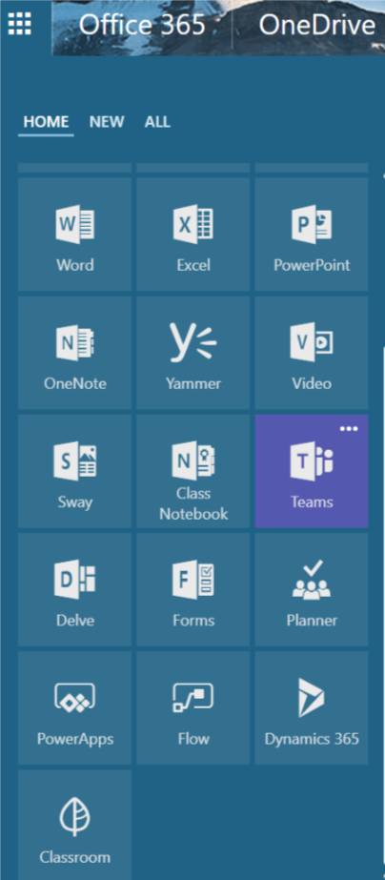
Microsoft Teams is a new Collaboration App that is part of the O365 Productivity Suite. It is found in the office app switcher menu or waffle menu. Microsoft Teams is a digital hub that brings conversations, content, and different apps all together in one place. Educators can create collaborative classrooms, connect in professional learning communities, and communicate with school staff all from a single experience in Office 365 for Education.
Create Teams for different classes, Professional Learning Communities or Staff Department Teams
Setting meetings (which will appear in Outlook Calendar)
Work on content in real-time using OneNote and Files (Word, PowerPoint etc)

Ability to chat in real-time, Staff or Students (Team Members) will receive push notifications via mobile app letting them know there has been activity. Channels are then shown in BOLD to indicate activity.
Teams is a safe space for students to engage in the social aspect of learning, all of which can be monitored by the Team Owner. As the Team owner, you can delete posts, replies to conversations and if need be MUTE a disruptive or offensive member of your team.
Built into Teams is the ability to video call to work or team members in real-time. However, this function is switched off to students for obvious reasons.

Creating a New Team
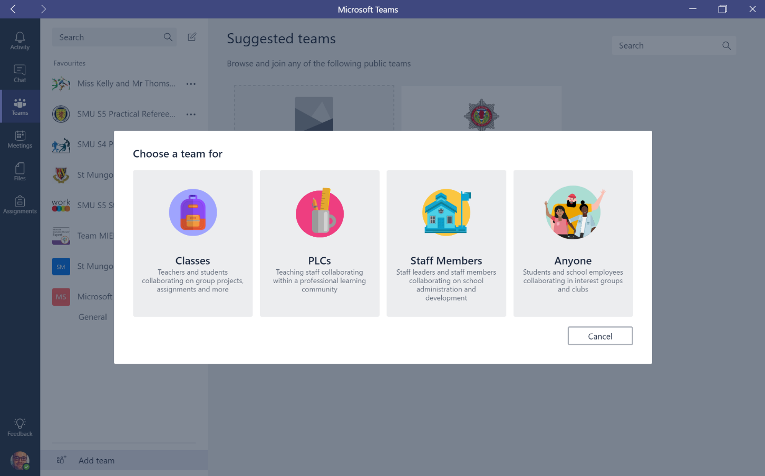
Click on Add Team – This will open a window giving you two options, create a new team and it will also provide some suggested teams.
On the above image I have highlighted that I wish to create a new team for staff – Departmental Staff.
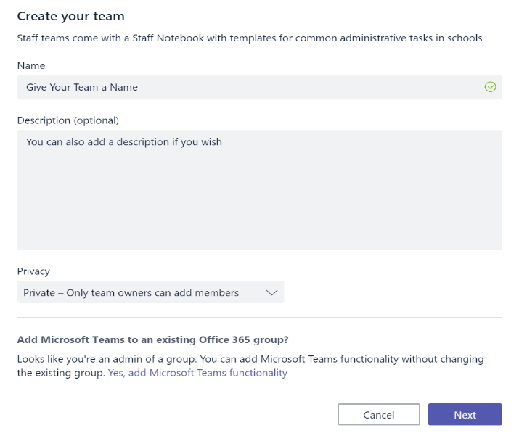
This will open the new window that will allow you to give your team a name and a description if you wish.

You can choose to make your team Public or Private. Public will be open to everyone in your organisation, Private is invite only.

Adding members to your Team
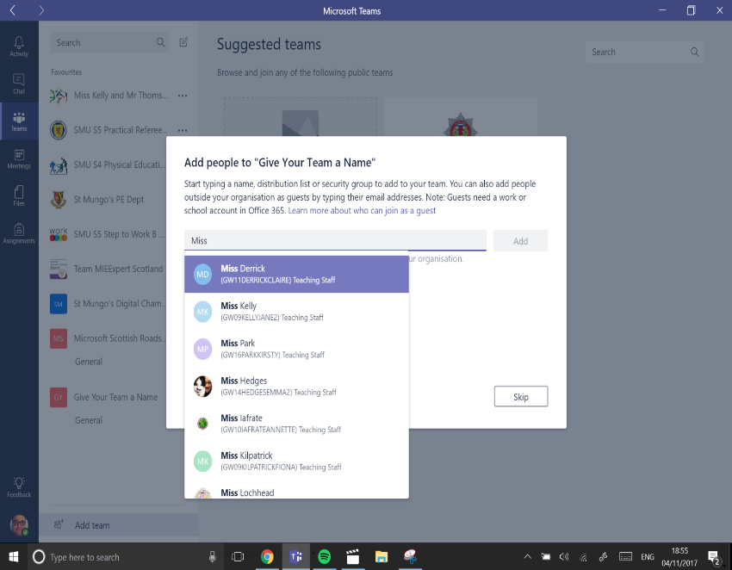
Private Team will allow you to invite people from inside your organisation.
Once you have added members to your Team you will be given the option to complete the setup.

Adding a new Channel or Conversation
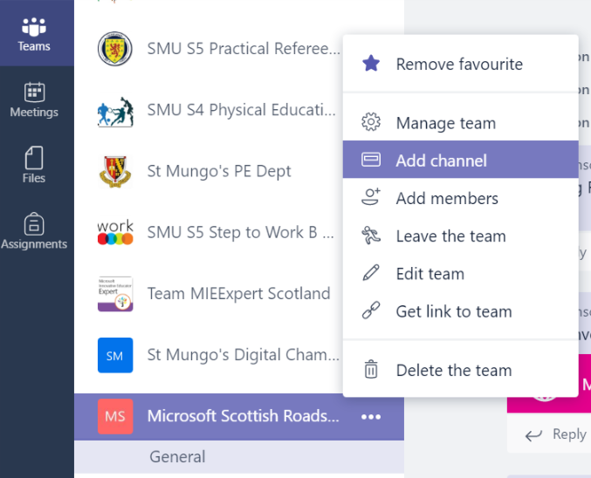
Teams will always open with a pre-set channel called General.
You can create a new channel or conversation by clicking on the three dots. This will open the option menu on the left. Here you can add channels and manage your team.

Manage Team in Settings
In settings you can set your own Team profile image to help you identify it from your list of Teams. You can also set member permissions and user settings from the same menu.
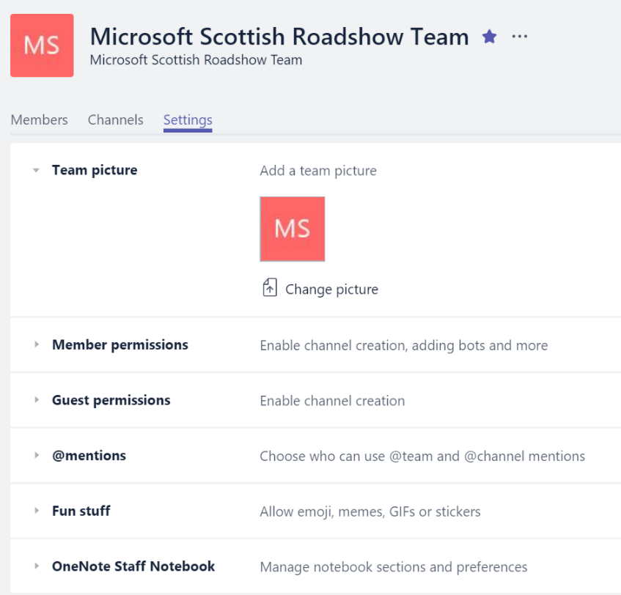
Adding a new Tab
Tabs allow you to integrate the tools and services you love right into your chat or channels. They are always visible at the top for easy access and by default have some already visible and set-up, ready to use. Tabs will also help Teams keep track of all the documents that have been uploaded to the channel.
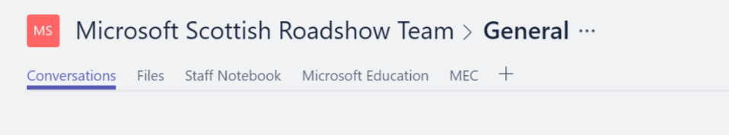
I have added two websites to the Tabs bar, Microsoft Education and the MEC. + will allow you to create new Tab.

Highlight that the Team Owner can add secure websites as Tabs that students can reference and look-up frequently.

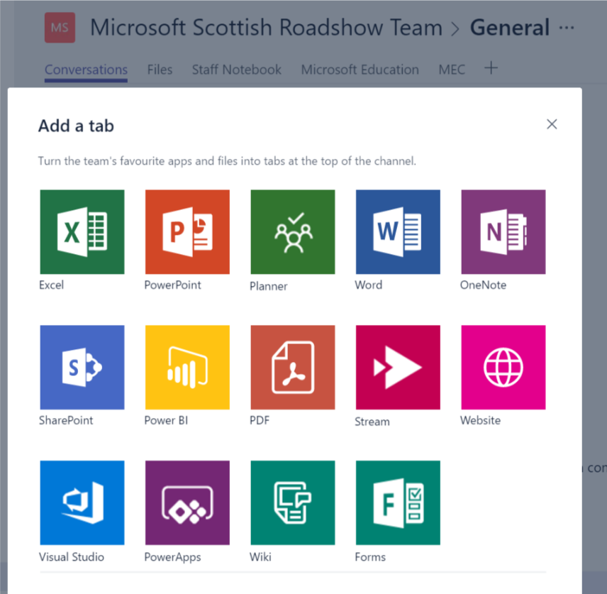
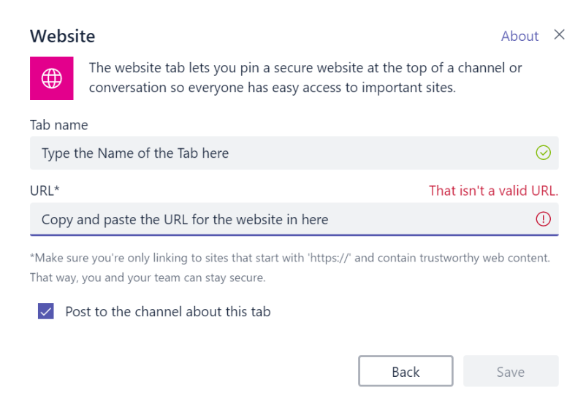
Once you have clicked on save this will appear on the Tab list at the top. This will also be posted on the conversation channel to notify Team members.

