Glow Login Screen –
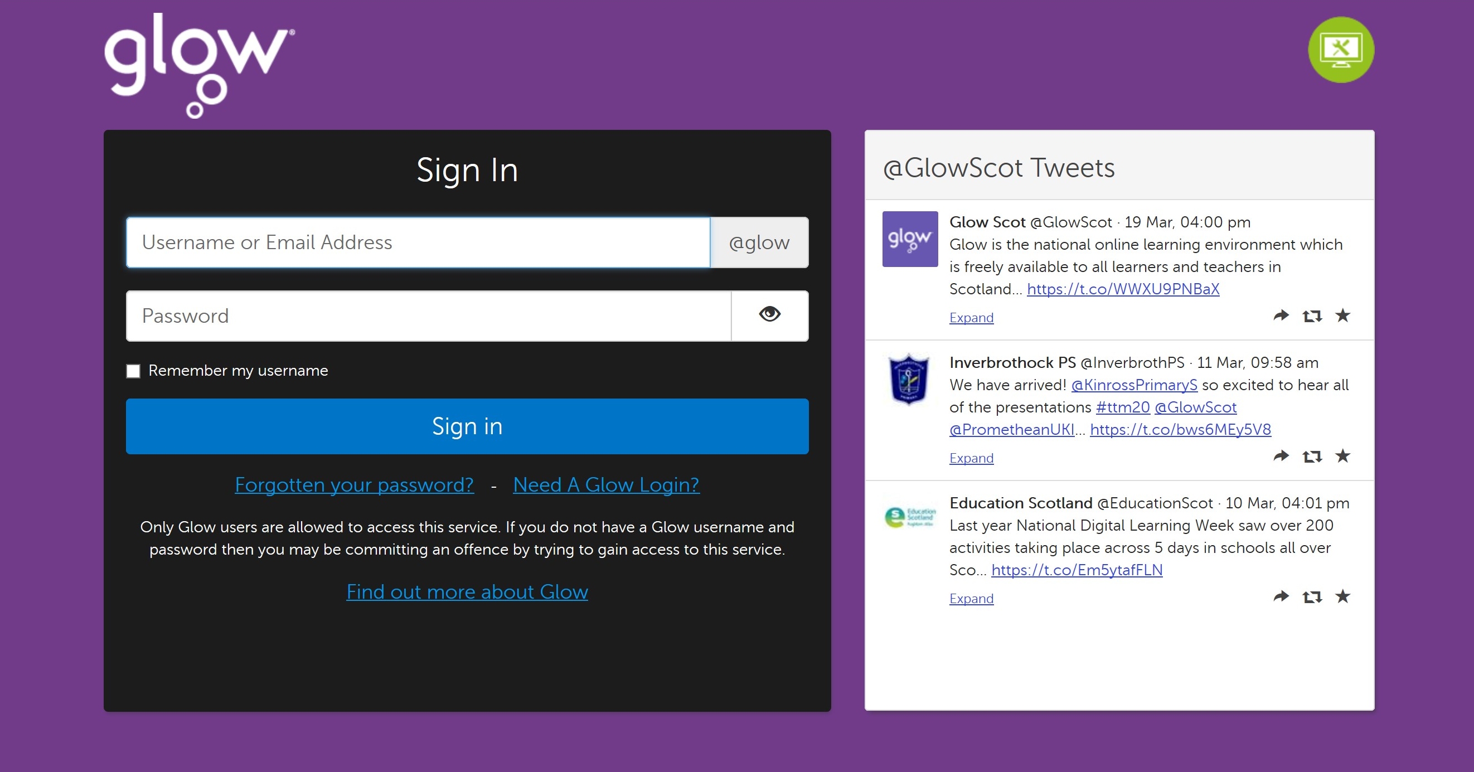

Launch Pad is the next Screen that will open make sure you are on your own Launch Pad as highlighted on the left of the Screen in Red. To access Glow Email, click on the Mail Tile, this will open a new window to your Outlook mail provided through Glow. Remember, Glow login and email addresses are the same and finish with @glow.sch.uk.
