Suggested Snow Day Activities
Create a picture to show what you like best about wintertime.  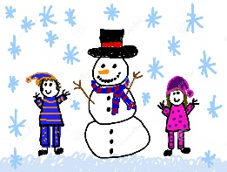 | 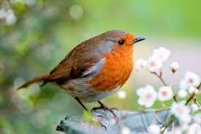  Create a chart to record how many types of birds you spot outside. | Go for a walk with a grown-up and take a camera to capture some lovely winter photographs.
Build a snowman and take photographs of him to document how he melts. | Go on a sensory winter walk with an adult. What can you see? What can you smell or hear? | 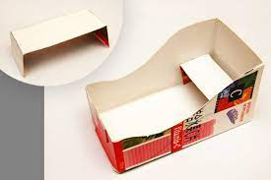  Build a sledge for a small toy using household materials.
Create the perfect winter menu. What would be your ideal meal for the chilly, wintery months? | Become a detective and search for animal footprints in the snow.  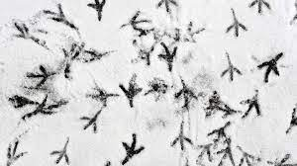 | Work on your throwing skills by throwing snowballs at a target.
With an adult, bake a festive treat for someone. | Count how many baubles are on your Christmas tree. | Make an outdoor festive picture using outdoor materials like stones, sticks and fallen leaves.
Online games
Hit the Button - Quick fire maths practise for 6-11 year olds (topmarks.co.uk)
Caterpillar Ordering - An Ordering and Sequencing Game (topmarks.co.uk)
Teach Your Monster: Free Phonics, Reading and Mathematics Games

