Suggested Snow Day Activities
How many did you manage to do?
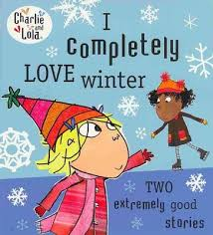  Write an imaginary story about a snowy day adventure. | 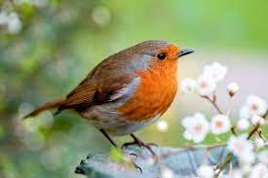  Create a chart to record how many types of birds you spot outside. | Have a hot chocolate.
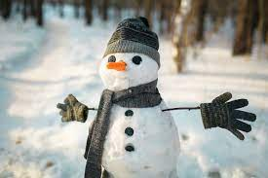  Build a snowman. | Do a How to Draw tutorial on Art Hub (YouTube) | Play a board game.  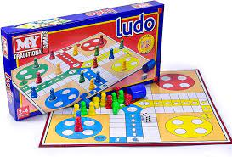
Measure out ingredients to help bake something delicious. | Become a detective and search for animal footprints in the snow.  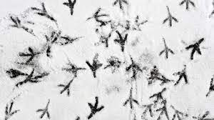 | Work on your throwing skills by throwing snowballs at a target.  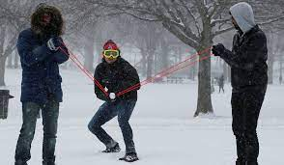
Read a book | Build a snow fort (or a warm inside fort made from blankets)  (Tidy bedroom) | Make something creative our of recycled materials.
Help to shovel some snow from a path or a driveway | Make a paper snowflake  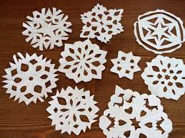 | Make a wintery collage using clippings from magazines and newspapers
Online games
Hit the Button - Quick fire maths practise for 6-11 year olds (topmarks.co.uk)
Teach Your Monster: Free Phonics, Reading and Mathematics Games
Remember to send in photos!

