`

Brae High School

Out of School Club
Handbook

Welcome to the Brae High School Out of School Club

Brae High School are working alongside ELC Shetland to provide a service for families in the North Mainland. The service will provide a Breakfast club and After School club. A Holiday club will run for part of the Easter, summer and October holidays.

Our Vision:

‘Brae Out of School Club’s ethos is to provide a service for families in Brae for Primary school aged Children. Enabling children to have access to high quality play, care and learning opportunities which meet their individual needs, before and after school, and all day during school holidays, in a safe, caring environment.’

Our Staff

Our Out of School Club service is run by the Manager of Early Years and Childcare, Miss Karis Morton. Within the team we have:

Mrs Mairi Jamieson and Miss Danielle Johnson – Senior Practitioners - ELC
TBC - Play Practitioner - ELC
TBC - Play Support Worker - ELC

You can contact the service by email:
braeoosc@shetland.gov.uk
Or call:
01595 745600 (during school hours)
01595 745649 (out with school hours)

Where are we located?

We are located alongside the nursery. To access this, parents must come to the white door next to the nursery department. See picture below for reference.

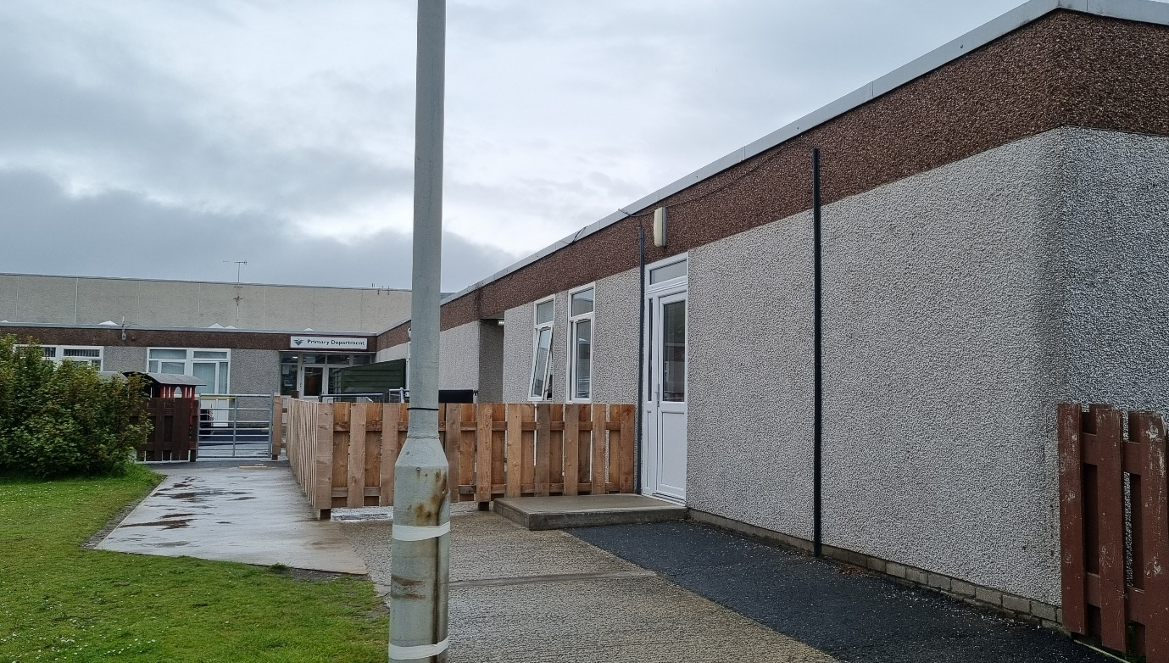

Our Service

Breakfast Club

“A Positive Start to the Day”

Breakfast Club is available Monday to Friday during term time from 08:15-09:00am.

Breakfast at school provides the opportunity to begin the day with a healthy balanced meal. It has the additional benefits of improving children’s concentration, punctuality and attendance, providing early morning childcare and an opportunity for educational and social activities. There will be an opportunity for children to play outside in the Primary playground before school starts while a member of staff is present.

Our Out of School Club staff then escort the children safely to their class for the start of the school day.

After School Club

Our After School Club runs from Monday to Thursday from 15:15-17:30. Fridays from 14:00-17:30.

The children are collected from the school’s front foyer at start time and taken to the Out of School club. The children are signed in and then can choose a play activity either indoors or outdoors.
A light healthy snack will be offered along with refreshments including milk or water.

After our snack the children return to activities or choose new ones. The children are collected at different times throughout the session by their parents/carers and signed out by the adult responsible for collecting them. An opportunity will be available for children to complete homework during the After School Club session.

Holiday Club

Our Holiday Club will run Monday to Friday 09:00-16:00

Parents will have the opportunity to sign in for a half day or full day session. During the day activities will be available along with walks within our community. Lunchtime arrangements will be confirmed in due course. Holiday Club dates will run from the first week of the Easter and October Holidays and the first 4 weeks of the summer.

OPENING TIMES AND FEES:

The Out of School Club is available at Brae High School in the Nursery and Out of School Club area. Availability is for primary school aged children.

Times and prices per session are below:

- Breakfast club times: 08:15-09:00 £2.85 per session
- After school session: 15:15-17:30 (Monday to Friday) and 14:00-17:30 (Friday) £4.88 per hour (snack included, trips additional).
- Holiday club times: 09:00-16:00
- Full day session, up to 7 hours £34.00.
- Holiday club half day session, up to 4 hours £17:00.

Payment and fees will be paid through Parent Pay.

Booking Procedure

Brae OOSC will invite parents/carers to apply for a block booking for the subsequent term/holiday period. We will send out the booking details with a date by which applications need to be returned.

After the return date, the setting will allocate places based on the priority list.

Bookings returned after this date will only be considered once all applications received within timescale have been allocated.

Brae OOSC will confirm the block booking with the parent/carer by email, in return the parent/carer will accept confirmation via email.

Ad hoc bookings can be made, if there is capacity in the setting. This needs to be agreed 24 hours in advance.

If a child is not allocated a place, their name will be placed on a waiting list. If a place becomes available, they will be allocated based on the priority list.
Cancellations must be made at least 24 hours in advance or the parent/carer will be charged in full.

If a child is unwell, the parents/carers will be charged for the first session if they are unable to give 24 hours’ notice. After this, the parents/carers will not be charged however it is essential that the parents/carers keep the setting informed about the duration of absence. Parents / carers must contact Brae OOSC to confirm their child is unable to attend; braeoosc@shetland.gov.uk

In the unlikely event of the setting having to close, parents/carers will not be charged.

If parents/carers are late to collect their child, they will be charged a further hour.

Children attending after-school sessions will be charged for a minimum of 1 hour. If children are staying between 1 hour and 2 hours, parents / carers will be charged by the half hour.

Holiday sessions are either half day or full day. There is no hourly charge.

Priority List

In the event that there are insufficient spaces to accommodate all the block-booking requests for school-aged childcare at Brae OOSC, Shetland Islands Council will allocate places in the priority order listed below:

- Children who already attend the setting in the previous term or holiday period
- Children who are Looked After by the local authority, kinship carers or live with a Parent Appointed Guardian
- Children referred by Additional Support Needs, Social Work or Health professionals
- Children who have siblings in the setting
  - Youngest children first.

Policies/Procedures & Guidelines

Brae OOSC provide a high quality service which ensure they follow all relevant policies and procedures. If you’d like to see any of the policies, please ask a member of staff.

Staff will make the children aware of expectations and limits of behaviour. These must appear reasonable and achievable to the child and where possible be child led.

We also have guidelines which the club follow. These help with the day to day running of the club. These guidelines may be amended or updated throughout the year as and when required.
Some guidelines we have include – Confidentiality, Emergency Closure, Outings, School Transport, Good Hygiene amongst many more. If you’d like to see any of our guidelines, please ask a member of staff.

Adverse Weather/Emergency Closure

In the case of bad weather the club will follow the course taken by schools. If weather should deteriorate dramatically before pick up parents/carers shall be called to collect their children.

REMEMBER – If it is announced locally that schools are closed the club will also be closed.
Staff will not phone around parents if the schools close early or are closed all day.

Accidents/Emergencies

In the event that your child has to be taken to hospital due to illness/accident they will be accompanied by a member of staff and you will be called. If we are unable to reach you we will contact the child’s emergency contact. Please also ensure that you keep staff up to date with any medical conditions your child may currently have or has formed.

Complaints Procedure

Brae OOSC follow Shetland Island Councils complaints procedure. If you have a concern it can be beneficial to raise this with the manager or member of staff in the first instance. This is often the quickest way to resolve a problem.

Please discuss with:

- Any Member of Brae Out of School Club staff
- The Manager of Brae Out of School Club (Karis Morton)
- In the absence of the manager, the head teacher of Brae High School – Logan Nicolson; 01595745600.

Alternatively, you can raise your concerns with The Care Inspectorate:

Tel: 0345 600 9527 between 9am and 4pm, Monday to Friday

Email: concerns@careinspectorate.gov.scot

