  Literacy | We are enjoying familiar stories using repetition, songs, props and can talk about these stories together.  We are working on fine motor skills and developing our pincer grip.  We are learning to recognise the following sounds: SATPIN
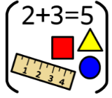  Numeracy & Maths | We are learning our numbers to 10 and beyond, and using these to count, order, sequence and write.  We are developing our knowledge of pattern and completing increasingly complex patterns using shapes, colours and numbers.
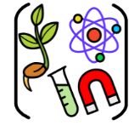  Social Studies/ Sciences | We are learning about “Our School” and the people who work in Bell’s Brae.  We are learning how different people have different jobs in our school which keep us safe, respected and achieving.
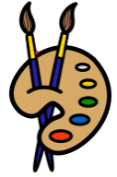  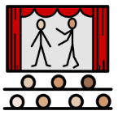  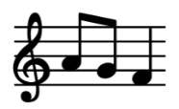  Expressive Arts | Art:  Self Portrait pencil drawing and Flower Still Life
Drama:
We are learning to use drama to explore real and imaginary situations, helping me to understand my world.

Music:
I am learning to sing a variety of songs about harvest and my school.

By completing sound stories and simple dance routines, I am gaining a better understanding of tempo and pulse.
  Technologies | We are using the Interactive Whiteboard to play games and engage with resources which enhance our literacy and numeracy learning.
  Religious & Moral Education | As we play and learn, we are developing our understanding of what is what is fair and unfair and the importance of caring for, sharing and co-operating with others.
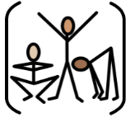
Health & Wellbeing
 | PE - Hockey and Basketball with Respect and Tolerance

