**Parasport Festival**

**Shetland**

**Saturday 30th March 2024**

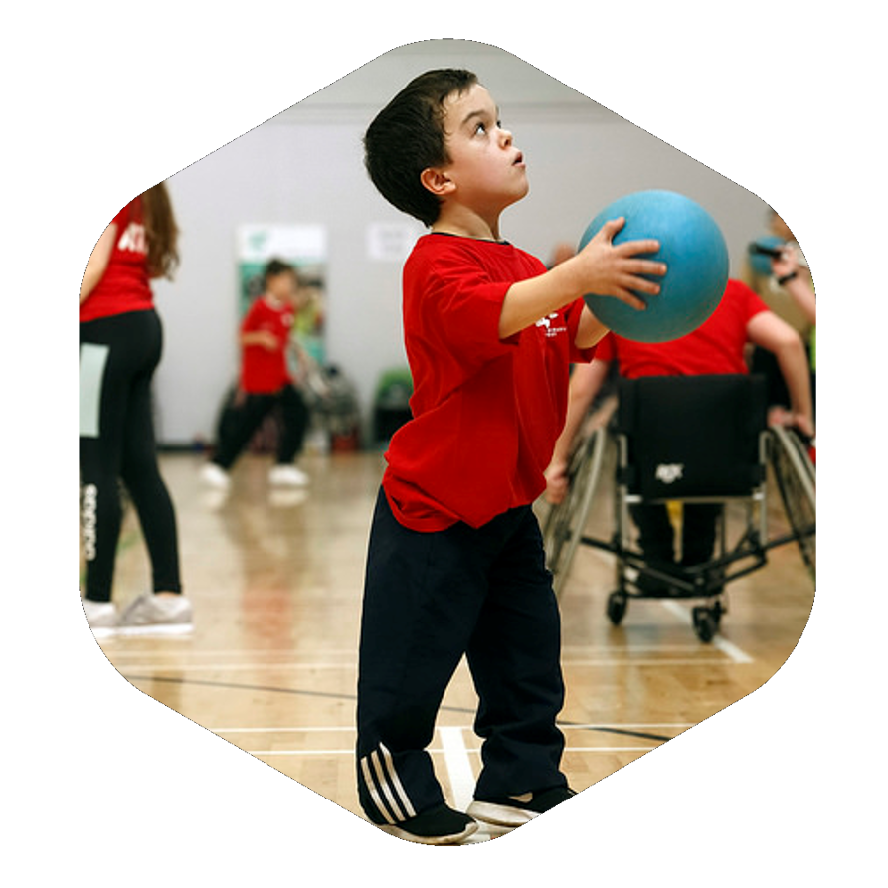

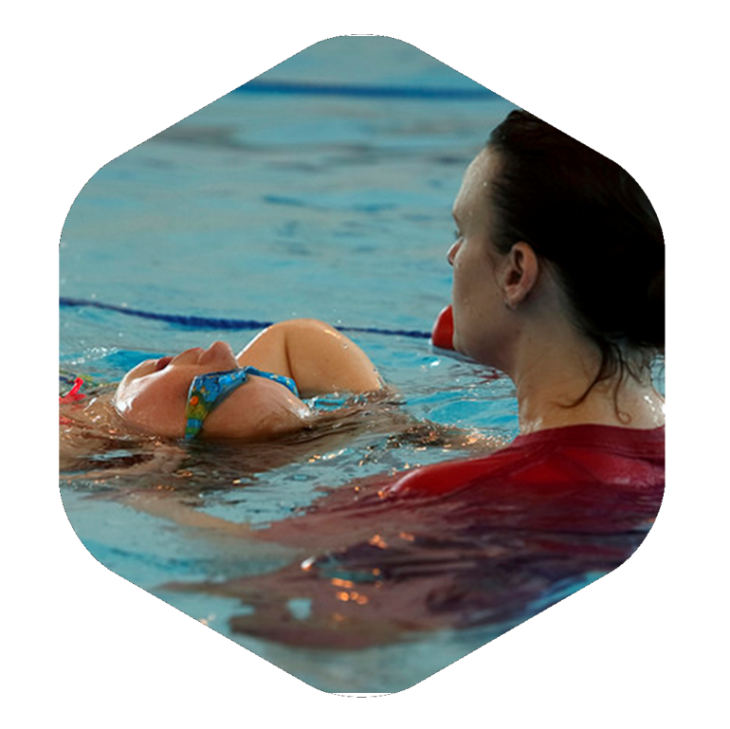

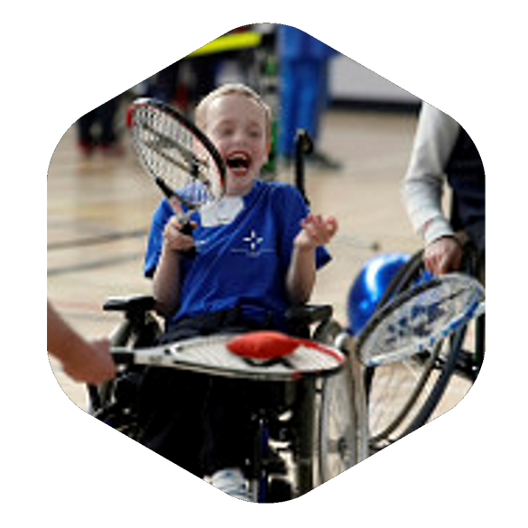

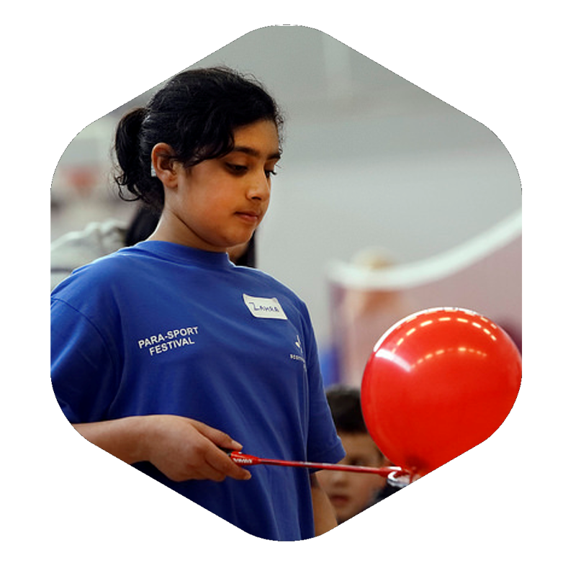

**Clickimin Leisure Complex**

**Lerwick, Shetland**

**Welcome**

Welcome to Shetland’s 2024 Parasport Festival.   
  
The Parasport Festival is about providing a range of opportunities for young people with a physical, visual or hearing impairment to try new and exciting sports and learn more about the pathways that are available in the region. It will be delivered by some of the best clubs and coaches available in Scotland. Furthermore, the event will highlight the opportunities for young people with disabilities to achieve at the highest level and hopefully inspire them to become our stars of the future.

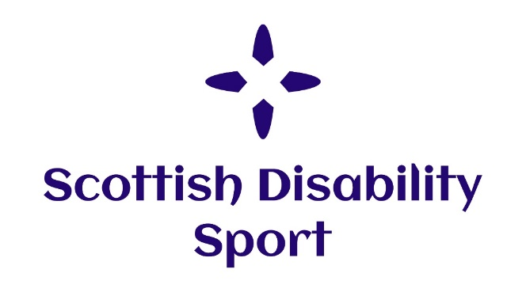**About Scottish Disability Sport**

Scottish Disability Sport (SDS) is the Scottish governing and co-coordinating body of all sports for people of all ages and abilities with a physical, sensory or learning disability, and is also the governing body of Boccia. SDS has the vision of developing opportunities and improving performance in disability sport for children, athletes and players with a physical, sensory or learning disability in Scotland and contributing to UK and international initiatives.

Scottish Disability Sport has a team of Regional Managers across Scotland. The Regional Manager’s role is to lead the implementation, coordination and monitoring of an integrated Disability Sport Development Plan across the region for athletes and players with a physical, sensory or learning disability.

**Regional Manager: Grampian & Shetland**

Josef Tautscher is the Regional Manager for Grampian & Shetland.

Josef covers Aberdeen City, Aberdeenshire, Moray & the Shetland Islands

Email:Josef.Tautscher@scottishdisabilitysport.com

Mobile: 07889281795

**How to register?**

**You must register before Friday the 22nd of March.** You can register by contacting [charis.scott3@shetland.org](mailto:charis.scott3@shetland.org) or 07493528917.

Alternatively, you can register online using the link below.

<https://sds.justgo.com/Workbench/i/r/public/EventsAndBookingsPublic/details/C34EAD7EAED684A50390A5251D2243D29B0B6DF4/>

**Time**On the day registration will take place between 10:00am and 10:30am in the Waterside Suite.  
  
The day will start promptly at 10:30am and finish at 16.00pm

**Event Staff**

Scottish Disability Sport staff will be wearing polo shirts with the SDS logo. Ability Shetland staff, Active Schools Staff and coaches from clubs and Scottish Governing Bodies will also be in attendance and will be wearing their respective club kit. Event volunteers will be wearing volunteer t-shirts. We are all here to help you and give you the best experience possible. **Sports**  
  
There will be a variety sports on offer throughout the day. A timetable for the event is listed below. If your child would not like to take part in a specific sport, please speak to Charis Scott from Ability Shetland.

If for any reason this timetable changes we will contact you with the updated timetable for the day.

|  |  |  |
| --- | --- | --- |
|  | **Parasport Group 1** | **Parasport Group 2** |
| 10.00-10.30am | Registration  *Waterside Suite* | Registration  *Waterside Suite* |
| 10.30-11.00am | Table Tennis  *Squash Court* | Fencing  *Squash Court* |
| 11.00-11.30am | Fencing  *Squash Court* | Table Tennis  *Squash Court* |
| 11.30-12.00pm | Turn over | Turn over |
| 12.00-12.30pm | Kayaking/Swimming  *Pool* | Kayaking/Swimming  *Pool* |
| 12.30-13.00pm | Kayaking/Swimming  *Pool* | Kayaking/Swimming  Pool |
| 13.00-13.30pm | Lunch | Lunch |
| 13.30-14.00pm | Lunch | Lunch |
| 14.00-14.30pm | Basketball  *Main Hall* | Badminton  *Main Hall* |
| 14.30-15.00pm | Badminton  *Main Hall* | Basketball  *Main Hall* |
| 15.00-15.30pm | Football  *Main Hall* | Netball  *Main Hall* |
| 15.30-16.00pm | Netball  *Main Hall* | Football  *Main Hall* |
| 16.00-16.30pm | Finish | Finish |

**Refreshments**

Lunch will take place between 13:00pm and 14:00pm. Children, young people, parents, etc are welcome to eat their packed lunches in the Waterside Suite at the Clickimin. However, there is also a café located in the Clickimin. Please note that lunch is not provided as part of the event.  
 **First Aid**

First aid is provided by Clickimin. If you require any first aid, please contact a member of Parasport Festival staff.

**Facilities**There are accessible toilets & changing facilities located at Clickimin. For more information about this facility, please ask Clickimin staff.

**Can I take photos or videos at the event?**

If you would like to take photos or videos, you must complete a request form beforehand. This can be obtained from contacting Charis Scott. Some children cannot be photographed. There will be an event photographer present.

**Social Media**

It would be greatly appreciated if you could highlight yours or your child’s involvement at the event across social media. As part of this, we would be grateful if you could tag Scottish Disability Sport:



Scottish Disability Sport and Ability Shetland



@SDS_sport and @AbilityShetland



[Ability Shetland (@abilityshetland) • Instagram photos and videos](https://www.instagram.com/abilityshetland/)

InspiringThroughInclusion

**What happens after the festival?**

Charis Scott, Sports Development Coordinator for Ability Shetland will contact you in order to find out if there are any sports that your child would like to partake in further. If you have any questions or would like to contact her regarding sporting opportunities in the area, please do so at charis.scott3@shetland.org or on 07493528917.

Thank you to all of our partners who have made today possible!

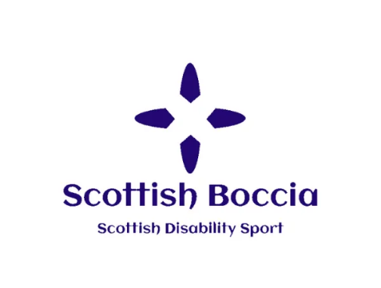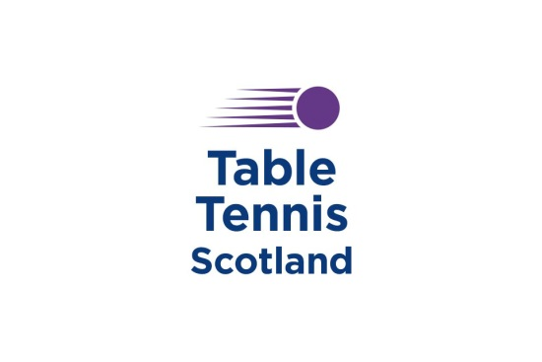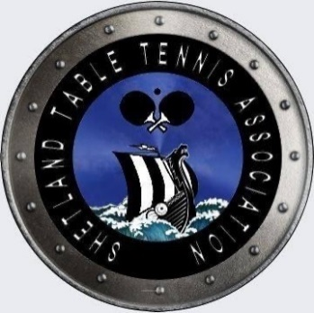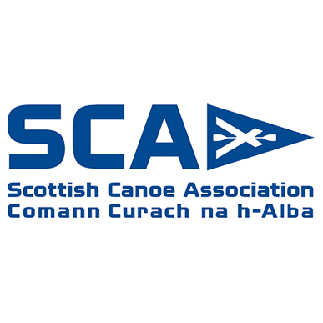



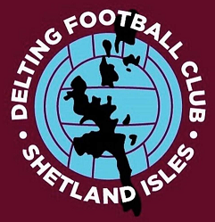

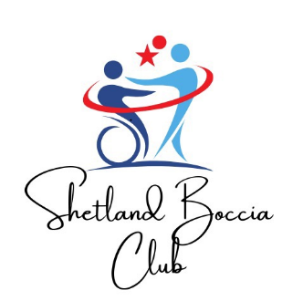

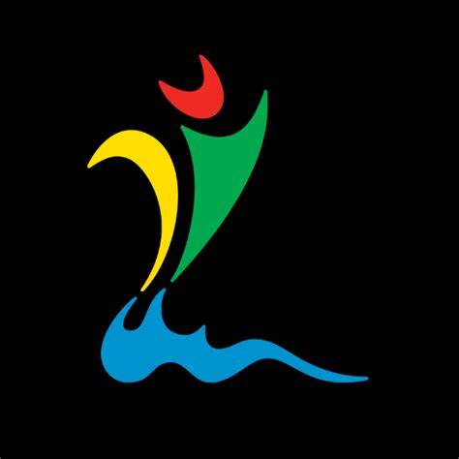

**Scottish Disability Sport Privacy Notice**

Scottish Disability Sport is a “controller” of the personal information you provide to us.

**What we need**

When you provide information about yourself for events, courses, workshops or other opportunities, we will ask you for the following information:

* Contact details including name, address, telephone number, email address and date of birth;
* Details of your role in sport, e.g. coach, athlete, volunteer, official, parent, support staff;
* Equality information including age, disability or medical condition, employment information, ethnic group, religious belief, gender identity and sexual orientation.

**Why we need your personal information**

**Contractual purposes**

We need to collect personal information in order to manage attendance and participation. We will use this information to:

* Provide you with services such as training or activities;
* Administer your attendance;
* Process awards and qualifications;
* Send you communications in relation to opportunities we think may interest you.

If you do not provide all of the personal information we request then this may affect our ability to offer you services and benefits.

**Legitimate purposes**

We also process personal information in order to:

* Promote and encourage participation in disability sport by sending communications about forthcoming opportunities. Our events may be photographed or filmed and information captured in this way may be used for promotional and education purposes. You will always be given the option to refuse this;
* Provide opportunities and competition in disability sport by managing entries for events and checking your personal information to ensure you are participating at an appropriate level;
* Monitor and develop participation in disability sport by monitoring engagement and participation and, on occasion, inviting participants to take part in surveys for research and development purposes;
* Develop and maintain qualifications and awards, including sending communications to inform you of forthcoming courses, renewal requirements and to verify that you have completed any mandatory training requirements;
* Respond to and communicate with participants regarding questions, comments, support needs or complaints in relation to disability sport.

Where we process your personal information in pursuit of our legitimate interests, you have the right to object to us using your personal information for these purposes. If you wish to object to any of these, please contact Scottish Disability Sport on 0131 317 1130, email [admin@scottishdisabilitysport.com](mailto:admin@scottishdisabilitysport.com) or write to us at Caledonia House, South Gyle, Edinburgh EH12 9DQ.

**Legal obligations**

We are under a legal obligation to process certain personal information for the purposes of complying with:

* The Protection of Vulnerable Groups (Scotland) Act 2007 to check that our coaches and volunteers are able to undertake regulated work with children and vulnerable adults;
* Our **sport**scotland regulatory requirements to report on size, achievements and profile;
* The Equality Act 2010, which requires us to process personal information to make reasonable adjustments where necessary.

**Equality monitoring requirements**

We are required by **sport**scotland to use personal information relating to equality for monitoring purposes.

We will process such personal information through aggregated and anonymised reports to identify and keep under review equality of opportunity or treatment of groups of people, to promote or maintain equality within disability sport.

**Other uses of personal information**

We may ask you if we can process your personal information for additional purposes. If so, we will provide you with additional information on how we will use your information.

**Who we share your personal information with**

If your personal information is included in any images or videos we take, we may share this with event or project partners or governing bodies, including **sport**scotland, for promotional purposes.

We may be required to share personal information with statutory or regulatory organisations, such as Disclosure Scotland or Police Scotland.

We may also share personal information with our professional and legal advisors in order to take advice.

Where we share personal information with third parties, we will only share the personal information strictly required for the specific purposes and will take reasonable steps to ensure that recipients shall only process the disclosed personal information in accordance with those purposes.

We may employ contractors to process personal information. Such contractors are subject to written contracts to only process that information under our instructions, to process and to abide by the restrictions of existing legislation on data protection.

**How long we keep your personal information**

We will only keep your personal information for as long as necessary or for as long as we believe you to maintain an interest in disability sport.

We will keep certain personal information for longer in order to confirm your identify.

**Your rights**

You can exercise any of the following rights by contacting Scottish Disability Sport on 0131 317 1130, email [admin@scottishdisabilitysport.com](mailto:admin@scottishdisabilitysport.com) or write to us at Caledonia House, South Gyle, Edinburgh EH12 9DQ:

* The right to request access to the personal information we hold about you by making a “subject access request”;
* The right to have personal information corrected or completed;
* The right to request that we restrict the processing of your personal information for specific purposes;
* The right to request us to delete your personal information.

Any requests received by Scottish Disability Sport will be considered under data protection legislation. If you remain dissatisfied, you have a right to raise a complaint with the Information Commissioner’s Office at [www.ico.org.uk](http://www.ico.org.uk).