Parasport Festival

Shetland

Saturday 26th March 2022

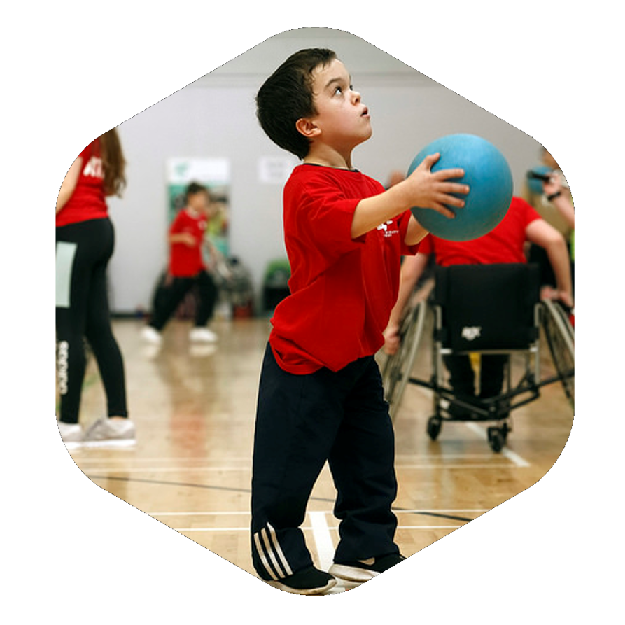

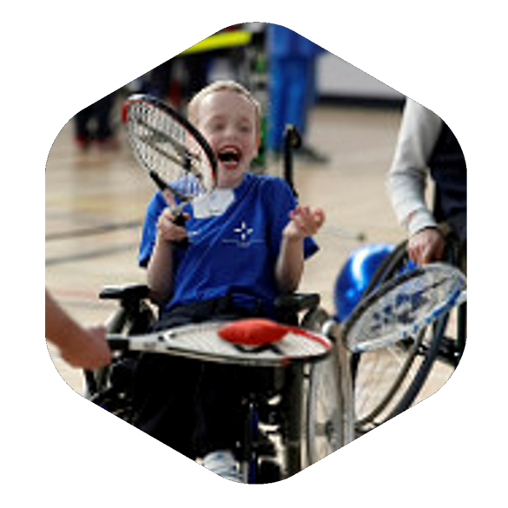

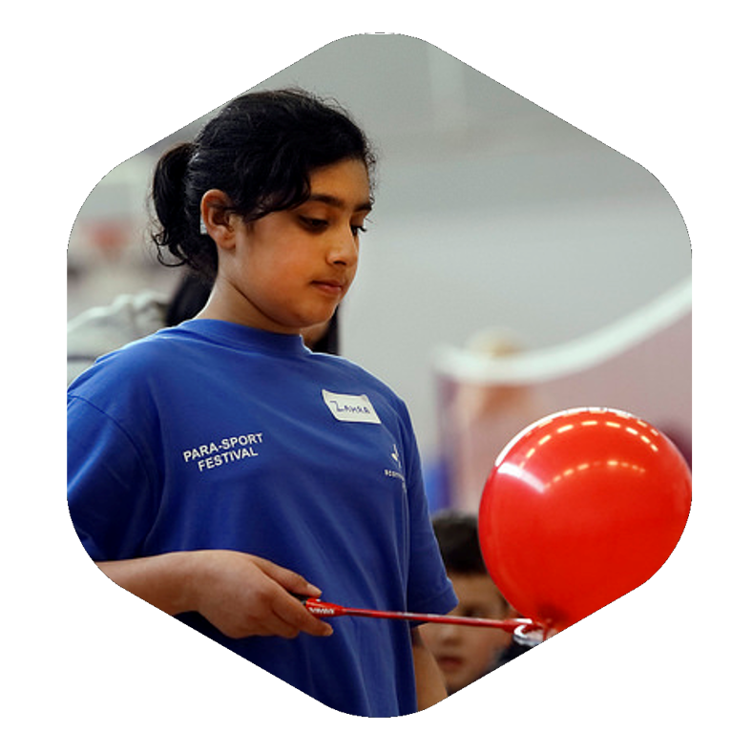

Clickimin
Lerwick, Shetland

Welcome

Welcome to Shetland’s 2022 Parasport Festival.
The Parasport Festival is about providing a range of opportunities for young people with a physical, visual or hearing impairment to try new and exciting sports and learn more about the pathways that are available in the region. It will be delivered by some of the best clubs and coaches available in Scotland. Furthermore, the event will highlight the opportunities for young people with disabilities to achieve at the highest level and hopefully inspire them to become our stars of the future.

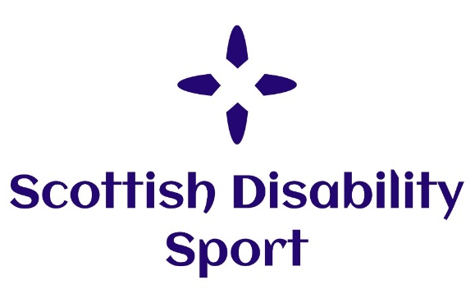
About Scottish Disability Sport

Scottish Disability Sport (SDS) is the Scottish governing and co-coordinating body of all sports for people of all ages and abilities with a physical, sensory or learning disability, and is also the governing body of Boccia. SDS has the vision of developing opportunities and improving performance in disability sport for children, athletes and players with a physical, sensory or learning disability in Scotland and contributing to UK and international initiatives.
Scottish Disability Sport has a team of Regional Managers across Scotland. The Regional Manager’s role is to lead the implementation, coordination and monitoring of an integrated Disability Sport Development Plan across the region for athletes and players with a physical, sensory or learning disability.

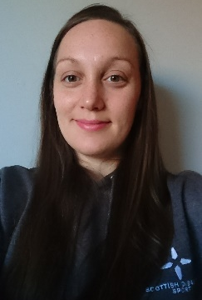
Regional Manager: Grampian & Shetland

Alison Shaw is the Regional Manager for Grampian & Shetland.
Alison covers Aberdeen City, Aberdeenshire, Moray & the Shetland Islands
Email: alison.shaw@scottishdisabilitysport.com
Mobile: 07828 744 848

How to register?

You must register before Monday the 21st of March. You can register by contacting charis.scott3@shetland.org or 07493528917.

Alternatively, you can register online using the link below.
https://www.scottishdisabilitysport.com/details-for-inaugural-orkney-and-shetland-parasport-festivals-2022/

Time
On the day registration will take place between 09:30am and 09:55am.
The day will start promptly at 10:00am and finish at 15:00pm

Event Staff

Scottish Disability Sport staff will be wearing polo shirts with the SDS logo. Ability Shetland staff, Active Schools Staff and coaches from clubs and Scottish Governing Bodies will also be in attendance and will be wearing their respective club kit. Event volunteers will be wearing volunteer t-shirts. We are all here to help you and give you the best experience possible.
Sports
There will be a variety sports on offer throughout the day. A timetable for the event is listed below. If your child would not like to take part in a specific sport, please speak to Charis Scott from Ability Shetland.

If for any reason this timetable changes we will contact you with the updated timetable for the day.

Time | Activity 1 | Activity 2 | Alternatives
09:30-09:55 | Welcome and Registration  Main Hall
10:00- 11:00 | Boccia  Main Hall | Rugby  Main Hall
11:00- 12:00 | Boccia  Main Hall | Badminton  Main Hall
12:00- 12:30 | Lunch  Waterside Suite
12:30- 13:30 | Athletics  Athletics Track | Cycling  Athletics Track | Sitting Volleyball  Main Hall
13:30- 15:00 | Kayaking  Clickimin Pool | Swimming  Clickimin Pool | Basketball  Main Hall

Refreshments

Lunch will take place between 12pm and 12.30pm. Children, young people, parents, etc are welcome to eat their packed lunches in the Waterside Suite at the Clickimin. However, there is also a café located in the Clickimin. Please note that lunch is not provided as part of the event.
First Aid

First aid is provided by Clickimin. If you require any first aid, please contact a member of Parasport Festival staff.
Facilities
There are accessible toilets & changing facilities located at Clickimin. For more information about this facility, please ask Clickimin staff.

Can I take photos or videos at the event?

If you would like to take photos or videos, you must complete a request form beforehand. This can be obtained from contacting Charis Scott. Some children cannot be photographed. There will be an event photographer present.

Social Media

It would be greatly appreciated if you could highlight yours or your child’s involvement at the event across social media. As part of this, we would be grateful if you could tag Scottish Disability Sport:

Scottish Disability Sport and Ability Shetland
@SDS_sport and @AbilityShetland
InspiringThroughInclusion

What happens after the festival?

Charis Scott, Sports Development Coordinator for Ability Shetland will contact you in order to find out if there are any sports that your child would like to partake in further. If you have any questions or would like to contact her regarding sporting opportunities in the area, please do so at charis.scott3@shetland.org or on 07493528917.

Thank you to all of our partners who have made today possible!
