
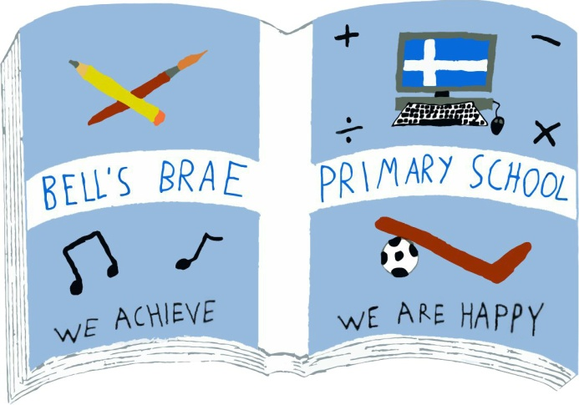

Mrs J Wadley  Head Teacher |  | BELL’S BRAE PRIMARY SCHOOL  LERWICK, SHETLAND, ZE1 0QJ  Tel Lerwick (01595) 743720  E.mail: bellsbrae@shetland.gov.uk  https://blogs.glowscotland.org.uk/sh/bellsbraeprimary/

27 October, 2020

Dear Parents and Carers

Term 2 – 2020

I just wanted to get in touch with you all to confirm that I have now returned to my post as Head Teacher in Bell’s Brae Primary School.

I am delighted to be back and looking forward to seeing all the young people later in the week. I managed to visit at the end of last term and was so pleased to see many of the children. I am also looking forward to engaging with you all over the coming weeks and months.

Due to the current pandemic, there has been a number of changes at Bell’s Brae. I have been familiarising myself with these and know that the staff here will continue to ensure that your child’s safety and wellbeing is the priority.

Yours sincerely,
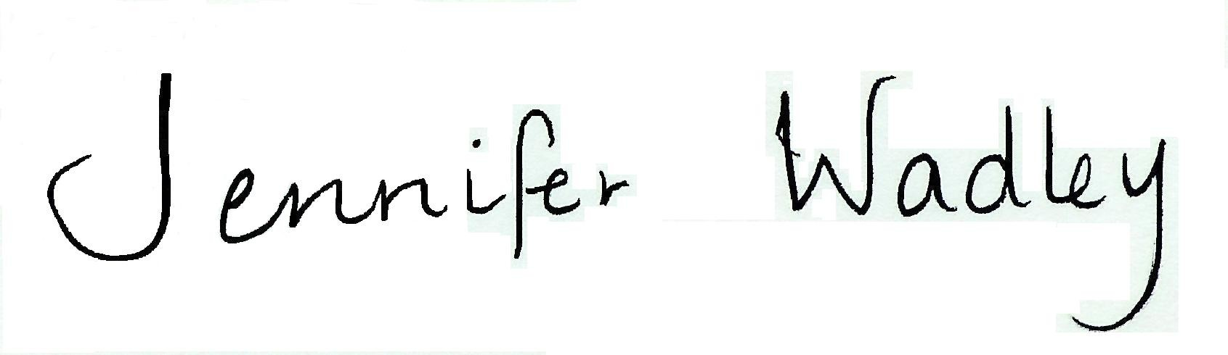

Jennifer Wadley
Head Teacher

