
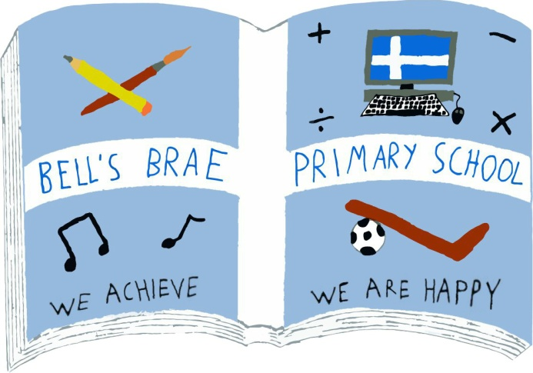

Mr Melvyn Clark  Acting Head Teacher |  | BELL’S BRAE PRIMARY SCHOOL  LERWICK, SHETLAND, ZE1 0QJ  Tel Lerwick (01595) 743720  E.mail: bellsbrae@shetland.gov.uk  https://blogs.glowscotland.org.uk/sh/bellsbraeprimary/

9th September, 2020

Dear Parents/Carers,

Home Learning Term 1 and Annual Data Check

I am getting in touch regarding Home Learning this term. It is hard to believe that it has been four weeks since the pupils returned full time to school! The pupils have all settled back really well and we have focused on reconnecting and ensuring that everyone is feeling safe and happy at school. Allowing time for pupils to familiarise themselves with their new teachers and new routines has been the priority. The pupils have responded really well to all the changes but we recognised this would be a lot to take in and would be tiring after the long spell of closure. Keeping this in mind, we decided to postpone homework to allow everyone, children and families, a chance to get back into a routine.

From Monday 14th September, pupils in P4-7 will have homework shared digitally through the use of Microsoft TEAMS within GLOW. All the pupils have been practising logging into their new class TEAM with their teachers in the ICT suite. Each week the class teachers will be adding a spelling task for each pupil in the assignments area of the TEAM to complete at home. The spelling tasks will be uploaded on a Monday to be completed for the following Friday.

The pupils will also continue to practise using this at school in the ICT suite to ensure they are developing their digital skills. Class teachers may also use the TEAM to direct the pupils to a maths task either in their TEAM or in SUMDOG. All teachers will be using the ASSIGNMENTS area of GLOW for pupil work to ensure consistency in all classes. ASSIGNMENTS are tasks or units of work assigned to a pupil in a class as part of their study.

All pupils will receive a card to take home with their GLOW username and password. This will also have the log in details for SUMDOG and PRODIGY. These can be used by the pupils to continue to develop their literacy and numeracy skills.

Logging in to GLOW and accessing Class Microsoft TEAMS:
- Use Google Chrome or Microsoft Edge as your internet browser.
- Type ‘Glow login’ into the search bar.
- Click on the link: https://sts.platform.rmunify.com/Account/SignIn/glow

This will take you to the login page where your child can enter their GLOW login details.

Enclosed in this pack is a ‘TEAMS User Guide’ and ‘Team Assignments user guide’. These will support you and your child to access their Class Microsoft TEAM and their assignments.

Should your child not have access to a suitable device then please let the school know, as we will support families where we can with access to devices and connectivity. If you need to discuss this or any other matter regarding GLOW please email the Bells Brae inbox bellsbrae@shetland.gov.uk or phone the school and ask to speak to myself.

Annual Data Check

Enclosed in this envelope is our Annual Data Check, this contains the details we currently have on record for your child/children. Please can you carefully check it and return with any amendments, it is essential we have the correct contact information and medical details on record.

Yours Sincerely

Cheryl Simpson

Cheryl Simpson
Depute Head Teacher

