
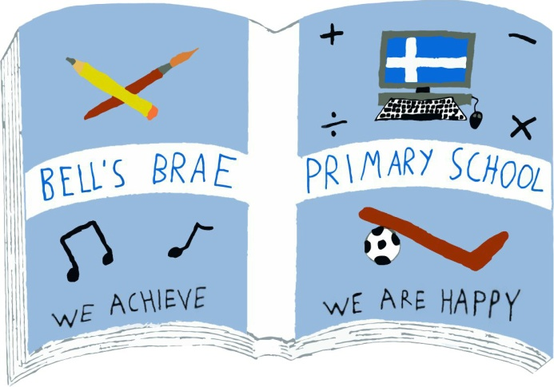

Mr Melvyn Clark  Acting Head Teacher |  | BELL’S BRAE PRIMARY SCHOOL  LERWICK, SHETLAND, ZE1 0QJ  Tel Lerwick (01595) 743720  E.mail: bellsbrae@shetland.gov.uk  https://blogs.glowscotland.org.uk/sh/bellsbraeprimary/

9th September 2020

Dear Parents/Carers

Home Learning Term 1

It is hard to believe we have been back 4 weeks! The pupils have all settled back into school well and we have spent time reconnecting and ensuring everyone is happy and safe at school. Giving the staff and pupils time to settle into new routines and getting to know each other, has been the priority. Keeping this in mind, we have not yet set any homework for pupils.

As of Monday 14th September the pupils in P1-3 will have homework shared digitally with you through a GLOW blog. Each class has been set up with a blog, which will be secure and only class members and teachers will have access to this. Each week the class teacher will add the week’s homework task onto GLOW on a Monday. This homework task will need to be completed by Friday. Your child will have 2 jotters, which will go home alternative weeks to enable the teacher to look at and mark any activities completed at home. A jotter will go home with your child on a Monday to be handed in again on Friday.

All children will be given a card with their GLOW username and password. This will also have login details for SUMDOG. This can be used by the pupils to develop their numeracy and literacy skills in a fun way.

Logging in to GLOW and accessing the Blog

- Use Google Chrome as your internet browser
- Click on the link https://sts.platform.rmunify.com/account/signin/glow (Here you enter your child’s login details)
- Click on the GLOW Blogs tile
- Click on My sites
- Click on your Class Blog

If for any reason you cannot get logged on please get in touch with us and we can try to sort this for you. Also, if you have limited internet or do not have a suitable device for your child to access GLOW, please contact bellsbrae@shetland.gov.uk.

Annual Data Check

Enclosed in this envelope is our Annual Data Check, this contains the details we currently have on record for your child/children. Please can you carefully check it and return with any amendments, it is essential we have the correct contact information and medical details on record.

Yours Sincerely
F Tait
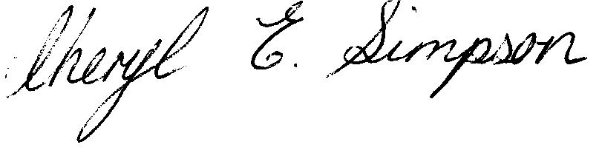
Frances Tait
Acting Depute Head Teacher (Early Years)

