
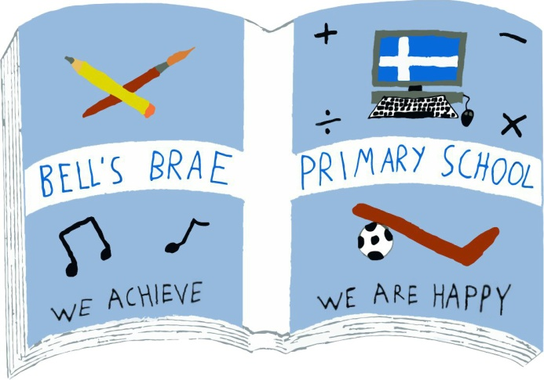

Mr M Clark  Acting Head Teacher |  | BELL’S BRAE PRIMARY SCHOOL  LERWICK, SHETLAND, ZE1 0QJ  Tel Lerwick (01595) 743720  E.mail: bellsbrae@shetland.gov.uk  https://blogs.glowscotland.org.uk/sh/bellsbraeprimary/

15 September, 2020

Dear Parents/Carers

As we move into the second half of this first term back at school, this letter will quickly provide some updates and new information, including links to a number of web-sites.

First of all, I want to say that you should all be very proud of your children. They have adapted brilliantly to the new ways of doing things here at Bell’s Brae. Their willingness to accept change, their flexibility and the way they have simply “got on with things” has been wonderful to see. They are a credit to both you, and themselves.

This, together with your support and understanding, has made it possible for us all to have as positive a return to school as anyone could have hoped for.

Attendance at school
I also extend my thanks to you all for closely following the current advice regarding whether or not to send your children to school if they are unwell. I realise that this can be confusing, and frustrating, at times but by doing so you are helping to keep everyone safe.

For clarity, please keep your child(ren) at home if anyone in the household is displaying COVID-19 symptoms. The main symptoms to look out for remain -
- a new, continuous cough
- fever/high temperature
- a loss of, or change in, sense of smell or taste.

Information on arranging corona virus testing can be found at - https://www.nhsinform.scot/illnesses-and-conditions/infections-and-poisoning/coronavirus-covid-19/test-and-protect/coronavirus-covid-19-testing

We will continue to follow Children’s Services guidance and send home any child who informs us they are feeling unwell. Those who present as having, or who tell us they have, COVID-19 symptoms will be isolated and supported in school while they wait to be collected.

Flu Vaccination
Today, you will receive information in your child(ren)’s schoolbags regarding the annual flu vaccination. Given the ongoing Covid-19 situation, NHS Scotland are highlighting that it’s more important than ever to get the flu vaccine. Please take time to look over the information and return the consent forms. The vaccination team are due to be in Bell’s Brae on Wednesday 28 October.

Homework
Yesterday, you should have received information from Mrs Simpson and Mrs Tait explaining the ongoing use of Microsoft Teams and Glow for your children’s homework. Please contact the school if you haven’t received anything.

PTO...

Annual Data Check
This was also included in the envelope you received yesterday. Please carefully check it and return with any amendments, it is essential we have the correct contact information and medical details on record.

School Improvement
Each year, we as a school look at our own practice and identify what we are doing well and the things we need to work on. We ask pupils, parents/carers and staff to contribute and give us their views. This, along with priorities identified by Education Scotland and the local authority help to shape our annual School Improvement Plan (SIP).

Covid-19 has had an impact on all aspects of our lives, particularly how we all work and learn. Therefore, I would be very grateful if you would take a little time to complete a short survey on your experiences of remote learning and the return to school. It really won’t take you very long but will provide us with valuable information to consider as pull together our SIP for 2020-21. Here is the link for the survey - https://forms.office.com/Pages/ResponsePage.aspx?id=oyzTzM4Wj0KVQTctawUZKa3tAJyjeYhHrIqCITcixwlUREhGNlhIODI5M1JCOFU3SjY2UlA3UTlIMi4u

Snack
Due to the current restrictions, we are currently unable to offer a Tuck Shop here in the school. Therefore, we are asking that children take their own snack to school with them for morning interval.

Instrumental Tuition
Children’s Services have asked me to share the following information with you. All forms are now online and any information ‘waiting list’ paper forms they currently have are out of date. All instrumental information and forms can be found on the website at http://www.shetland.gov.uk/education/creative_learning.asp#InstrumentInstructions

The links below will take you direct to the forms;
Waiting list ; https://my.shetland.gov.uk/en/AchieveForms/?form_uri=sandbox-publish%3A//AF-Process-567b6ca8-e1cc-4aa5-b85c-941f1f4c0c7f/AF-Stage-ba648fe5-caaa-43eb-8fad-9cc2c8ca9998/definition.json&redirectlink=/en&cancelRedirectLink=/en

Guitar waiting list; https://my.shetland.gov.uk/en/AchieveForms/?form_uri=sandbox-publish%3A//AF-Process-0103c47a-da02-4ea3-b0d3-083c34354a72/AF-Stage4b6da648-94b0-475a-9c12-86a1d181c8ad/definition.json&redirectlink=/en&cancelRedirectLink=/en

If you have problems accessing the online forms, please phone Katrena Anderson on 01585 743832 who will be happy to fill it in with you over the phone.

Clothing
While we will keep them in when the weather is really poor, the children here at Bell’s Brae will be encouraged to be outside for break times whenever possible. PE lessons also continue to be outside for the time being. Light rain or drizzle won’t see them kept in so it would be greatly appreciated if everyone could come to school dressed for what the Shetland weather may bring, e.g. a jacket, appropriate footwear, etc. It may even be an idea to have a spare pair of dry socks in their school bag!

One positive of the current arrangements is that there is virtually no lost property at the moment! However, there was a considerable amount of clothing left in school before lockdown commenced and we have started looking through it and returning any items with names on them. Weather permitting, those items that are unnamed will be displayed on tables outside the main school door from 1445 on Monday 21 and Tuesday 22 September. Please come and have a look, at a safe physical distance, if you think your child(ren) may have left things.

As always, please get in touch with the school if you have any questions about any of the above.

Melvyn

Melvyn Clark
Acting Head Teacher

