
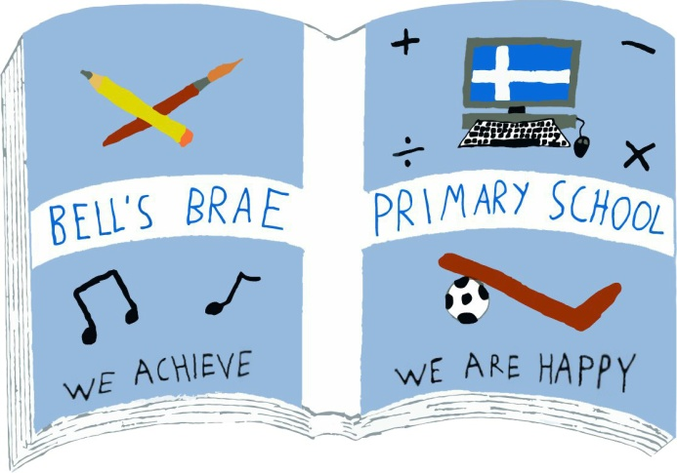

Miss D Murray  Acting Depute Head Teacher ASN |  | BELL’S BRAE PRIMARY SCHOOL  LERWICK, SHETLAND, ZE1 0QJ  Tel Lerwick (01595) 743720  E.mail: bellsbrae@shetland.gov.uk  https://blogs.glowscotland.org.uk/sh/bellsbraeprimary/
05 August 2020

Dear Parents/Carers

I would like to start this letter by saying “Hello” in my new role as Acting Depute Head Teacher of ASN at Bells Brae. I hope you have all had a lovely summer holiday. I am really looking forward to seeing all the pupils back at school and wanted to share with you the arrangements in place for starting back next week.

Arrangements for the return of children and young people during the first week of the new school term, Tuesday 11 August to Friday 14 August

On Friday 31 July, Mrs. Budge, the Director of Children’s Services, wrote to inform you that the Scottish Government confirmed on Thursday 30 July that all Scottish schools will reopen full-time in August.

Mrs Budge’s letter explained that a number of measures will be in place to reduce the risk of transmission and support the health and safety of all our children, young people and staff on their return to school.

The ‘soft-start’ to the new term: the phased return to school of children and young people

In Friday’s letter, there was also confirmation that, given the length of time children and young people have been away from school, the fact that many children will be starting out in a new school, and the need to go over important safety procedures and arrangements, the local authority are planning a ‘soft-start’ to the first week of the new term.

This means a gradual and phased return of children and young people into schools from Tuesday 11 August to Friday 14 August, as opposed to all children returning on the one day. This will support children reconnect with staff, their peers, and the school environment, as a whole, and enable staff to go over important safety procedures and arrangements.

As far as possible, all children and young people will be back in school full-time by Monday 17 August.

The purpose of this letter is to provide further clarification about arrangements for the first week of the new term in our school.

Arrangements for Bells Brae ASN

Monday 10 August – In-service training for all staff. Pupils do not attend school.

Tuesday 11 August and Wednesday 12 August – School visits for some pupils and families.

If you feel your child would like to come in to Bells Brae for a short visit to see their new classrooms and meet teachers/staff please email bellsbrae@shetland.gov.uk and I will get back to you to arrange a mutually convenient time.

Thursday 15 August and Friday 16 August – Bells Brae ASN department will be open to all ASN pupils, attendance for both days is optional before school resumes to everyone on Monday 17 August.

Further information about drop-off and pick-up arrangements, transport, break-times, lunches and any necessary resources your child may need to take with them to school will be shared with you next week.

I really look forward to welcoming you all back to Bells Brae, if you have any questions or queries please feel free to get in touch.

Kind Regards

Donna Murray
Acting Depute Head Teacher (ASN)

