
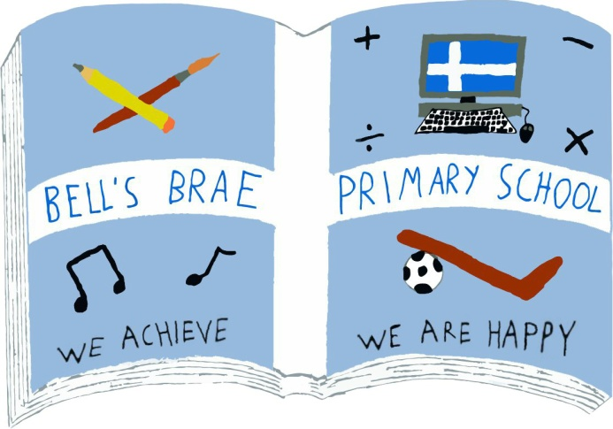

Mr M Clark  Acting Head Teacher |  | BELL’S BRAE PRIMARY SCHOOL  LERWICK, SHETLAND, ZE1 0QJ  Tel Lerwick (01595) 743720  E.mail: bellsbrae@shetland.gov.uk  https://blogs.glowscotland.org.uk/sh/bellsbraeprimary/

4 August, 2020

Dear Parents and Carers

Arrangements for the return of children and young people during the first week of the new school term, Tuesday 11 August to Friday 14 August

On Friday 31 July, Mrs. Budge, the Director of Children’s Services, wrote to inform you that the Scottish Government confirmed on Thursday 30 July that all Scottish schools will reopen full-time in August.
Mrs Budge’s letter explained that a number of measures will be in place to reduce the risk of transmission and support the health and safety of all our children, young people and staff on their return to school.
The ‘soft-start’ to the new term: the phased return to school of children and young people
In Friday’s letter, there was also confirmation that, given the length of time children and young people have been away from school, the fact that many children will be starting out in a new school, and the need to go over important safety procedures and arrangements, the local authority are planning a ‘soft-start’ to the first week of the new term.
This means a gradual and phased return of children and young people into schools from Tuesday 11 August to Friday 14 August, as opposed to all children returning on the one day. This will support children reconnect with staff, their peers, and the school environment, as a whole, and enable staff to go over important safety procedures and arrangements.
As far as possible, all children and young people will be back in school full-time by Monday 17 August.

The purpose of this letter is to provide further clarification about arrangements for the first week of the new term in our school.

PTO....

Arrangements for Bell’s Brae

We are really looking forward to welcoming everyone back into Bell’s Brae but want to do so in a safe and measured way. Therefore, the following arrangements are in place for next week –

Monday 10 August – In-service training for all staff. Pupils do not attend school.

Tuesday 11 August and Wednesday 12 August – School visits for some pupils and families.

School staff will contact the families of pupils with additional support needs to offer visits to school that will hopefully alleviate any worries about returning to Bell’s Brae. These families will be contacted before the end of this week to arrange a short visit.

However, we appreciate that the return to school may be causing other children and families some anxiety. If you think that a visit to the school on Tuesday or Wednesday would help, please contact us via the school email bellsbrae@shetland.gov.uk someone will get back to you to arrange a mutually convenient time.

In line with Local Education Authority advice, our pupils will initially return in a smaller group on either Thursday 13 or Friday 14. This will ensure that no one is overwhelmed by what may be the largest number of people they have encountered for months. This will also ensure that all Health and Safety measures can be explained clearly to everyone and your children have a greater opportunity to ask any questions they may have in a quieter, relaxed environment.

Your child(ren) will attend school for a full day on Thursday 13 August.

We are confident that this will enable everyone to settle back in before a full return to the ‘new normal’ here at Bell’s Brae from Monday 17 August.

Further information about drop-off and pick-up arrangements, break-times, lunches and any necessary resources your children may need to take with them to school will be shared with you next week. This will include information regarding transport for pupils from Bressay and those with additional support needs.

Parents/carers of children due to start Primary 1 next week will be receiving a separate letter from Mrs Tait with specific information about the arrangements for their classes.

Yours sincerely

M Clark

Melvyn Clark
Acting Head Teacher

