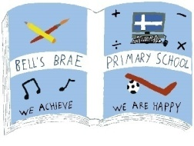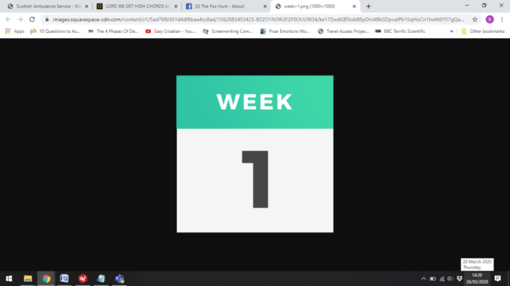**P6 Term 4 Learning Choice Board**

|  |  |  |  |
| --- | --- | --- | --- |
| Collection of superhero kids | Free VectorHeroes – Draw someone in your life as a superhero. Design a costume for them. What is their superpower? | Chef Cartoon | Free Vectors, Stock Photos & PSDAssistant Chef Help make breakfast,  lunch or dinner at home. (Do this three times this week – perhaps help out with a different meal each time?) | Egg-cellent Number Crunching The first ever chocolate egg in the U.K. was made by a company called “Fry’s of Bristol” on March 14th 1873.   * How many *years* ago was this? * *Challenge*: How many  *months* ago was this? * *Extra challenge*: How  many *days* ago was this? | Cartoon artist boy stock vector. Illustration of character - 36211596Cover artists – Find your favourite book, and draw the front cover.  Take your time adding all the details, and add colour if you can.  *Challenge* - come up with your own idea for a story, and design a front cover for it! |
| Easter Bunny Pictures Images | Easter bunny images, Easter bunny ...Busy Bunny  The Easter Bunny can only carry 3 eggs at once. He has to choose 3 eggs from the following colours: **Red**, **Green** or **Blue**. How many possible ways can the Easter Bunny carry the eggs? (He can carry the same colour more than once.) | Video Camera Clipart Png | Camera cartoon, Camera clip art, Clip art    Lights, Camera, Action!  Hollywood Art Lights Camera Action Vector Online - Lights Camera ...Academy Awards Png, The Oscars Png, Download Png Image - Oscar ...Put your drama skills to use – recreate/act out a scene from your favourite book or movie. | A girl running with confidence and charm » Clipart StationDaily Mile – Keep this up! Aim for three times this week.  Make it a minimum of 15 minutes!  (*Remember to stick to social distancing rules!) | https://i.dlpng.com/static/png/4696196-throw-ball-graphics-designs-templates-from-graphicriver-throw-ball-png-590_700_preview.pngRecord Breakers - With someone in your family, count how many throws and catches of a ball you can do in 1 minute. Try again, kicking the ball this time. Can you beat your record?  (If you don’t have a ball you could use a pair of rolled-up socks 😊) |
| Factfile  Cartoon Cartoon clipart - Cartoon, Graphics, Illustration ...Create a fact file on a famous inventor from  the Victorian era. What did they invent? Did their invention change the world? How? Include a drawing of their invention. | Headlines  Watch *CBBC Newsround*  three times per week to  Newsround | Logopedia | Fandomkeep up with current events.  Choose one news item to share with someone in your family. [www.bbc.co.uk/newsround/news/watch_newsround](http://www.bbc.co.uk/newsround/news/watch_newsround) | What’s Your Game?  Create a game to help you practise your times tables.  Write down  the rules and play  the game with  Maths Cartoon 24 - 1001 X 1047 - WebComicms.Netsomeone at home. | Music – Click the link below to learn about a famous composer called **Edward Elgar**. He was born in 1857 and his earliest works were for his church choir. His first important orchestral piece was the*Enigma Variations*, which he composed in 1899. In 1904, he was knighted for his contribution to British music and became Sir Edward Elgar. [https://youtu.be/m2XuAdoCh6M](https://www.youtube.com/watch?v=m2XuAdoCh6M)  Next, complete the activity below 😊 |

Remember to keep up with your **personal reading**, at least 15 minutes per day! Please also complete one **“Mental Maths” exercise** each day in your homework jotter.

If you have access to a computer/tablet, you can play **Prodigy** to practise maths – your questions have been updated! ([www.prodigygame.com/play](http://www.prodigygame.com/play))



Once you have watched the video, see if you can complete this crossword.  It is all about instruments of the string family, many of which you saw being played in the clip.  The ten answers to choose from are:

**CELLO    VIOLA    HORSEHAIR    BASS    HARP**

**FOUR    PLUCK    VIOLIN    BANJO    BIGGER**