Primary 4 Home Learning Choice Board
TIME  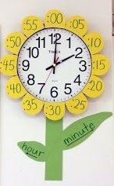  Design a flower clock, as seen in the picture keep for next week’s activity. | WRITING  Start a diary, describing your day e.g. who you meet, what activities you do, how you are feeling. You can add to this weekly or daily. | HEALTH & WELLBEING  Go for a walk or cycle with someone in your house. | ART  If you could have any pet in the world, what would it be? Draw a picture of it, adding as much detail as possible. It doesn't have to be a real animal! I've always wanted a dragon...
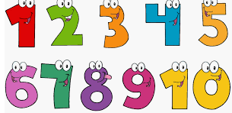  NUMBER  Make up a song or dance routine for the 2, 4 or 8 times table. You could use youtube or number rock videos for inspiration. | GRAMMAR  Write a list of animals in alphabetical order then add alliteration e.g. Awesome Ant, Beautiful Bee. You could also try adding two adjectives e.g. clever curious cat. | HEALTH & WELLBEING  Play a card or board game with another person in your house.  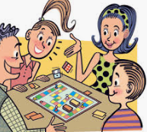 | P.E.
MONEY  How many different coins can you find in your house?  With the coins you find write down all the different ways as you can make £1. | SPELLING  Login to GLOW to access your spelling words. Practice spelling your words out loud with someone in your house. | HEALTH & WELLBEING  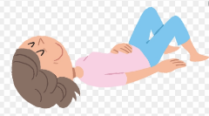  Put on some relaxing music of your choice lie down on the floor and close your eyes for 5 minutes. Enjoy! | MUSIC  Now that it is Easter, can you remember how to sing "The Chocolate Song?" It's a fast song! https://youtu.be/ld4SlUqvP8U  