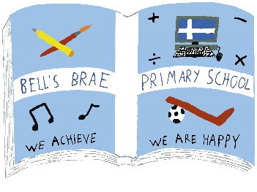
Term 4 Learning Grid
Paired reading  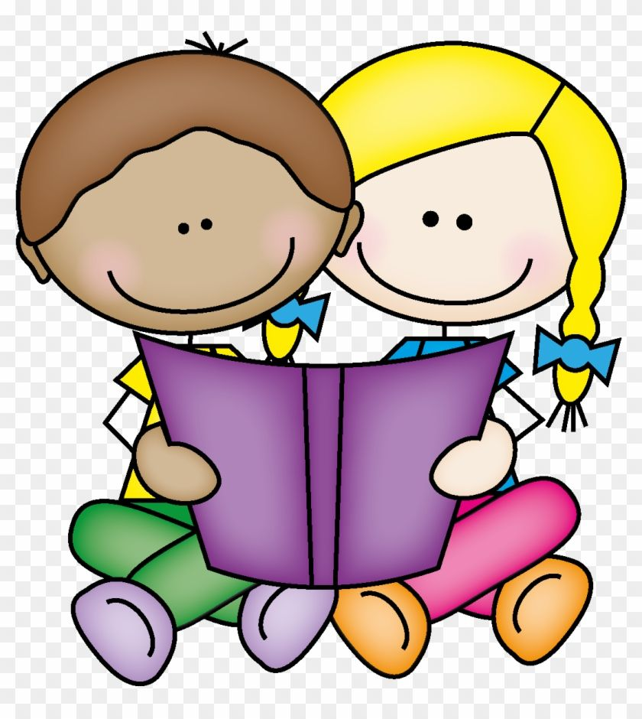  Choose a reading partner (it can be someone different each day if you want). Find somewhere relaxing and cosy and you are ready to get started. | 2 x table  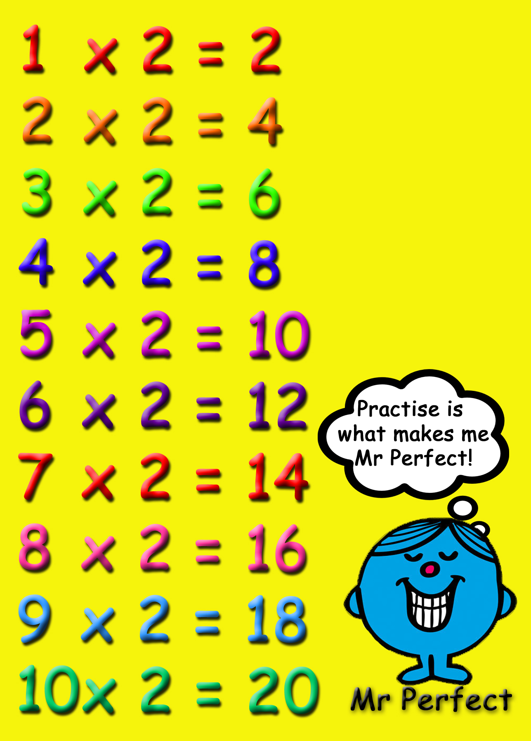  Revisit the 2 x table. Have a look on the back of this page for some ideas. | 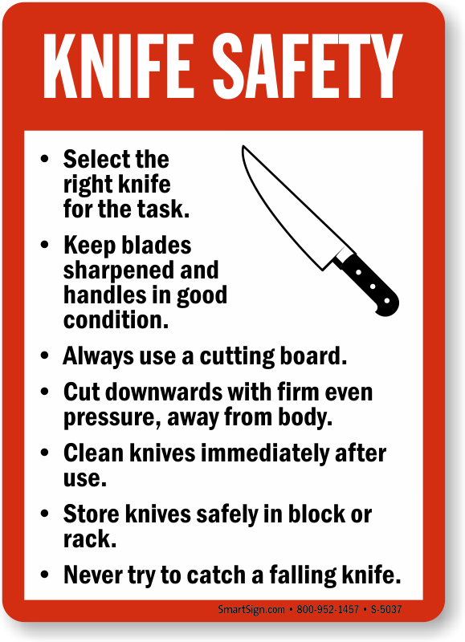  Prepare a healthy snack.  E.g. peeling a carrot, practising your basic cutting skills. Remember to ask an adult to help supervise. | Get Creative  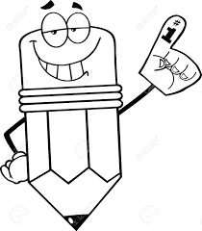  If you could have any pet in the world, what would it be? Draw a picture of it, adding as much detail as possible. It does not have to be a real animal! I've always wanted a dragon...'
Create a step-by-step guide on how to wash your hands. Use your poster to teach a family member. | Fractions  Watch the episode of Odd Squad https://www.dailymotion.com/video/x6v69yn  - Remember we call fourths quarters. Get a rectangular piece of paper fold it in half, then quarters,  - Now try this with a circle and a square. | Play a game with someone. Focus on taking turns and being respectful. Make sure you turn off all technology to give your full attention and eye contact. | ALPHABET WORKOUT  Try to get everyone in your house to complete the alphabet workout. You could spell out your name or look in the dictionary & challenge y ourselves.  Instructions on the back  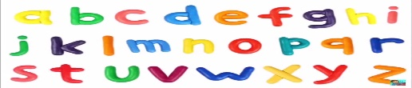
Active spelling  Choose an activity to practise your tricky words using these lists: https://www.jollylearning.co.uk/resource-bank/handy-tricky-word-list/  - Back writing  - Toss a ball  - Cut and stick letters out of newspapers/magazines  - Choose one of your own! | Estimate how many steps it takes to get from your bedroom to the kitchen.  Check your answer.  Were you accurate? Try this for other journeys around your house. Get someone else to join in. Who is more accurate? Why are your estimations different? | Balloon badminton 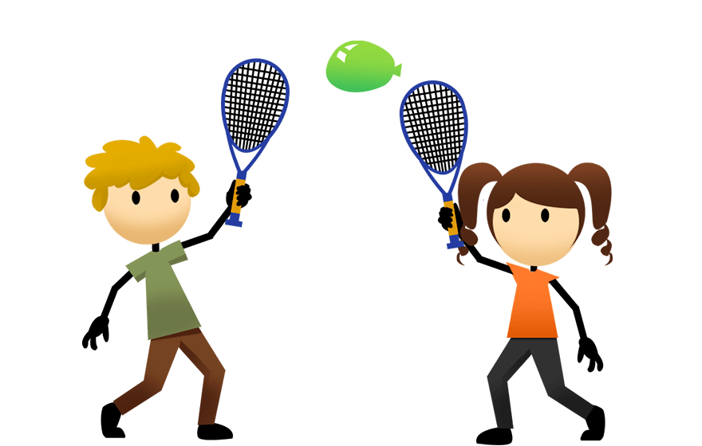  Look at the back of the page for instructions | Music  Last term, we learned a song called "Loki the Joker." Click on the link below and see if you can sing along. Can you draw a picture of one of the Viking characters mentioned in the song?  https://youtu.be/GmSagugkLjU  Now that it's Easter, see if you can remember how to sing the "Chocolate Song." What is your favourite kind of chocolate?  https://youtu.be/ld4SlUqvP8U

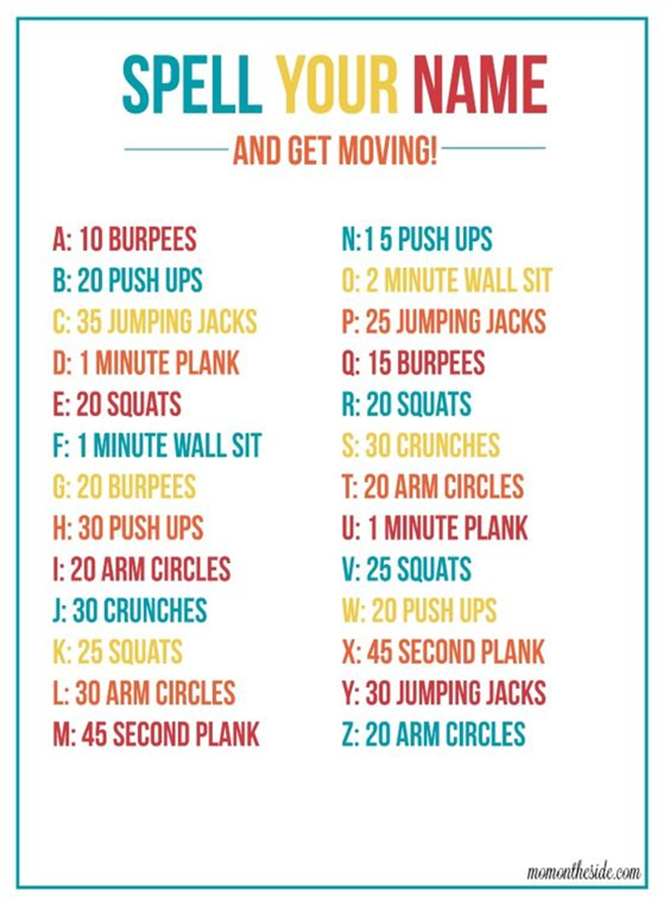
2 x table ideas:
-Practise counting up and down in 2s from 0 to 24
-Sing along and dance to this 2xtable rap: https://www.youtube.com/watch?v=BGWMPqh04o4
-Find indoor/garden objects (buttons, stones, leaves etc.) to create arrays. For example, children could make 2 rows of 6 buttons to visually display 2 x 6
-Make a treasure hunt of the 2xtable around your house
-Play online games to practise your 2xtable. Choose a multiplication game from: https://www.topmarks.co.uk/maths-games/5-7-years/times-tables
-Create a game of your own
*Try to practise daily to improve your speed and accuracy

Balloon badminton
Set up a ‘net’ somewhere in your house (you can use string, a bedsheet etc.)
Stick paper plates onto something long and strong (e.g thick card) for a badminton racquet.
Blow up a balloon.
You are now ready to play balloon badminton with a partner!

