
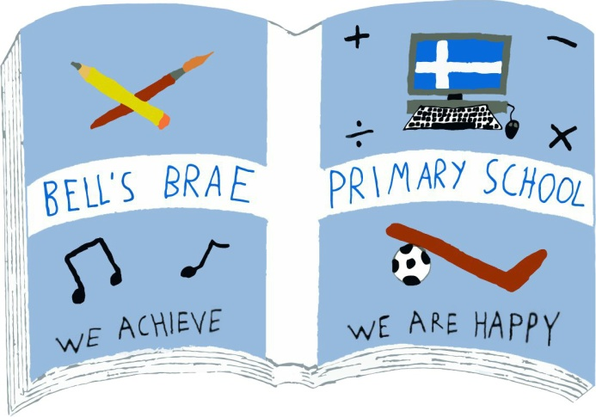

Mr M Clark  Acting Head Teacher |  | BELL’S BRAE PRIMARY SCHOOL  LERWICK, SHETLAND, ZE1 0QJ  Tel Lerwick (01595) 743720  E.mail: bellsbrae@shetland.gov.uk  https://blogs.glowscotland.org.uk/sh/bellsbraeprimary/

5 November 2019

Dear Parents/Carers

This is always a very, very busy term with lots going on in school. There are some key pieces of information in this letter so please take a short moment to read it over.

Fundraising

Our Fish and Chip night will be on Friday 8 November with fish, macaroni and sausage suppers on the menu. It will start at 5pm, with last orders being taken at 6.45pm. Prices will be £6 for an adult fish supper and £3 for a child’s one. Macaroni and Sausage suppers will both be £5 for an adult and £2 for a child. There will also be ice-cream and sprinkles for £1 for any bairns looking for something sweet to finish their meal!

Wider Achievement

Last Friday saw the pupils in P4-7 have their first wider achievement group sessions. These will hopefully give children the chance to develop their skills in a variety of ways as they not only take part in activities they may already familiar with but also by trying something new. Some parents/carers will already have received letters regarding requirements for particular groups but it would be great if all children could ensure that they have any necessary clothing/footwear with them on the day. The remaining wider achievement afternoons for P4-7 this term are November 15 and 29 and December 13.

Breakfast and Study Clubs

Both of these will be continuing as before with breakfast club happening every morning from 0830 to 0900 and study club from 1500 to 1545, Mondays to Thursdays. Parents/carers should contact the school office to book their child(ren) into the study club. Please ensure you also contact the office if there has been a change of plan and they will not be attending.

After school arrangements
To avoid uncertainty and potential distress could parents/carers make sure that, before leaving home in the morning, children know what arrangements are in place for after school. Phone calls to the school with after school arrangements should only be made in exceptional circumstances.

Dates for your diary
Friday 15 November | Children in Need – as pupils may be involved in some fundraising activities please feel free to send in donations for this worthy cause.
Monday 9 and Tuesday 10 December | P1 performances – 1400
Tuesday 17 December | P7 performance to parents/carers – 1800
Friday 20 December | School closes for Christmas holidays
Wednesday 8 January 2020 | School re-opens for pupils

Further information regarding Christmas parties, performances, concerts, etc. will be shared later in the term. Also, please keep an eye on our website for information and updates about what is happening in school.

Road Safety
Please remember that parking outside the school on Gilbertson Road is restricted. This area should only be used to pick up/drop off pupils and anyone parking in this area may be issued with a parking ticket. There should be no stopping whatsoever on the zig zag lines. The law states you cannot stop, wait or drop off passengers on zig zag lines during the hours given on the accompanying sign. It is an offence to park on the double yellow lines.

The staff car park should only be used by staff and must be kept easily accessible for the emergency services and should not be used to pick up and drop off children.
PTO...

Illness and absence

Parents/carers are asked to report all absences between 0830 and 0930 on each day of absence. The Scottish Government advises that where the school does not receive notification from parents/carers, pupils’ absence will be recorded as ‘truancy’. Where the school has not been informed of an absence, staff will endeavour to contact parents/carers/emergency contacts before 1030 to ensure they are aware that their child is not at school and to confirm the reason for their absence. If parents/carers cannot be contacted, the absence will be referred to the school management team who will decide on the most appropriate action to take. This may have to include contact with another agency. Schools are legally obliged to keep records of both authorised and unauthorised absences and these are reported annually to the Scottish Government.

NHS Shetland have a lot of advice on norovirus (winter vomiting bug). The key message is to advise the public to stay at home for 48 hours after their norovirus symptoms have stopped to avoid spreading it further.

Staff are able to administer medicines to children only when a Care Plan has been drawn up – these are available at the school office. If your child has asthma we will require you to complete a School Asthma Card. These are available on the school website https://blogs.glowscotland.org.uk/sh/bellsbraeprimary/files/2017/04/Appendix-1-School_Asthma_Card1.pdf or from the school office. Also, please ensure any inhalers your child has in school are renewed as necessary.

Parents/carers are reminded that they should notify the class teacher either by sending in a note or by writing in their child’s homework diary when they know in advance that their child is to be taken out of school for an appointment. It is only necessary for the parent/carer to phone the school if the appointment has been arranged on the day and they have been unable to inform the class teacher in writing.

Winter Weather
It’s that time of year again when we must remind you about dealing with deteriorating weather conditions.

Whenever the weather is reasonable, we will continue to encourage children to get fresh air and exercise so please ensure that your child has a waterproof jacket with them every day and appropriate footwear. As always, try to ensure that all clothing/footwear has your child’s name in it. A pair of tracksuit bottoms would be a valuable addition to their PE kit.

Information about school closures due to bad weather will be announced on local and national radio – Radio Shetland at 1730, Radio Orkney at 0730 and on SIBC. However parents/carers are responsible at all times for deciding whether to send their children to school. Parents can follow alerts on twitter. A direct link to this can be accessed through the Shetland Islands Council home page www.shetland.gov.uk click on twitter ‘follow@shetlslandsCll’ button at the top right corner of the page. We will also add updates to our school website: https://blogs.glowscotland.org.uk/sh/bellsbraeprimary/

Working together
Finally, in line with our school vision (see below) and in order to foster positive relationships within the Bell’s Brae community, school staff make every effort to communicate with pupils and their families with understanding and respect. In return we would ask that pupils and parents/carers make a similar effort and do not make inappropriate or unkind comments during their interactions with staff. That way, we can ensure that “Bell’s Brae is a community where everyone achieves and gains happy memories.”

Yours sincerely
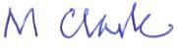

Melvyn Clark
Acting Head Teacher



