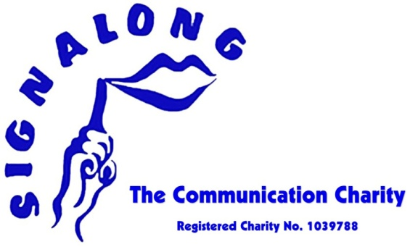
Are you interested in learning about key word signing?
Do you know some sign but want to develop your skills?
Come to an Introduction to Signalong Course.
At this one hour session you will learn some of the principles of signing, learn some simple signs and there will be an opportunity to find out about future training opportunities.
The course is open to parents and professionals.
Date -Thursday 7th February
Time- 4.00-5.00pm
Where- Bell’s Brae Primary School
Tutor-Susie Fox
Cost-Free.

Please e-mail or speak to Susie to book your place
susan.fox@shetland.gov.uk
There will be a follow up 3 week course starting in March

