
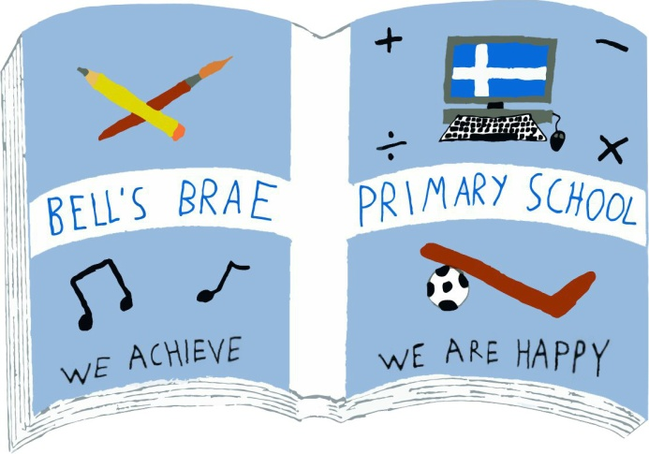
Mrs J Wadley  Head Teacher |  | BELL’S BRAE PRIMARY SCHOOL  LERWICK, SHETLAND, ZE1 0QJ  Tel Lerwick (01595) 743720  E.mail: bellsbrae@shetland.gov.uk  https://blogs.glowscotland.org.uk/sh/bellsbraeprimary/
24 September 2018

Dear Parents/carers

S2 Peer Football Coaching at 60/40

As part of their Wider Achievement course, pupils at the Anderson High School have been developing their football coaching skills this term. Their teacher, Mr Malcolmson, has been in touch to offer the Primary 4 classes the opportunity to go to participate in a coaching session at the 60/40 which will be led by the Secondary 2 pupils.

There will be 2 separate sessions, one for each class on the following dates:

Primary 4s (Miss Day) Friday 28th September at 1315 – 1405

Primary 4n (Ms Wishart) Friday 12th October 1315 – 1405

The children will get their school lunch early on these days.

Please can you ensure your child comes with trainers and comfortable but warm clothing as it can be quite cold in the 60/40 ( ie. tracksuit, jogging trousers/leggings). If your child uses an inhaler please makes sure they have it with them for the activity.

We do hope your child enjoys this opportunity.

Yours sincerely

Cheryl Simpson

Cheryl Simpson
Depute Head Teacher

