Clothes Swap
Fundraising for Bell’s Brae Primary School
On Saturday 1st September 2018
At Bell’s Brae School
From 11am till 2pm

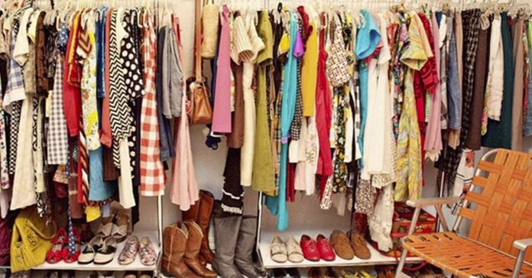
Donations of ladies clothes, shoes, handbags, jackets, jewellery and accessories gratefully received.

You can drop off donations to Bell’s Brae School front entrance or contact Lisa Johnson on 07919 038132 to arrange drop off/collection.

Thank you for helping to raise funds for Bell’s Brae Primary School.

