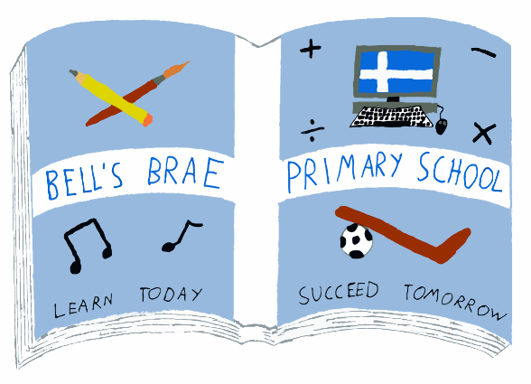    1 May 2017  Dear Parent/Carer  For the next eight weeks of this term P3s will be using the SRA Reading Laboratory kit.  The purpose of using this programme is to develop comprehension and study skills through a wide selection of factual and fictional reading passages. Pupils work independently according to their own abilities and this helps to encourage them to develop a sense of responsibility as they take charge of their own learning.  While pupils are on this programme they will continue with their ‘reading book’ but at a reduced frequency or on a novel of their own choosing.  Yours faithfully  Melvyn Clark  Depute Head Teacher (Early Years) | 1 May 2017  Dear Parent/Carer  For the next eight weeks of this term P3s will be using the SRA Reading Laboratory kit.  The purpose of using this programme is to develop comprehension and study skills through a wide selection of factual and fictional reading passages. Pupils work independently according to their own abilities and this helps to encourage them to develop a sense of responsibility as they take charge of their own learning.  While pupils are on this programme they will continue with their ‘reading book’ but at a reduced frequency or on a novel of their own choosing.  Yours faithfully  Melvyn Clark  Depute Head Teacher (Early Years)
  Mrs J Wadley  Head Teacher |  | BELL’S BRAE PRIMARY SCHOOL  LERWICK, SHETLAND, ZE1 0QJ  Tel Lerwick (01595) 743720  Fax Lerwick (01595) 807302  E.mail: bellsbrae@shetland.gov.uk  Website: www.bellsbrae.shetland.sch.uk
  Mrs J Wadley  Head Teacher |  | BELL’S BRAE PRIMARY SCHOOL  LERWICK, SHETLAND, ZE1 0QJ  Tel Lerwick (01595) 743720  Fax Lerwick (01595) 807302  E.mail: bellsbrae@shetland.gov.uk  Website: www.bellsbrae.shetland.sch.uk

