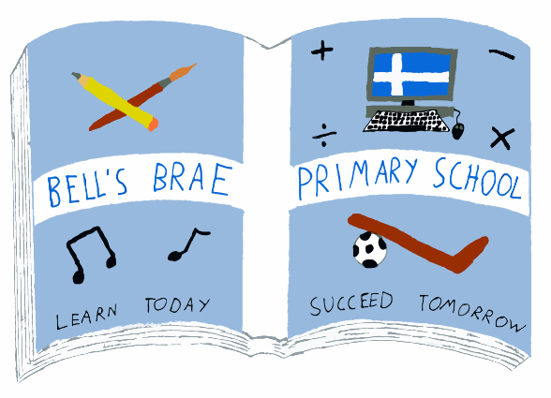  1 May 2017  Dear Parents/Carers  Starting this week, and for the following 5 weeks, the children from Bell’s Brae Early Years will be visiting the Shetland Library on the Lower Hillhead.  The children will be leaving for the library at 11.15 to spend the last part of their day there. We want to make these visits as rewarding and enjoyable for everyone, including other library users. So, rather than the whole class going at one time, the children have been put into three smaller groups – your child’s group will be going to the library on the following dates –  On these days we need you to come to the Library to collect your child at the usual time.  Children who attend the extended session in EY Room 1 will return to Bell’s Brae for their usual pick up time of 12.40.  Being read to is recognised as one of the most important ways in which young children develop literacy and expand their vocabulary. We hope that these visits, alongside the time you spend reading with your child and their experiences here in EY, will promote the importance of books and the fun that can be had from them.  Yours faithfully  Melvyn Clark  Depute Head Teacher (Early Years) | 1 May 2017  Dear Parents/Carers  Starting this week, and for the following 5 weeks, the children from Bell’s Brae Early Years will be visiting the Shetland Library on the Lower Hillhead.  The children will be leaving for the library at 11.15 to spend the last part of their day there. We want to make these visits as rewarding and enjoyable for everyone, including other library users. So, rather than the whole class going at one time, the children have been put into three smaller groups – your child’s group will be going to the library on the following dates –  On these days we need you to come to the Library to collect your child at the usual time.  Children who attend the extended session in EY Room 1 will return to Bell’s Brae for their usual pick up time of 12.40.  Being read to is recognised as one of the most important ways in which young children develop literacy and expand their vocabulary. We hope that these visits, alongside the time you spend reading with your child and their experiences here in EY, will promote the importance of books and the fun that can be had from them.  Yours faithfully  Melvyn Clark  Depute Head Teacher (Early Years)
  Mrs J Wadley  Head Teacher |  | BELL’S BRAE PRIMARY SCHOOL  LERWICK,  SHETLAND,  ZE1 0QJ  Tel: Lerwick (01595) 743720  Fax: Lerwick (01595) 693860
  Mrs J Wadley  Head Teacher |  | BELL’S BRAE PRIMARY SCHOOL  LERWICK,  SHETLAND,  ZE1 0QJ  Tel: Lerwick (01595) 743720  Fax: Lerwick (01595) 693860

