
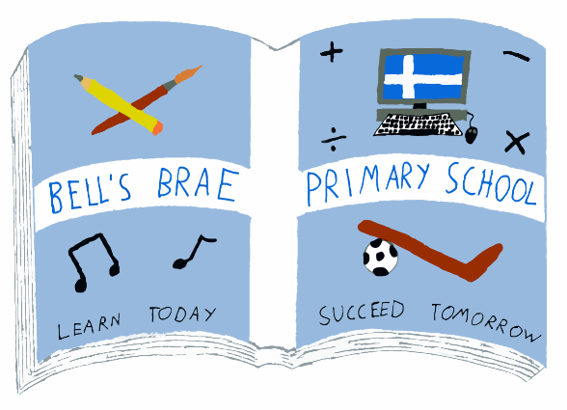

Mrs J Wadley  Head Teacher |  | BELL’S BRAE PRIMARY SCHOOL  LERWICK, SHETLAND, ZE1 0QJ  Tel Lerwick (01595) 743720  E.mail: bellsbrae@shetland.gov.uk  Website: www.bellsbrae.shetland.sch.uk
Dear Parents/Carers

P7pupils Edinburgh Trip June 2018

As a large majority of parents have shown an interest in a P7 trip, plans are moving ahead. We have been making arrangements with R G Jamieson & Son, our tour operator, looking at possible activities to include in our itinerary and have agreed that we will be taking part in activities in Stirling and Edinburgh. Our exact itinerary will be confirmed at a later stage. (On the back of this letter we have included a rough itinerary although this is subject to change).

We will travel south on the boat departing Lerwick on Sunday 3rd June and return on the morning of Friday 8th June 2018. We will stay in hostel accommodation in Edinburgh on Monday and Tuesday nights and in Stiring on Wednesday evening on a breakfast only basis. All the bedrooms there are en-suite. Mr Jamieson will provide packed lunches and he will arrange evening meals at a range of mutually agreeable eateries.
We plan to have a minimum of 6 adults accompanying the children.
We estimate the cost of the trip will be no more than £400.00 and this will be payable in a minimum of four deposits, as follows

- 2 October 2017 non-refundable deposit of £100
- 4 December 2017 second payment of £100
- 5 February 2018 third payment of £100
- 26 March 2018 final payment of £100

We intend to do some fundraising to provide additional treats during the trip. One of our main fundraisers will be a P7 Jubilee Dance – more details to follow. We would welcome support from parents who have any further suggestions for fundraising. Last year some parents organised their own fundraising which reduced their own child’s fees. This may be an approach that some of you wish to adopt this year.

To confirm your child’s place on the trip a non-refundable deposit of £100 is required by Monday 2 October. This should be given to office staff along with the consent form. Your child will receive a payment card as receipt and this should be sent to school with all subsequent payments. With each payment it will be updated and returned to your child. Cheques should be made payable to ‘Bell’s Brae School’. If paying any large sums by cash I would encourage you to personally bring this to school. Please note that anyone withdrawing from the trip after the Easter holidays will not be reimbursed unless in exceptional circumstances – as per RG Jamieson’s insurance policy.

If you have concerns about meeting the cost or any other details of the trip, please call the school to speak to a member of the school management team.

Yours sincerely

Jennifer Wadley
Head Teacher
--------------------------------------------------------------------------------------------------------------------------------------------------------------------------------------------------
P7 School Trip June 2018

I * would / would not like my child to participate in the trip detailed above (please delete as appropriate)

Name of Pupil Class

Signature of parent

*Please return this slip to the school

Draft Itinerary for P7 Bell’s Brae Edinburgh Trip 2018

SUNDAY 3 June | 4.30-5.00pm  6.15pm  7.00pm | Report to Bell's Brae Primary School to load baggage onto bus  Report to Group Leader at NorthLink (Remember overnight bag)  Sail from Lerwick
MONDAY 4 June | 6.30am  8.00am  11.00am  4.00 pm  5.30pm  7.00pm | Breakfast on Boat (voucher from Mr Jamieson/group leader)  Depart Boat  Blair Drummond Safari and Adventure Park  Travel to Edinburgh  Arrive at hostel/settle in  Evening Meal - Cosmos
TUESDAY 5 June | 8.15am  9.30am  11.30am  2.00pm  5.30pm  7.15pm approx | Breakfast  Edinburgh Castle  Camera Obscura  Butterfly and Insect World  Evening Meal – Toby’s Carvery  Bowling
Wednesday 6 June | 8.15am  9.30am  10.00am  1.00pm  2.00pm  3.00pm  4.00pm  6.00pm  7.30pm | Breakfast  Leave for Ratho Climbing Centre  Ratho Climbing Centre  Lunch  Leave for Stirling  Arrive Stirling and settle in to hostel  Explore Stirling  Evening Meal - TBC  Evening activity in Stirling
Thursday 7 June | 8.00am  9.30am  12.30 pm  1.30pm  4.00pm  5.00pm | Breakfast  Leave Hostel  Possible activity in Dundee  Arrive Aberdeen for lunch  Shopping  Back at Northlink  Sail from Aberdeen
Friday 8 June | 7.30am | Arrive Lerwick – children to be collected promptly by parents
This is a draft itinerary. It is subject to change. This is based on the activities from the 2017 Bell’s Brae Primary 7 trip. We have included it so that parents/carers and children can get an idea of the sort of activities on offer. All meals and activities are included in the price of the trip. The only other cost of the trip would be pocket money for your child. The maximum amount we would allow a child to take would be £100. £50 would be looked after by your child’s group leader but they would be responsible for any other money they took.

