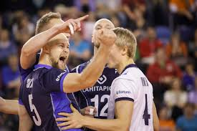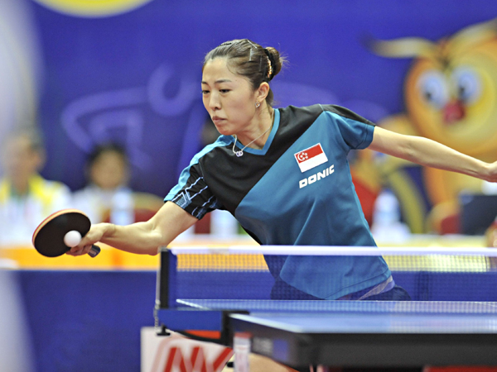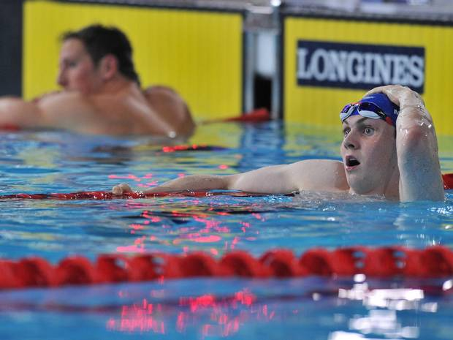
Higher PE
Scenario Booklet
Contents
Scenario 1 – Basketball Scenario
Scenario 2 – Badminton Scenario
Scenario 3 – Hockey Scenario
Scenario 4 – Volleyball Scenario
Scenario 5 – Feedback Scenario
Scenario 6 – Trampoline image
Scenario 7 – Newspaper extract
Scenario 8 – Swimming analysis
Scenario 9 – Newspaper extract
Scenario 10 – Olympics medal winning
Scenario 11 – Newspaper extract
Scenario 12 – Extract from newspaper article
Scenario 13 – Various sporting images
Scenario 14 – Feedback scenario
Scenario 15 – Self evaluation extract
Scenario 16 – Various sporting images
Scenario 17 – Training diary extract
Scenario 18 – Self evaluation extract
Scenario 19 – Game analysis extract
Scenario 20 – Various sporting images
Scenario 21 – Extract of performance statistics
Scenario 22 – Table Tennis Scenario
Scenario 23 – Volleyball Scenario
Scenario 24 – Archery Scenario
Scenario 25 – Badminton Scenario
Scenario 26 – Basketball Scenario
Scenario 27 – Netball Scenario
Scenario 1
Read the scenario below and attempt the question which follows.
Situation/lesson:
During this lesson, you will play Basketball against others in a class whilst using zone defence. A game of 4 quarters will occur with your team having substitutes to use in rotation as the game progresses. Following the game you will be asked to reflect on the 4 factors from MESP that could be considered as having an influence on your performance.

From Mental – what are the mental demands, both individually and as a team?
From Emotional – what are the emotional demands for you individually?
From Social – what are the social demands for you both individually and as a team?
From Physical – what are the fitness, skill and tactical demands on your performance?

Homework
- Explain how social factors could have an impact on performance. (4)
1b. Explain the physical factors that could have an impact on performance. (4)

Scenario 2
Read the scenario below and attempt the question which follows.
Situation/lesson:
During this lesson, you will play singles badminton against an opponent. Following the game you will be asked to reflect on the 4 factors from MESP that could be considered as having an influence on your performance. During the game you will be given some feedback on your performance for you to try and act upon to see if you can improve your game situation. (E.g. which of your opponents weaknesses are you going to focus on specifically).

From Mental – what are the mental demands, both individually and/or as a team?
From Emotional – what are the emotional demands for you individually?
From Social – what are the social demands for you both individually and/or as a team?
From Physical – what are the fitness, skill and tactical demands on your performance?

Homework
- Analyse the factors that can influence your performance. In your answer you must refer to the following factors impacting on performance: mental and one other – from physical, social or emotional. (8)

Scenario 3
Read the scenario below and attempt the question which follows.
Situation/lesson:
During this lesson, you will play a game of indoor hockey, whilst using a diamond shape formation, with a goalkeeper. The game situation will be that both teams are tied with only 3 minutes left. One team has a penalty corner to start the game off. Should the game go into overtime and remain a draw, then penalty flicks will be used to decide the winner.

From Mental – what are the mental demands, both individually and/or as a team?
From Emotional – what are the emotional demands for you individually?
From Social – what are the social demands for you both individually and/or as a team?
From Physical – what are the fitness, skill and tactical demands on your performance?

Homework
- Analyse the possible reasons why the game will now become a stressful situation for players as the game is approaching its confusion. You must refer to the following factors impacting on performance: emotional and one other from mental, social or physical. (8)

Scenario 4
Read the scenario below and attempt the question which follows.
Situation/lesson:
During this lesson, you will take part in a training session where your group are working on the volley and spike. Demands will be that you will undertake the role of the setter and hitter throughout the session. Following the practice sessions you will take part in small sided games with the goal of using the set and spike effectively throughout the game.

From Mental – what are the mental demands, both individually and/or as a team?
From Emotional – what are the emotional demands for you individually?
From Social – what are the social demands for you both individually and/or as a team?
From Physical – what are the fitness, skill and tactical demands on your performance?

Homework
- Referring to the social factor and one other from physical, mental and social, analyse the impact these factors could have on the success of your training session while performing Volleyball. (8)

Scenario 5
Read the scenario below and attempt the question which follows.
Situation/lesson:
This is an extract of feedback to a performer.

More mistakes were made as the performance went on...
Eventually lost focus and gave up...
This was not the best performance...
Signs of anger and frustration were observed...

From Mental – what are the mental demands, both individually and/or as a team?
From Emotional – what are the emotional demands for you individually?
From Social – what are the social demands for you both individually and/or as a team?
From Physical – what are the fitness, skill and tactical demands on your performance?

Homework
- Analyse reasons why a performer might receive this feedback. In your answer you must refer to the following factors impacting on performance: Physical and one other – from mental, social or emotional. (8)
1b. Explain how this feedback might be used to plan future performance development for the two factors chosen in 1(a). (8)

Scenario 6
This picture shows a girl performing in trampoline.
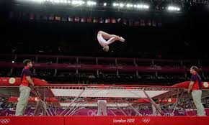

Homework
- Analyse which factors would impact on her performance. You must refer to the mental factor and one other from emotional, social or physical. (8)
1b. Explain how this feedback might be used to plan future performance development for the two factors chosen in 1(a). (6)

Scenario 7
Read the scenario below and attempt the question which follows.

That the tennis that preceded the most nerve=shredding of final moments varied hugely in quality did not matter. Murray, stretching emotions to the limit, needed four match points to break the resistance of the toughest fighter in tennis and said afterwards: “I have no idea what happened. I don’t know how long it was. Sorry.” – Guardian, 7th July 2013
In the final of Wimbledon 2013, Andy Murray was leading 40-0 in what could be the final game of the Championship needing just one point to win. Djokovic won the next three points to bring the game back. Murray then closed out the win to be crowned Wimbledon Champion.

Homework
- Analyse the possible reasons why Andy Murray lost those three points. You must refer to the following factors impacting on performance: emotional and one other from mental, social or physical. (8)
- Explain how performers can prepare themselves for these situations referring to the two factors chosen in a). (8)

Scenario 8
Race Preview
Michael Jamieson is a 25 year old Scottish Swimmer who won the silver medal in the 200m breaststroke at the London 2012 Olympic Games. Since then he went on to become the ‘poster boy’ for the Glasgow 2014 Commonwealth Games and is favourite to win gold in the above event. Ross Murdoch is a 20 year old Scottish Swimmer and is relatively inexperienced at competing at senior level. Both swimmers are from Glasgow and will therefore be eager to perform at their best in front of the home crowd.
Ross Murdoch
Pre-Race Thoughts
Let’s do this.
Start well.
Maintain Focus
Finish strong
Michael Jamieson
Pre-Race Thoughts
Wow! What an atmosphere. I need to win this race. I can’t lose and let all of my supporters down.

Results
1st – Ross Murdoch
Distance (metres) | Stroke Count | Split Time | Overall Time
0-50 | 15 | 31 secs | 31 secs
50-100 | 16 | 33 secs | 1 min 4 secs
100-150 | 16 | 33 secs | 1 min 37 secs
150-200 | 15 | 30 secs | 2 min 7 secs

2nd – Michael Jamieson
Distance (metres) | Stroke Count | Split Time | Overall Time
0-50 | 15 | 32 secs | 32 secs
50-100 | 16 | 33 secs | 1 min 5 secs
100-150 | 16 | 32 secs | 1 min 38 secs
150-200 | 16 | 32 secs | 2 min 9 secs
Homework
- Using all of the information above, analyse reasons why Michael Jamieson lost the race. In your answer you must refer to the following factors impacting on performance: physical and one other – from mental, emotional or social. (8)
- Describe one approach that Michael could use to develop his performance of any one of the factors you selected in part (a) and explain the benefits of using this approach. (8)
Scenario 9
On May 6th 1954, Bannister became the first human to run a sub 4-minute mile. Prior to this moment many in the medical and running communities considered the 4-minute mile “unconquerable”. So great was the perceived barrier that Bannister stated, somewhat facetiously, “Doctors and scientists said that breaking the 4-minute mile was impossible, that one would die in the attempt. Thus, when I got up from the track after collapsing at the finish line, I figured I was dead.”
Runners flirted with the 4-minute mile for decades, unable to eclipse the mark. But a funny thing happened soon after Bannister’s accomplishment: runner after runner broke the 4-minute mile. It is now commonplace for elite runners, and even the occasional high school star, to eclipse the mark.

Homework
- Analyse the factors which impact on performance for athletes running a sub 4-minute mile. You must refer to the mental factor and one other from physical, emotional or social. (8)
- Why do you think so many runners were able to break the 4-minute barrier so soon after Bannister did? You must refer to the two factors from you answer in a). (8)

Scenario 10
The Medal Bounce
“Home nations were shown to win approximately three times more medals in home Olympics, they reported, and approximately two times more in Olympic Games either side of their home Olympics.”

At London 2012, Team GB won 28 gold, 17 silver and 18 bronze – a total of 63 medals – their highest total since 1908 – when the Olympics were also held in London.

Homework
- Referring to the social factor and one other from physical, mental or emotional, analyse what you think causes the “medal bounce”. (8)
- For each factor selected in part a) analyse a method which could be used to collect data to support your suggestions in. (8)

Scenario 11
This is an extract of a newspaper report:

THE DAILY CHRONICLE
SPORT PAGES...


Romford Thistle Clinch Title With Dramatic Extra Time ‘Golden’ Goal
Romford were crowned champions for the fourth time as Mario Ferguson’s extra-time winner beat Eastend in the 2014 Cup final.
Ferguson demonstrated perfect technique and commendable calm to chest down Thompsons pass and sweep in a left-foot finish with the prospect of a penalty shootout only seven minutes away.
Despite flashes of brilliance, Eastend looked tired and subdued for the best part of the second half and into extra time...
MacDonald is ecstatic following his teams late winner in the 2014 cup final: “Our team were fantastic out there today. Working for each other and giving everything they have for the benefit of the team.

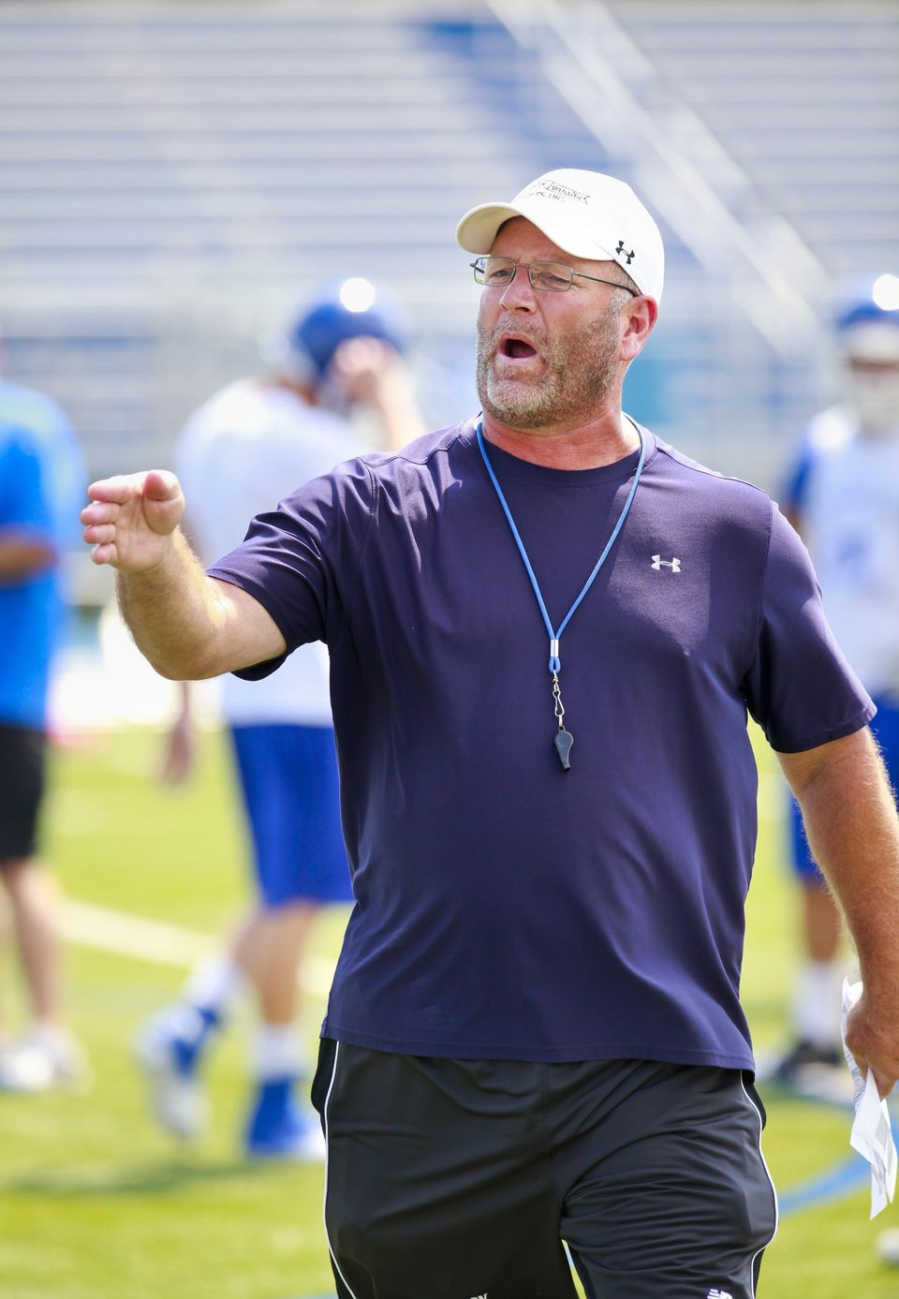


Smith to challenge for Shetland Championship once again after missing out last year due to ‘injury’. Veteran Smith, 48, claims “there is life in the old dog yet!” He goes on to explain “life at work has become easier with my staff always striving to go that extra mile, taking much workload off me. I actually do very little now.” See Page50...

Homework
- Based on the evidence above, analyse reasons why one performance might be superior to another. In your answer you must refer to the following factors impacting on performance: physical and one other – from mental, social or emotional. (8)
- Explain how you could plan future performance development following a defeat or loss. You must refer to the two factors chosen above. (8)

Scenario 12
Read the scenario below and attempt the questions which follow:
The quotes below are taken from a Sports Report in a local Newspaper Article:
“The Players looked off the pace and unfit”
“The team lacked leadership”
Towards the end of the game the players gave up and verbal arguments broke out”
“Two players were set off for misconduct”
“A number of simple mistakes were made when performing basic skills”

Homework
- Analyse reasons why a performer might receive this feedback.
In your answer you must refer to the following factors impacting on performance:
- Emotional
- One other – from Mental, Social or Physical. (8)
- For each of the factors (Physical and your chosen factor from Mental, social and Emotional), analyse an approach a performer could use to enable them to improve their performance. (8)

Scenario 13
After a poor result in a big competition, you now need to prepare for your next competitive performance...

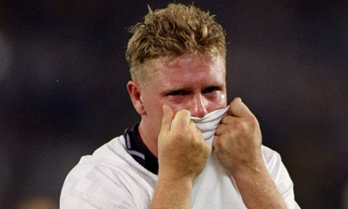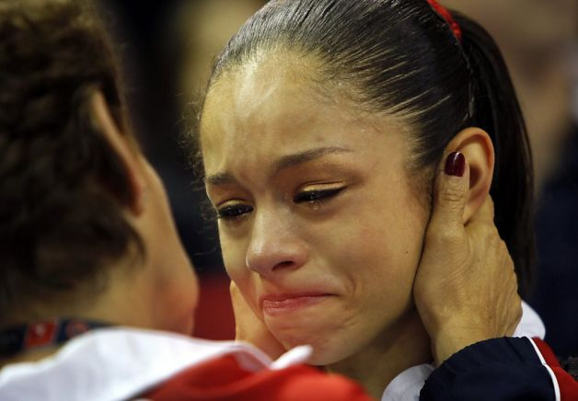
Paul Gasgoigne after losing to West Germany in the Semi Final of the 1990 World Cup

Disappointment after a poor gymnastics routine which leaves this performer out of the running for a medal.

- Explain how social factors could have an impact on performance. (4)
- In your answer you must refer to the following factors impacting on performance: Social and one other – from mental, physical or emotional.
- Analyse 2 methods that could be used to gather data on the factors that impact on performance. (6)
- Having gathered data, explain what you would take into account when setting goals to ensure improved performance in the future. Use examples to further develop your answer. (6)

Scenario 14
After a poor result in a big competition, you now need to prepare for your next competitive performance...

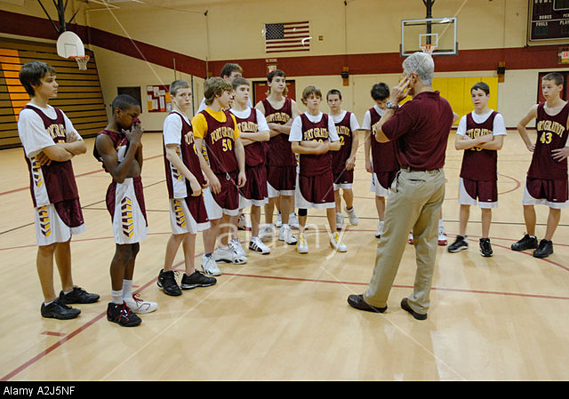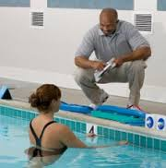

- Explain two emotional factors a performer might feel during coach feedback. (6)
- In your answer you must refer to the following factors impacting on performance: Emotional and one other – from mental, social or physical.
- Explain the importance of using different types of feedback when developing performance. (4)
- Analyse improvements that could be made as a result of the feedback in the picture(s). (6)

Scenario 15
Read the scenario below and attempt to answer the following questions.
This is an extract from a performer’s self-evaluation log:

Today I did not feel that this was my best performance...
I was criticised by the team for making mistakes and being out of position...
I continuously was beaten by my opponent...
I felt we were not working as a team and I probably was trying to do too much in the game because they were criticising me...

Homework
- Analyse the reasons why the performer may have logged this information about their performance. In your answer you must refer to the following factors impacting on performance: social and one other from physical, mental or emotional. (8)
- Describe an approach to develop each of the mentioned factors impacting on performance in question a). (4)
- Analyse the improvement that could be made as a result of the approaches used to develop the factors selected in question b). (6)

Scenario 16
After playing the first match of the new competitive season, there are factors impacting on performance.
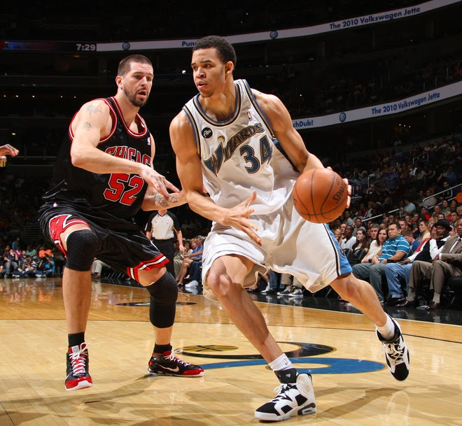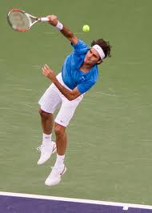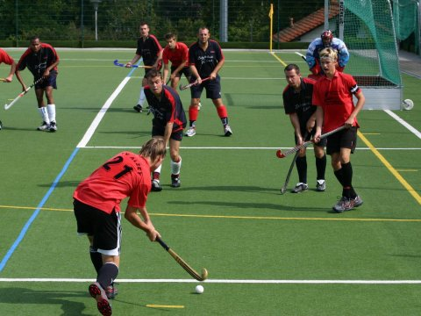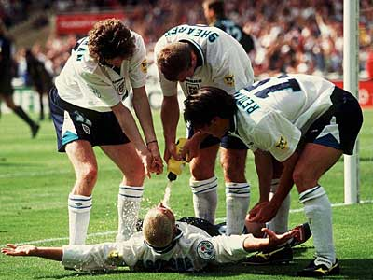

Homework
In all of your answers you must refer to the following factors impacting on performance: social and one other – from mental, emotional and physical.
- Analyse the picture(s) and give examples of feedback a performer may receive on their performance based on the two factors selected. (6)
- Evaluate the considerations you would make when planning a training programme to prepare for the new competitive season. (6)
- Explain the benefits of comparing your performance to a model performer. (4)

Scenario 17
This is an extract from a Performer’s Training Diary:

I was not performing at my best due to my poor decision making...
I was feeling very anxious and lacked confidence...
My opposition are a very high standard...
I struggled to motivate myself during this performance...

Homework
- Analyse the factors that can influence your performance. In your answer you must refer to the following factors impacting on performance: mental and one other from physical, social or emotional. (8)
- In relation to part (a) and the factors that you have selected, explain how a performer’s decision making can affect their performance. (8)

Scenario 18
The following comments are taken from a performer’s self evaluation of their own performance:

After the game today I felt so tired and disappointed...
We went 2-0 down in the first half and I had no drive in the second – we were already beat...
We ended up losing 3-0 and I made so many mistakes, especially in the second half...
I missed a penalty and got booked for having a late challenge and arguing with the referee...
I got so distracted by the crowd and felt so under pressure...
I can’t be bothered with training tomorrow. I am worried what my coach and team mates will say...

Homework
You must refer to the following factors: Mental and one other – from physical, social or emotional.
- Analyse the negative factors impacting on this individual’s performance. (8)
- Using the factors you have mentioned in part (a), evaluate two approaches that could be used to develop this individuals performance as part of a future development plan. (8)

Scenario 19
Read the scenario below and attempt to answer the following questions.
This describes part of a game situation for a team activity.

The play broke down due to our lack of concentration and failing to be a cohesive unit.
The team reacted negatively to our opponent’s effective play.
The coach analysed all the problems and gave us feedback.
We were more positive with a new strategy.

You must refer to the following factors: Mental and one other – from physical, social or emotional.
Homework
- Explain the factors that may have contributed to the poor team performance. (8)
- Evaluate the changes the coach made for a more effective team performance (8)

Scenario 20
Look at the two images below and attempt the question which follows.
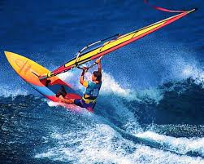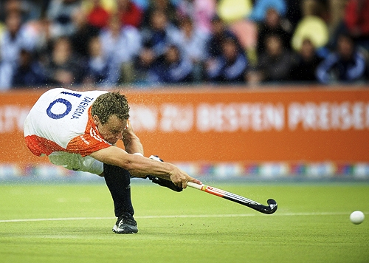

In your answer you must refer to the following factors impacting on performance: physical and one other – from mental, social or emotional.
Homework
- Analyse the factors which are similar to both performers in the images above. (8)
- Explain how you would plan and develop future performance for the two chosen factors in 1(a). (8)

Scenario 21
The extract is a summary of a footballer’s performance in a recent game:

Pass completion rate was only 40%
Booked in 40 minutes, sent off in 71 minutes
Was at fault for the oppositions first goal, not tracking the opponent
Appear agitated and distracted by the crowd

In your answer you must refer to the following factors impacting on performance: mental and one other – from physical, social or emotional.

Homework
- Analyse some of the reasons for the footballer putting in this kind of performance (8)
- Explain possible approaches to development that may be used to improve the footballers performance within the two factors mentioned in part (a) (8)

Table-Tennis Scenario
Table-Tennis

You are playing a conditioned game against someone in your class. The condition is that you are awarded 2 points if you win a rally using a forehand drive. The game is tied at 19-19. Your forehand drive has been inconsistent in this game, but one successful one would win you the game. Alternatively, you could play a ‘safe’, defensive game and not look to play the forehand drive, although this may set your opponent up for a forehand drive, consequently giving them the victory. The last time you played this opponent you lost 21-20, and you have never beaten them before.

Homework
- Analyse the main issues you now need to consider in your approach to the last few points of this game. In your answer you must refer to the following factors impacting on performance: physical and one other – from mental, social or emotional. (8)
- In this scenario, explain what your development needs would now be before the next class competition. (8)

Volleyball Scenario
Volleyball

During a league game, every time your opponents win a point, two of the opposing players direct their celebrations at you, through the net. They cheer and thump their fists all whilst making eye contact with you. Your coach notices that as the game progresses you become less and less involved, and you begin making an increasing number of errors.

Homework
In your answer you must refer to the following factors impacting on performance: emotional and one other – from mental, social or physical.
- Analyse the reasons why you become less involved as the game progresses. (6)
- Give examples of feedback you might receive from your coach when an opportunity arises during a game based on the two factors selected. (6)

Archery Scenario
Archery
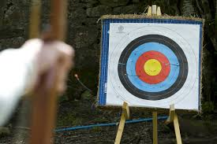

During a P.E. lesson, your class has an archery competition. The class is split up into groups and the total score for each group member is added together to give a total ‘group score’. During the practice for this competition, you were regularly hitting the middle area of the target, scoring the most points possible with your 4 arrows. Most of the time in this practice, you were the most consistent shooter in your group. Now that the competition has started, you are less consistent, and instead of scoring close to 40 points with your 4 arrows, you are struggling to get 20. Each team member has 4 shots at shooting their 4 arrows. Mr Moncrieff has promised a box of Freddos for the winning team.

Homework
- Referring to the emotional factor and either mental or social factor, analyse what you think caused this change in your performance. (8)
- What can you do to overcome the issues you have highlighted in part (a) before you shoot your next 4 arrows? (6)

Badminton Scenario
Badminton
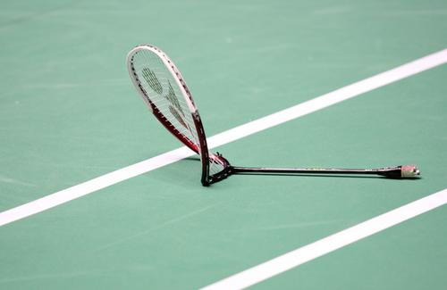
As your performance went on, you started making more mistakes...
You were losing against someone ranked lower than you in the competition...
You started blaming the umpire and your racket for your poor shots...

Homework
You must refer to physical factors and one other factor from mental, emotional or social.
- Analyse which factors could have been impacting on this performance. (8)
- Explain what the performer could do in future development to improve their performance in the two factors selected in (a). (8)

Basketball Scenario
Basketball
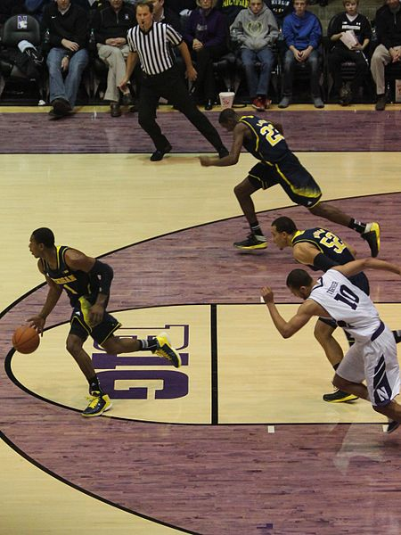

Through analysing your opponent’s recent league games, your coach has decided that your team are going to rely heavily on the fast break attack to try and score points. Your position is a Guard and your coach has explained that the main responsibilities for you are to carry the ball up the court at speed and then use your awareness to find the best route to the basket for the ball.
At half time, the score is 36-12 to your opponents.

Homework
- Explain the physical factors which may impact on your ability to perform your role effectively. (4)
- In your answer you must refer to the following factors impacting on performance: physical and one other – from mental, social or emotional.
- Referring to your chosen factors, describe some of the reasons why your team are losing at the half time mark. (8)
Extension
- For each of the factors (physical and your chosen factor from mental, social or emotional), analyse an approach a performer could use to enable them to improve their performance.

Netball Scenario
Netball

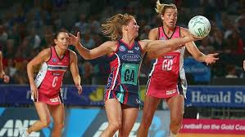

Your position for your netball team is Goal Defence. The captain of your team is the Centre, so she has a responsibility to play over a large area of the court, and to work closely with you and your team mates. The Centre has started making some mistakes when receiving a pass and this has caused her to lose possession 4 times in the second quarter alone. She has made 5 poor passes in this quarter also, allowing the other team to gain possession and start an attack which has resulted in a point for them each time. The score at this point in the game is 16-10 to the other team.

Homework
Choose a factor.
- What feedback would you give to this player (centre), and how would it impact on her performance in relation to the factor that you have chosen. (8)
- Explain what this player (centre) could do to ensure her next performance is improved. (8)

