Using the Shetland Library book catalogue at home

- Open any Internet browser on your computer, laptop or tablet. This could be Internet Explorer, Edge, Chrome, Safari, Silk, or so on.
- In the address bar, type in: www.shetland-library.gov.uk
- Alternatively, search for Shetland Library using your usual search engine, e.g. Google
The Shetland Library webpage will be displayed.
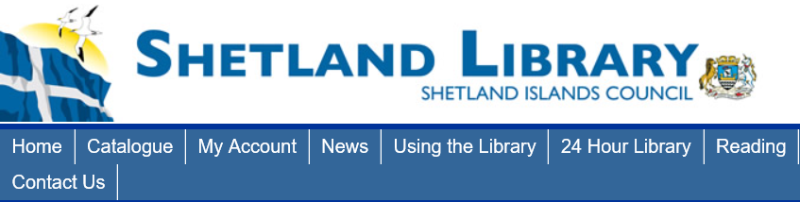
- Click on Catalogue

A new page will open: https://capitadiscovery.co.uk/shetland
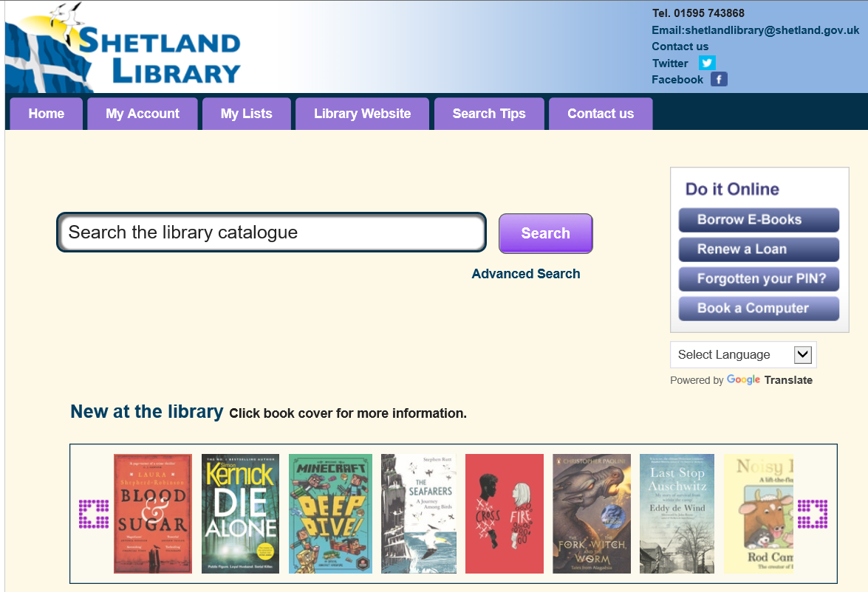
This is our library catalogue. Inside the catalogue you can see all the books, DVDs and CDs we have on display, what is in our schools and store rooms, and items that are on loan. You can also log in to see what you have on loan, and to reserve and renew items.
How do I search for an item?
- Simply type the name of the author, or the title of item you are searching for, into the ‘Search the library catalogue’ box, then select ‘Search’
- A new page will open listing the items by that author, or items which match that title
- Sometimes you will get a lot of suggestions, too many to look through. If you wish to filter your search, please read our ‘Search Tips’, or ask a staff member how to do this.

How do I reserve an item?
- First, log into your account by selecting the My account tab and typing in your library borrower number (13-digit number) and your PIN (a 4-digit number).
- If you don’t know your borrower number, please Contact us.
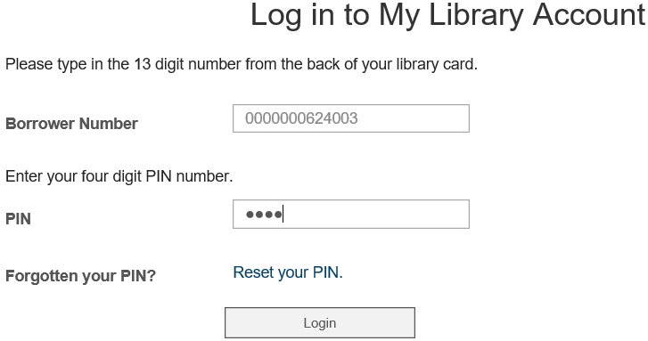
- If you know your borrower number, but not your PIN, you can reset your PIN by selecting Reset your PIN.
- Once logged in, you will be able to see the status of all your loans and reservations.
Reserving your chosen item:
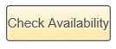
- On the item that you wish to reserve, select the button called

- If the item can be reserved, choose where you wish to collect it from, then select Reserve.

- You will be sent an email or letter when your item is ready to collect.

- eBooks, eAudio books, eMagazines and eComics can be searched for and downloaded from our rbdigital site: http://shetland.rbdigitalglobal.com/

