Home Learning Grid 15.01.24
Numeracy | Literacy | Health & Wellbeing
Factors and Prime Numbers  Complete the activities on these webpages:  What are multiples and factors? - BBC Bitesize  What are prime numbers? - BBC Bitesize  Remember a prime number is a number with only 2 factors.  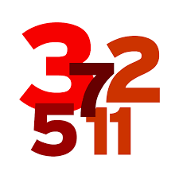  I will upload some additional activities that you can complete as an assignment on Microsoft Teams.  You will find the sheet set as an assignment on Microsoft Teams. | Spelling Revision – plurals  I will upload a sheet that will help you to revise plurals. Remember you can use a dictionary to help you check your answers. You can use an online dictionary to help.  You will find the sheet set as an assignment on Microsoft Teams.  Please use Nessy for spelling if you have a Nessy log in. | Winter Walk  If it’s safe to do so, then wrap up warm and spend some time outside. You could go for a wintery walk or spend time in your garden making a snowman. Think carefully about your senses. What can you:  see –  feel –  hear –  smell –  This will help you to make a wintry poem.  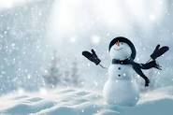
Parachute Multiplication  This game is brilliant for multiplication skills and number line skills  https://mathsframe.co.uk/en/resources/resource/596/Parachute-Multiplication  If you are confident, at your times tables, try practising square or cube numbers. | Acrostic Poem  Can you write an acrostic poem about winter?  W  I  N  T  E  R  Think carefully about description. Try to use interesting adjectives and adverbs. Try to include a simile.  Extend your learning:  Can you use other words for your poem, instead of just winter? | Scottish Dance  The next dance we are going to learn is the Dashing White Sergeant. Watch the 2 videos. One is the Scottish version and the second is the dance being done in Clickimin where you can see the Shetland version.  https://youtu.be/Wm_5l_bs-6Y?si=un0HCweCuEPsRisX  https://youtu.be/bCLhj-W55cI?si=frIoiTSIIihhl2h9
You can choose which tasks to do and please only complete these tasks if you are able to do so. Stay safe and have fun!

