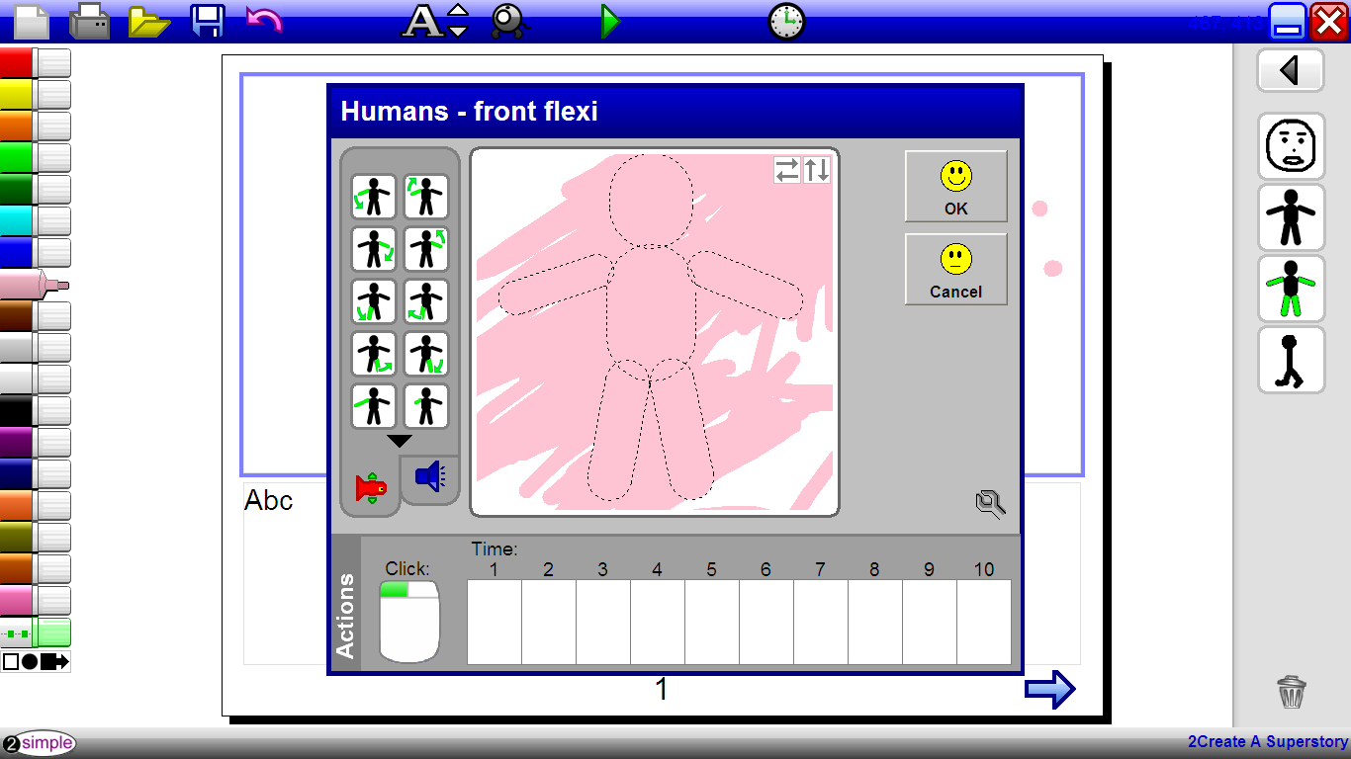
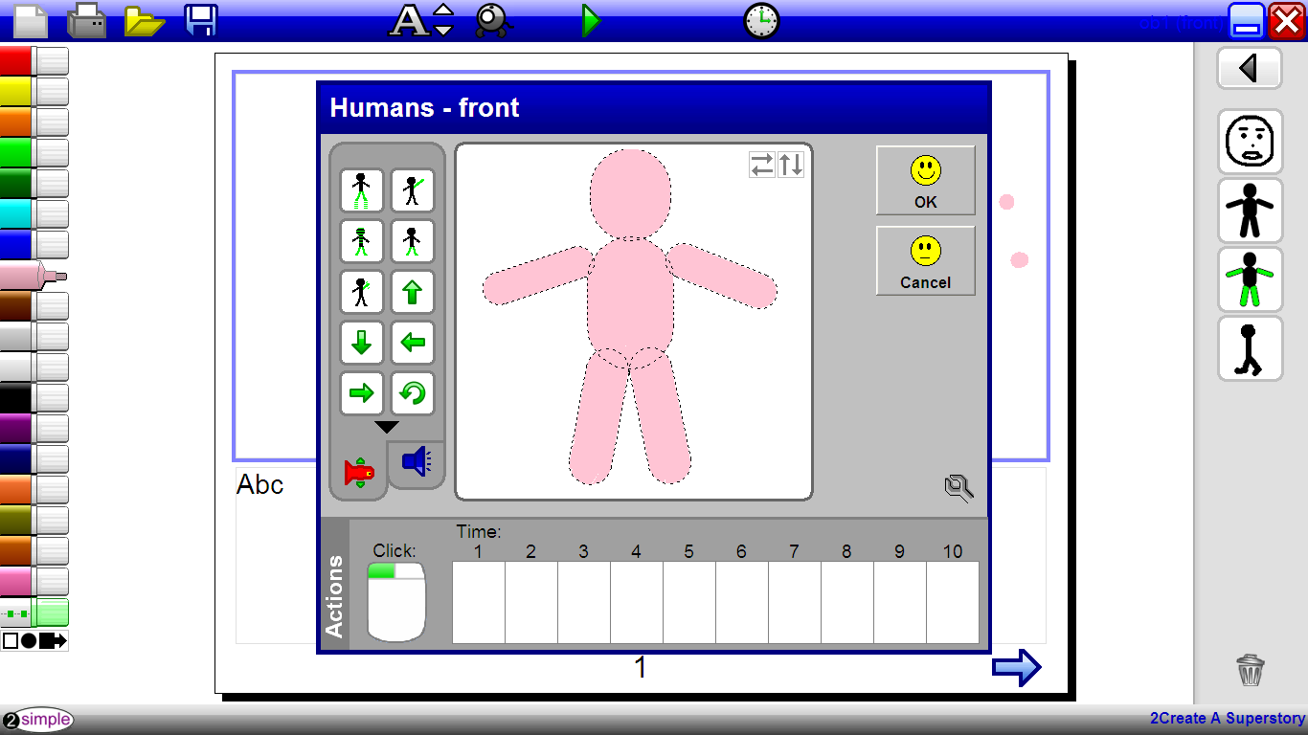
There is 2 pictures 1 is when you scribble and then you leave the mouse pad for 1 second it tidied the colouring up . I think it’s very clever.

