  Literacy | We are listening to the novel Cosmic by Frank Cottrell-Boyce and discussing the themes of friendship, imagination and responsibility.  Our target for the Daily Writing Project is to be able to use a range of conjunctions in our writing. We will create a range of texts: non-fiction and stories.  We will continue to read regularly in small groups, using a range of texts. We are developing our fluency and comprehension skills.
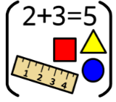  Numeracy & Maths | Place Value: we are learning the number sequence to 1,000,000 and rounding to the nearest 10, 100, 1000 or 10,0000.  Time: we are using calendars to calculate the number of days between events.  We are revising telling the time on digital and analogue clocks and  solving problems with time. We will read local timetables using 12- and 24-hour  time to plan a journey.  We will use Times Tables Rock Stars to improve our speed and recall.
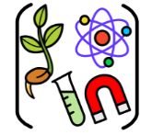  Social Studies/ Sciences | We are learning about features of our Solar System, so we can use simple models to show our understanding of it’s size and scale  We are learning about space exploration and inventions which have had an impact on our society
  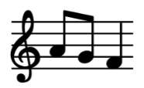  Expressive Arts | Art:  We will create self-portraits and study Cubism this term.
Music:
We are learning how to play the ukulele, and I know how to strum four chords (C, F, G and Am.)
We are learning to sing with confidence and perform a variety of seasonal songs.
French  | We are revisiting the colours and numbers to 30. We will join live French lessons every Tuesday for 6 weeks. We will join with other classes and learn through a range of games and activities delivered by Specialist teachers.
  Technologies | We are learning to use some of the features of Microsoft Word to create texts; changing fonts and size of text, inserting and outlining textboxes.  We will complete a STEM design challenge with the My World of Work team.
  Religious & Moral Education | We will create a Class Charter and discuss the school values and UNCRC.  We will begin to learn about creation stories from different religions..
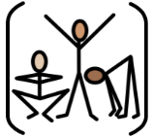  Health & Wellbeing | With Miss Birnie in P6, learners will understand the importance of a balanced and healthy diet. Explore the nutritional benefits of different fruit and vegetables. Taste and prepare a range of fruit and vegetables, including making smoothies and healthy snacks
PE Mrs Richie
Children will be learning hockey and basketball and focusing on playing with respect and tolerance.
Mrs Moar - we are learning to work as a team through games such as Kick Rounders and Dodgeball.

