Head Teacher: Ms Andrea Henderson Dunrossness Primary School
Dunrossness
Shetland ZE2 9JG
Telephone: 01595 745440
Fax: 01950 460803
E-mail: dunrossness@shetland.gov.uk
Blog: https://blogs.glowscotland.org.uk/sh/dunrossness/
11th September 2019

Dear Parents and Guardians,

All changes to nursery routines are now done centrally. If you would like to change your child’s pattern, please email elc@shetland.gov.uk directly and the central team will process your request. It is not guaranteed that all changes will be accommodated; it will depend on capacity within the setting.

If you have any queries about this, please contact the ELC team using the email address above.
You can find advice and guidance by using the link below.
https://www.shetland.gov.uk/education/documents/EarlyLearningandChildcareShetlandFINAL.pdf

Yours sincerely
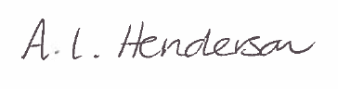
Andrea Henderson

