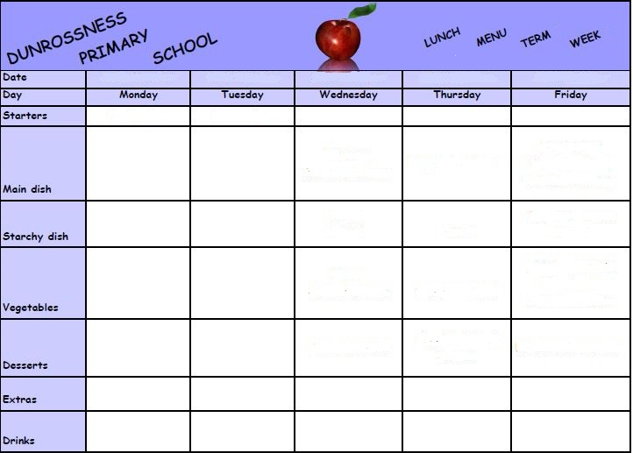

**Fruit selection & Yogurt**

**Flapjack**

**Custard**

**Tatties**

**Pasta**

**Chips**

**Sandwiches**

**Fruit**

**Yoghurt**

**Fruit selection & Yogurt**

**Salad**

**Broccoli**

**Spaghetti**

**3**

**6th Sept**

**5th Sept**

**4th Sept**

**3rd Sept**

**2nd Sept**

**Date gt**

**Fruit Selection  
Yoghurt**

**Fruit Selection  
Yoghurt**

**Fruit Selection  
Yoghurt**

**Salad**

**Salad**

**Sweetcorn**

**Salad**

**Salad**

**Peas**

**1**

**Water  
Milk**

**Water  
Milk**



**Water  
Milk**

**Water  
Milk**

**Water  
Milk**

**Milkshake**

**And Cookies**

**Caramel**

**Shortcake**

**Fruit**

**Yoghurt**

**Pizza**

**Chicken**

**and Stuffing**

**Fish**

**Lentil**

**Soup**

**Spaghetti**

**Bolognaise**