Head Teacher: Ms Andrea Henderson Dunrossness Primary School
Dunrossness
Shetland ZE2 9JG
Telephone: 01595 745440
Fax: 01950 460803
E-mail: dunrossness@shetland.gov.uk
Blog: https://blogs.glowscotland.org.uk/sh/dunrosness/
23rd April 2018

Dear Parent/Guardian,

Voar Redd Up

Please come and join us on Thursday 26th April 2018 when we will be taking part in the
Voar Redd Up at Boddam. We will be leaving school at 1.45pm and would appreciate as much help as possible.

We have arranged for two skips at the shore, one will be for plastic only and one for everything else. Gloves and bags can be collected from the school.

Please make sure that you and your children wear suitable clothing and footwear.

If you do not wish your child to take part, please contact the office as soon as possible.

We look forward to seeing you on Thursday.

Yours sincerely
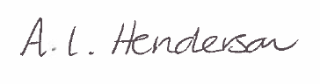
Andrea Henderson

