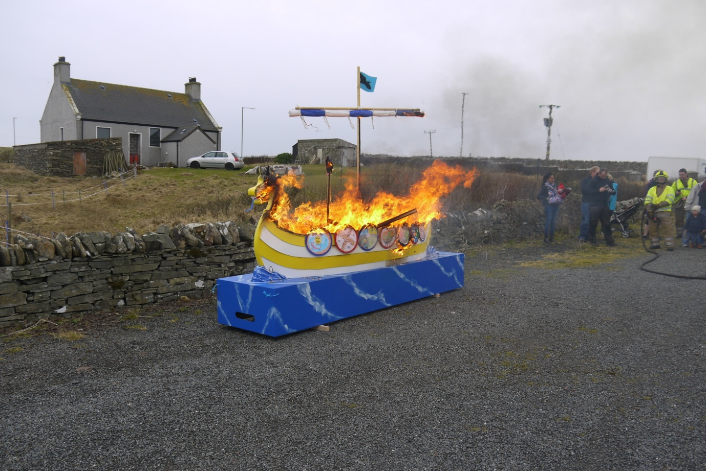
Friday 9th March 2018
The Jarl and his squad will be visiting us in the morning so our programme is as follows:
9.15-9.30 : Muster at school
9.30: Procession to Boddam Playing Field for Dunrossness Galley Burning
10.15: Everyone welcome to join us at the Boddam Hall for teas/coffees/snack
11.00: Dunrossness Primary Squad Acts
11.25: Jarl Squad visit
12.15: Pupils return to school for lunch
The times during the morning may vary slightly.
If the weather conditions are poor – please join us at school from 10.50. We will have squad acts and the visit from the Jarl Sqaud. We will update the school blog on the day to confirm arrangements.
https://blogs.glowscotland.org.uk/sh/dunrossness/

Everyone welcome!

