Primary One | Primary Two | Primary Three | Primary Four | Primary Five
a  and  he  I  in  is  it  of  that  the  to  was | all are as at be but can came for had have him his my new no not on one said she so they two we when with you | about an back because been before big by call come could did do down first from get go going has her here if into like little look made make me more much must now off old only or our other out over right see some their them there then this up want well went were what where which who will | after again always am ask another any away baby ball best black blue book boy bring children day dinner don’t door each egg end every farm fast fell find five fly four found girl gave give good green hand head help home house how jump just keep know last left live long many never next once open own play put read room round saw say school should soon stop take tell than these thing think three time too tree under very walk white why wish work woman would year your | above aeroplane afternoon allow although along any April arrive August autumn aunt balloon breakfast beach behind below brother brown centre circle city coming cousin December doctor door eight eleven England evening February fifteen fifty floor forty Friday friend front Grandad Grandpa Grandma Granny grey huge hundred holiday Ireland January June July kitchen knee later leave lie March May Monday million morning Mr. Mrs. Miss money name near night nine ninety nothing November October often orange phone picture place playground purple rectangle road Saturday Scotland September seven Shetland shoe sister small square street Sunday talk teacher team telephone television Thursday thousand time town today triangle Tuesday twelve twenty thirteen thirty tomorrow uncle under walk watch Wednesday white would world yellow yesterday
 | Children should be able to spell the words from preceding age groups too.

Below you will find a list of suggested common words to be taught in P1-5. Although you will find that some of your pupils will be able to spell many of the words at an earlier stage. These words could then be revisited in P6 and P7 if necessary.

The following page has some ideas for different ways to learn. There is lots of research to suggest that children learn better with short sharp bursts. No more than 10 minutes a day would be perfectly ample!

https://highlandliteracy.files.wordpress.com/2013/02/spelling-games.pdf
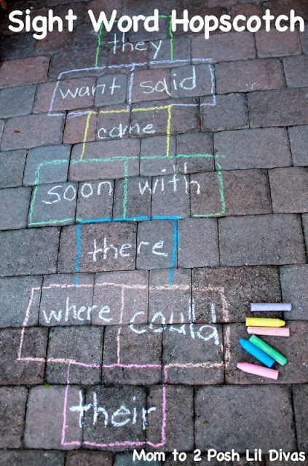
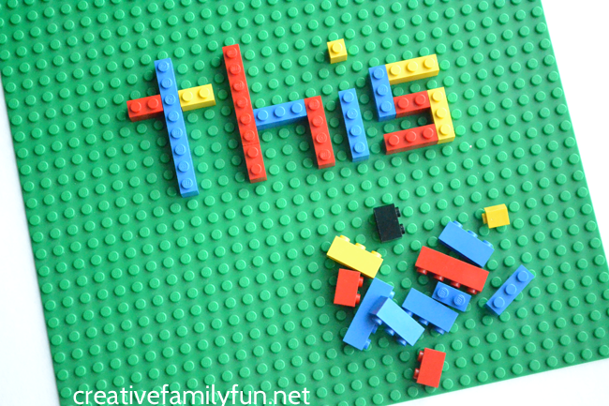
https://highlandliteracy.files.wordpress.com/2013/02/supporting-spelling.pdf
