

Shetland Islands Council

Dunrossness School
Information Handbook

Living, Laughing, Learning

2017/18
Contents
Introduction Page 3
Contact Details Page 4
Our Staff Page 5
New Parents Page 6
Visiting the school Page 6
Communication Page 6
Parental involvement Page 6
Transitions Page 7
Placing requests Page 9
Our School Ethos Page 10
Aims Page 10
Behaviour Page 11
School Rules Page 11
Community Page 11
Wider Achievement Page 12
Curriculum For Excellence Page 13
Numeracy and Mathematical Development Page 14
Literacy and Language Development Page 14
Health and Wellbeing Page 15
Learning, Teaching and Assessment Page 16
Support for Pupils Page 18
Getting it right for every child (GIRFEC) Page 19
Child Protection Page 19
School Improvement Page 19
School Policies and Practical Information Page 21
Policies Page 21
Religious Observance Page 21
Concerns Page 21
Complaints Page 22
Absence / Sickness Page 22
Family Holidays Page 22
Requests for Leave of Absence Page 22
Collecting your Child During School Hours Page 23
School Closure Information Page 23
School Day Page 23
Snack Time Page 23
Nursery Snack Page 23
School Meals Page 24
Allergies Page 24
Equipment Page 24
How Can you Help to Prepare your Child for School? Page 25
To Encourage Language Development Page 25
To Encourage Mathematical Awareness Page 26
To Encourage Writing Skills Page 26
To Encourage Independence Page 26
To Encourage Positive Relationships with Others Page 26
Calendar of Events 2017-18 Page 27
Calendar of Events Page 28
Financial Help Page 28
Online Protection Page 28
Parent Council Information Page 28

Introduction
Welcome to Dunrossness Primary School! Our school is situated in the South Mainland of Shetland in a rural setting on the east coast of the island. Our catchment area includes the communities of Levenwick, Bigton, Quendale, Boddam and Virkie.
We are fortunate to be set in beautiful countryside with excellent amenities close by. We have wonderful beaches and a variety of places to visit, including Jarlshoff, Old Scatness, Sumburgh Lighthouse, Quendale Mill and many more. There is a rich variety of wildlife to be seen in the local environment, including sea birds, otters and if you are really lucky you may even spot a whale!
Dunrossness School is proud of our strong relationship with our parents. This handbook provides information for parents for the school year 2017/18. Although the information is believed to be correct it is possible that changes have occurred, or will occur during the course of the year, that will affect the contents for this year or for the following school years.

For further information or clarification, please contact the school and/or look at our school blog. This is updated regularly and will contain the most up to date information.
https://blogs.glowscotland.org.uk/sh/dunrossness/

Throughout this handbook, links to websites are provided for further information. Hard copies and different formats of the handbook (for example in Braille or large print) will be made available by request to the school.

Handbooks for all Shetland Islands Council’s schools can be found on the council’s website.

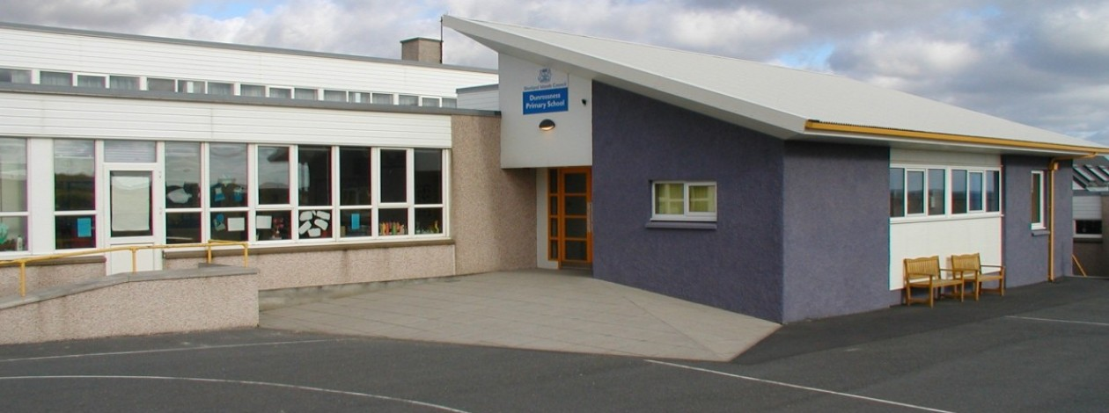
The direct link is: http://www.shetland.gov.uk/education/SchoolHandbooks.asp

Contact Details

Name: Dunrossness Primary School

Address: Dunrossness
Shetland
ZE2 9JG

Telephone: 01595 745440

Website: https://blogs.glowscotland.org.uk/sh/dunrossness/

Email: dunrossness@shetland.gov.uk

Stages of education: Early learning and childcare (nursery) and Primary

Roll: Primary: 112
Early Learning and Childcare: 28

Denominational status: non-denominational

Head teacher: Ms Andrea Henderson

Parent Council email: janine.johnson@btinternet.com

School Staff for 2017-2018

Head Teacher: Ms Andrea Henderson
Principal Teacher/ASN Teacher: Mrs Louise Leslie

Class Teachers:
Nursery Mrs Karen Osborn
Primaries 1/2 Mrs Linda Tait/Mrs Brenda Smith
Primaries 2/3 Mrs Valerie Inkster
Primary 4/5 Mrs Helen Moar
Primaries 5/6 Ms Gina Scanlan
Primaries 6/ 7 Mrs Sandra Hay

Support Staff:
Early Years Senior Practitioner TBC
Early Years Practitioners Mrs Leona Smith/Mrs Carrie Morrsion
Early Years Assistants Mrs Carrie Ann Bannister/Mrs Amy Colvin/TBC
Leaning Support Assistant Mrs Violet Casey
Mrs Marion Sutherland
Learning Support Workers: Mrs Emma Graydon
TBC (Pupil Equity Funded post)

Playground Supervisor/
Admin assistant: Mrs Jackie Jamieson
Clerical Assistant: Miss Jackie Bishop/Mrs Katherine Sandison
Janitor: Mr John MacKenzie

Visiting Teachers and Instructors:
P.E. and Swimming Mrs Joan Smith
Music Mrs Jeanna Inkster
Art and Design Ms Fiona Burr
Woodwind Mrs Jane Morton
Piano Mrs Moira Peterson
Traditional Fiddle Ms Eunice Henderson
Accordion Mr Peter Wood
Guitar Mr Stevie Hook

Canteen Staff:
Vacant Post (Head Cook)
Mrs Jane Flaws, Miss Katherine Henderson, Mrs Marina Smith.

Visiting the school
If you are seeking a place for your child, or you have been offered a place, we would be delighted to arrange for you to visit us. We will take you on a tour of the school and will introduce you to the staff members. We are committed to making sure that children are confident and ready to start and can work with you to put in place what your child needs to ensure their move is as straightforward as possible. Please contact the school directly to make arrangements.

Communication
Dunrossness School aims to develop effective lines of communication with our parents and we pride ourselves on our open door policy and welcoming ethos. Routine communication with parents is usually done through diaries, face to face contact, newsletters, email and via our website. We also use Class Blogs. Urgent communication may also be necessary through phone calls and radio announcements, in the case of school closure.

If there are events or circumstances which may affect your child’s enjoyment of their school experience such as a poor night’s sleep, a new baby in the family or a family bereavement, please let our staff know. We will treat the matter with absolute confidentiality and we will be able to support your child with any short or long term difficulty or need more effectively – communication is a two way process.

We will also use your child’s diary to communicate with you, so please ensure you look through it every night. We highly recommend you look through your child’s bag every night as we send home a number of information letters and other forms of paperwork that need your attention. We prefer to email letters to parents and will ask for a suitable email address on our enrolment form. Sometimes children are asked to bring in items connected with topics they are studying (photographs, toys, etc). We welcome parental input in this area, and, if your job, hobbies or pets could help us generate interest in a topic, please let us know and we’ll arrange for you to come in and give the class the benefit of your expertise.

Parental Involvement
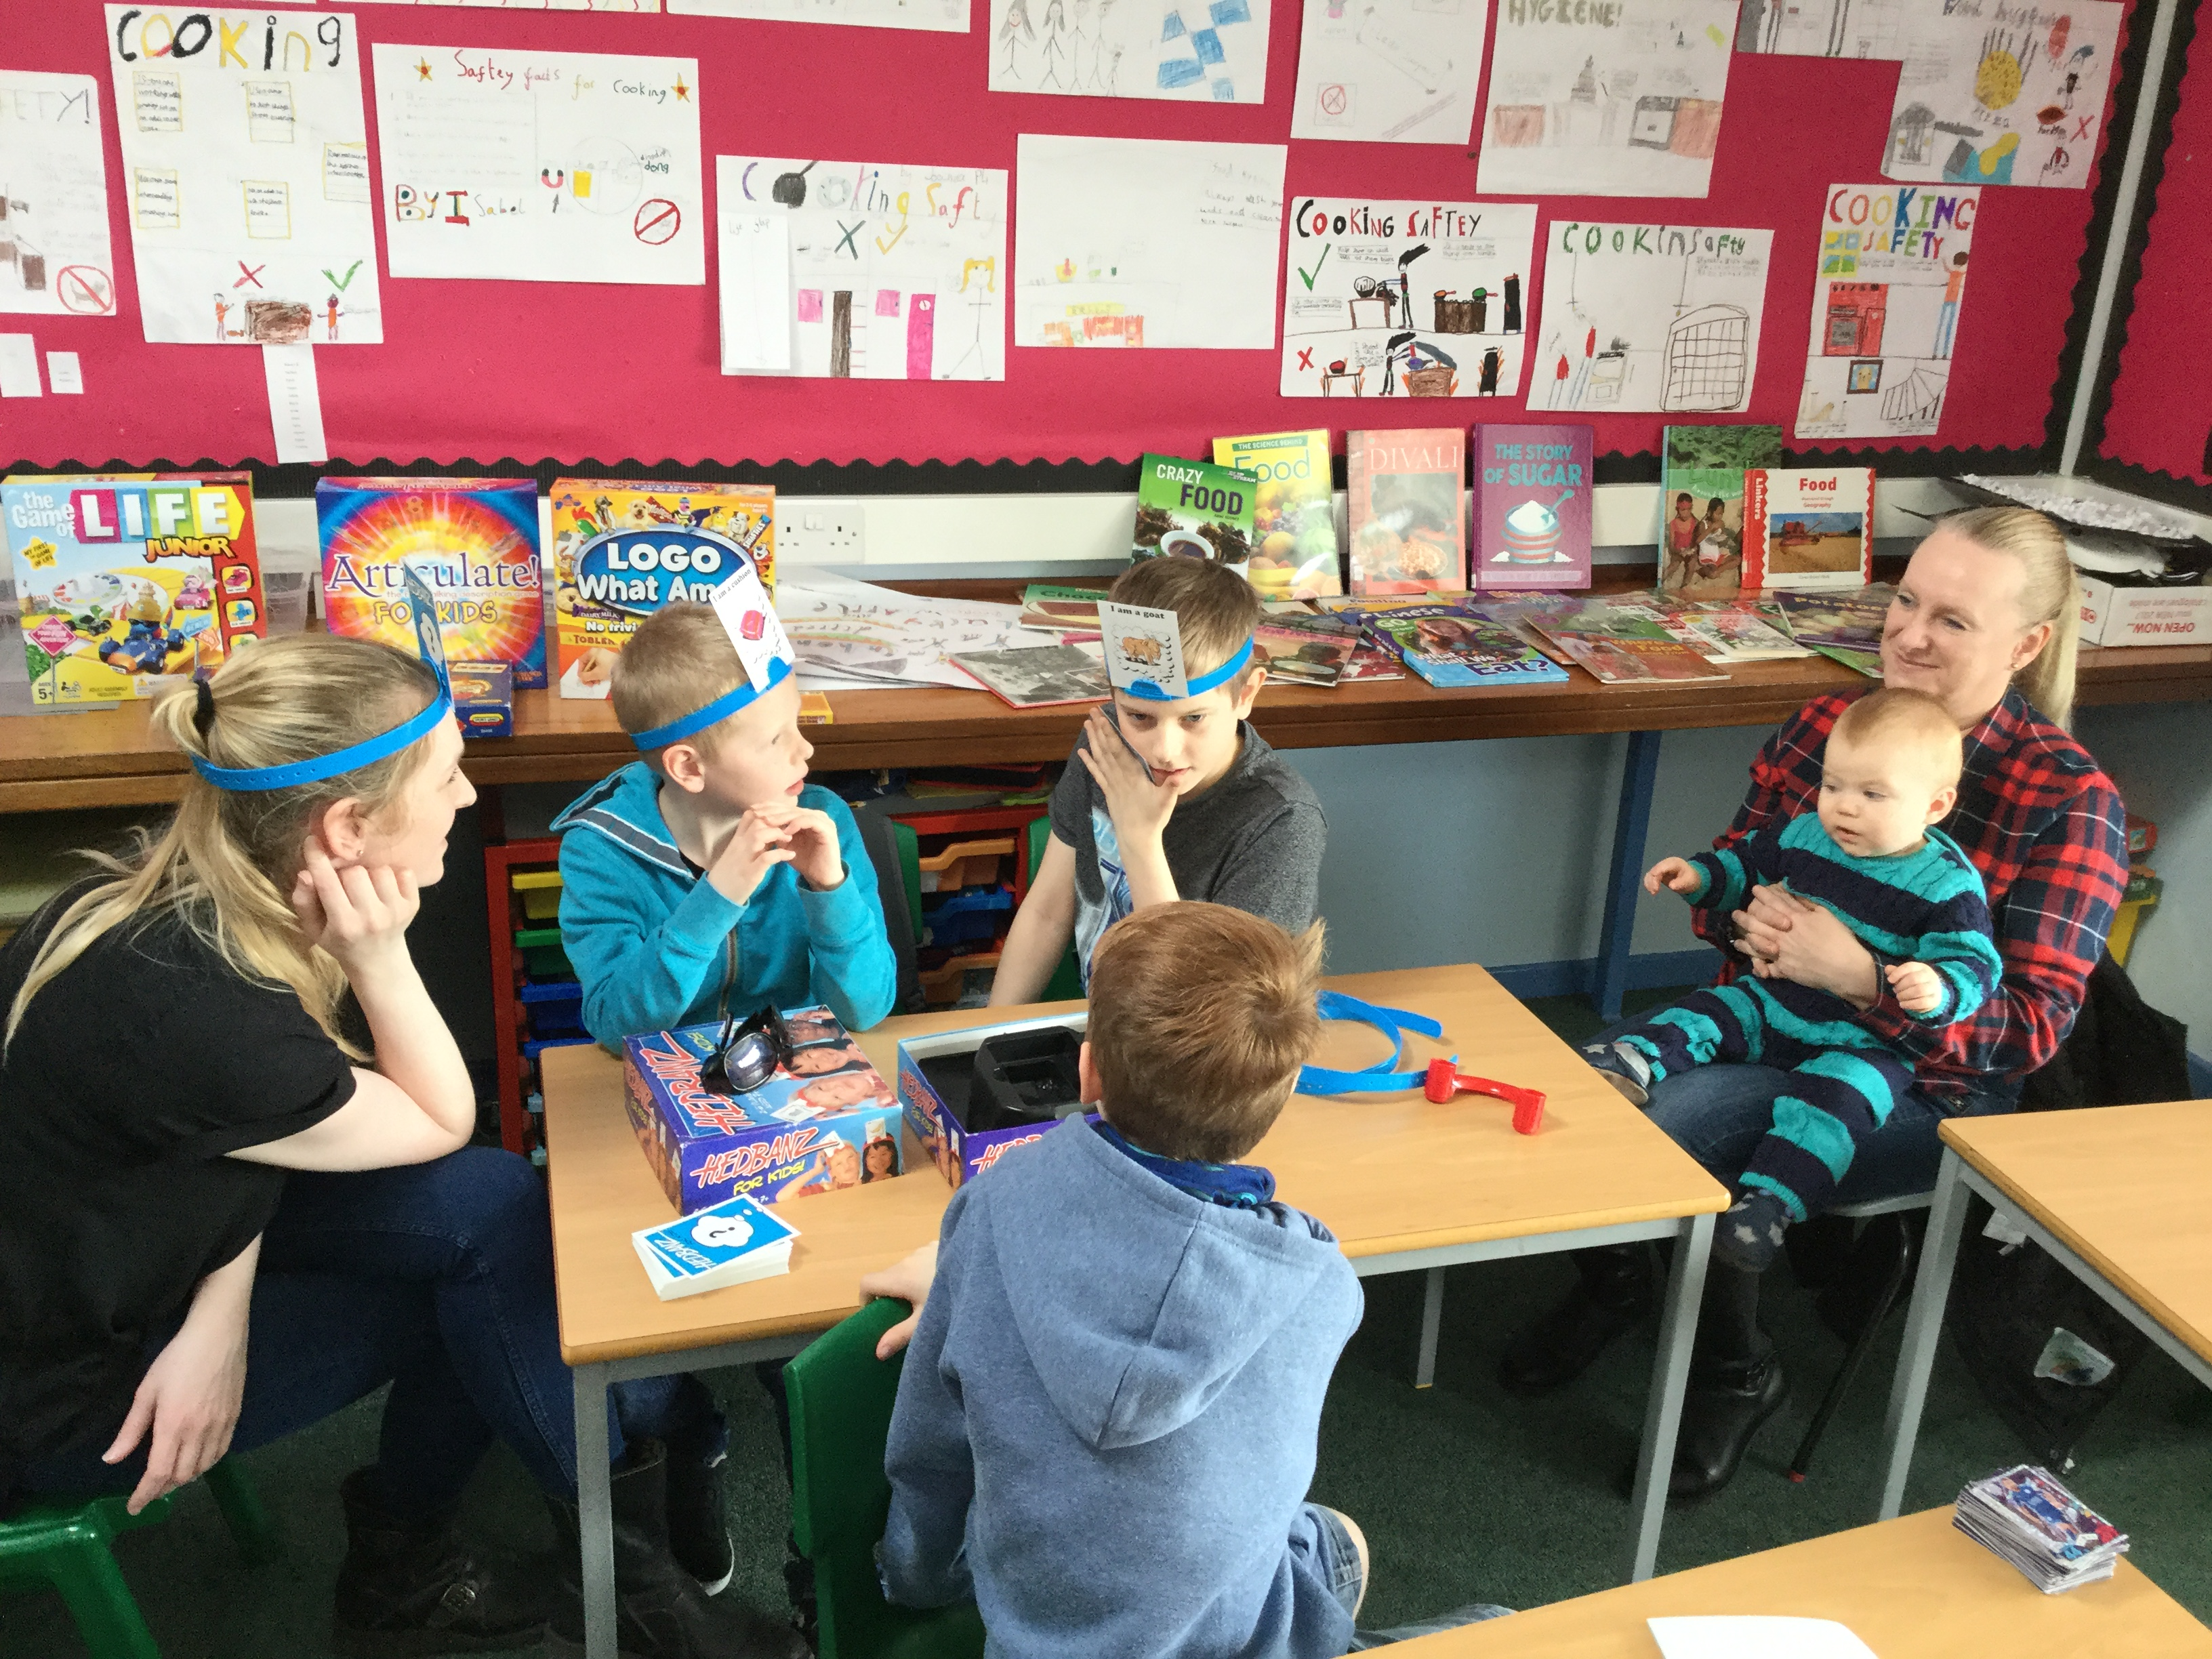
Dunrossness School openly welcomes the involvement of parents in the life and work of the school. This can take many forms, including sharing expertise and experiences in class or at assemblies, helping with extracurricular activities and clubs, supporting school trips and excursions, and fundraising.
We believe that the more involved you are as parents, the more successful your child’s learning experience within the school will be. We regard the fostering and maintenance of good relations between home and school is of vital importance in education. Please see our Reporting Calendar for opportunities to meet with staff and when you will be updated on progress.

At Dunrossness School, we value parents as partners and as such we strive to fully involve parents in their child’s learning. In addition to our ‘open door’ policy, there are a number of ways parental involvement is promoted. Wider Achievement afternoons in term 3 enable parents to come into the school to experience learning activities. Special class and school assemblies allow children to demonstrate aspects of their work to their parents. Curricular Overviews give targets and the learning planed for the term. Our formal parents meetings allow children’s progress to be discussed and provides a platform for parents and teachers to discuss how best to support learning at home. For further information and resources regarding getting involved with your child’s learning, please contact the school and/or take a look at Parentzone on Education Scotland’s website. The direct link is: https://education.gov.scot/parentzone/

The staff at Dunrossness School actively seek, and take account of, parental views on the education we provide. We welcome feedback and suggestions at any time, on any aspect of the life and work of the school. This can be done by telephone, email or by speaking to any member of staff. We regularly ask for parents views on specific areas of our work and each year we undertake a comprehensive audit of views in order to evaluate the school’s performance.

Our school benefits from a very active parent council which represents the views of our parents and plays an important role in supporting the life and work of the school. Up to date information on meetings and minutes of previous meetings can be viewed using the following link:
https://blogs.glowscotland.org.uk/sh/parentcouncil/

You may wish to learn more about the role of the Parent Council in representing your views on education matters. You can contact the school’s Parent Council directly and/or access information on Education Scotland’s website. The direct link is:
https://education.gov.scot/parentzone/getting-involved/parent-councils

Transitions
Transitions occur at key points in a child’s education when they move on to a different stage of learning. Transitions can include moving to the next stage of primary education, moving from primary to secondary school, moving to the senior phase of Curriculum for Excellence and then post-school learning, training or work. Transitions can also include any changes in a pupil’s learning journey, for example when a pupil changes school or when learning is interrupted.

Children are enrolled in the Dunrossness Early Learning and Childcare setting using the SIC Education Service admission policy. After enrolling your child, you will be contacted at home to arrange a ‘home visit’, if you wish. Staff members will bring with them, registration forms, an ‘All about Me’ booklet to be filled in by parents and children, tooth brushing consent and other relevant paperwork. This visit gives staff, children and parents a chance to develop relationships and please use this time to share a little more about your child’s development. If your child has any special requirements for snack or allergies please also let us know and any worries about toileting can be discussed so they can be sensitively handled. At this meeting you and your child will then be invited to visit the setting in the weeks before they are due to start. We have a relaxed induction programme, and sessions can be built up gradually as and when children are ready.

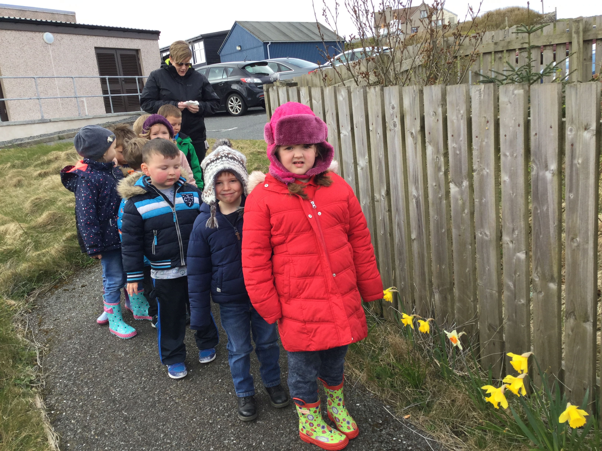
We want to make sure that your child’s time in at Dunrossness is a happy, safe and enjoyable experience from the beginning. Children learn through play and activity and each individual child comes with a variety of pre-school experiences. Some children settle quickly while others take longer to gain confidence. We get to know them very well as individuals, learning about their strengths and building on them. Staff and parents work together in partnership, sharing this important stage of your child’s development. Parents can stay initially with their child when they are settling in, with the time the child is able to spend on their own being gradually extended until the child stays for the whole session. Staff will advise you on this matter. Staff are always available daily and are delighted to answer any questions or concerns you may have.

The Nursery is very much part of the school and the children have many opportunities to become used to the whole school building and the wider school community. In the terms before starting school we begin to prepare children for the move into Primary 1, aiming to make the transition as smooth as possible. Closer to the end of the pre-school Nursery year children will also get the opportunity to ‘move on’ and experience a day in P1 along with lunch time in the canteen and break time in the playground.

Each year, the school has a ‘Transition Day,’ during which each year group in the school moves into their new class. This enables the children to experience their new class and teacher and help them with their transition into the next year.

Most of the children who come to Dunrossness School transfer to Sandwick Junior High School (SJHS) to start their secondary education. We have well established strong links with SJHS and throughout their time at Dunrossness School they will have opportunities to visit SJHS and meet many of the staff members there. For example, all our primary classes make a weekly visit to the school for a six week block each year during their swimming block.

We have in place an extremely well planned transition programme for the Primary 7 pupils. The programme aims to ensure that every child has a smooth transition into the next stage of their learning. This involves outdoor education days, a transition project, sporting events, visits from secondary staff and former pupils and three taster days at SJHS. Specific information is issued to the parents of primary 7 pupils each year.

National organisations, such as Parenting Across Scotland, provide advice to parents on supporting their child’s transitions. The direct link to Parenting Across Scotland is:
http://www.parentingacrossscotland.org/

We recognise that children with additional support needs may need transition arrangements that are additional to those made for their peers. Information sharing and planning will take place in advance of each transition. Further details can be found on Shetland Islands Council’s website. The direct link is:
http://www.shetland.gov.uk/education/documents/TransitionAdmissionsandPlacingRequestsInformationForParents.pdf

Placing Requests
If you do not wish for your child to attend your catchment area school, you can place a request with Shetland Islands Council that your child attend another school. Details of how to make a placing request can be found in Shetland Islands Council, Children’s Services, Admissions Policy. The policy can be found at: http://www.shetland.gov.uk/education/default.asp

Please make your Placing Request in writing to:

Director of Children’s Services
Children’s Services
Hayfield House
Hayfield Lane
Lerwick ZE1 0QD

To help you, the Scottish Government has published a guide for parents on choosing a school and the placing request system. It is available on the Scottish Government’s website. The direct link is:
http://www.gov.scot/Publications/2010/11/10093528/0

Enquire is the Scottish advice service for additional support for learning. If your child requires additional support for learning and you wish to place a request to have your child schooled elsewhere, you may wish to look at leaflets that Enquire have produced; Factsheets 2, 3 and 6 have particular relevance. Please request these from your child’s school or refer to Enquire’s website. The direct link is:
http://enquire.org.uk/information/factsheets

In Shetland, we have two special Additional Support Needs departments (attached to Bell’s Brae School and Anderson High School). A request for a child to access a place in one of these special departments is at the discretion of Children’s Services. Further information can be found on Shetland Islands Council’s website. The direct link is:
http://www.shetland.gov.uk/education/documents/TransitionAdmissionsandPlacingRequestsInformationForParents.pdf

Shetland Islands Council’s Children’s Services Admissions Policy can be found at:
http://www.shetland.gov.uk/education/default.asp

School Ethos
Living, Laughing, Learning

Our Vision

Dunrossness Primary School: A happy school where everyone is supported and encouraged to achieve their full potential.

Our Aims

- To provide a safe, secure, happy and healthy learning environment where respect is given to all and shown by all;
- To shape values, promote independence and responsibility and develop skills for life;
- To encourage, motivate and support everyone in our school to be the best they can be;
- To inspire, reward and celebrate success and achievement in all areas of learning;
- To be an integral and responsible element of the whole community that we are all proud to belong to.
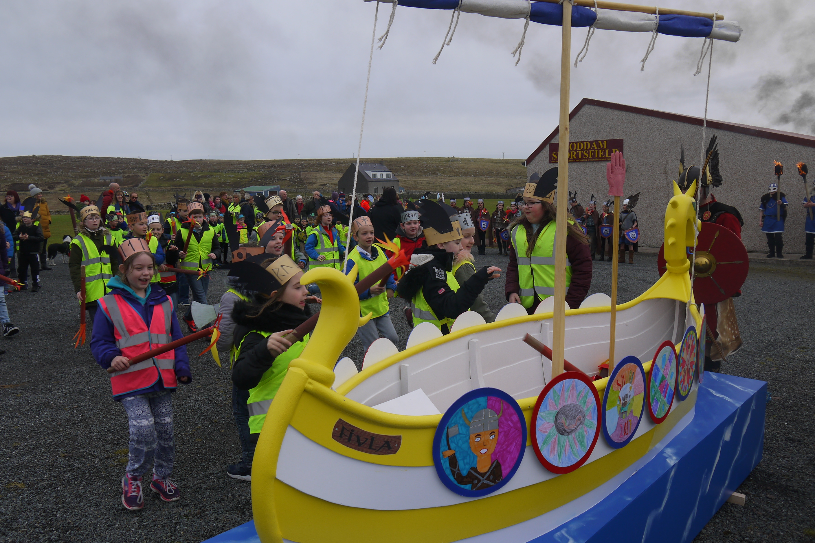
‘What a brilliant, feel good, morning we had! People feeling a bit down should come along to this! There was such a buzz. ‘
Parent comment March 17


‘I like when everyone is working together in the hall. I like working with people from other classes.’
P2 Pupil – June 17

Behaviour
We have high expectations of our learners. Staff members promote positive behaviour by developing good relationships between pupils, parents and staff. Each class develops their own set of rules and positive behaviour management system, which is reinforced by the Head Teacher. Behaviour issues are dealt with in accordance with the school Behaviour Management Policy. The policy is on the blog or paper copes are available at the office on request.
‘I’d happily take these children anywhere! They were so well behaved and were so supportive of other teams.’ Mrs J Smith – after Hockey Festival 2016

Our School Rules

We will:
- Show respect, kindness and consideration to others at all times;
- Use good manners at all times;
- Listen well and not interrupt;
- Walk quietly in the school;
- Look after our school and everything in it;
- Keep our playground voices for when we are outside;
- Be a good representative for the school at all times;
- Take responsibility for all of our actions.

You may wish your child to carry a mobile phone for after school events, but we ask that they are kept in your child’s school bag and not used at all during the school day. Any phone that is seen to be used will be taken from your child and returned to them at the end of the day.

Community
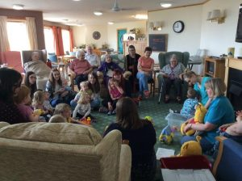
We pride ourselves on being at the heart of the local community and on making a positive contribution to the wider area. We develop opportunities for our community to come together by, for example, organising special assemblies and hosting local events. The school supports the work of voluntary groups operating in the local community by providing facilities, fundraising or collecting charity donations and taking part in community events. We support national events such as Children in Need and Comic Relief and link with schools in other countries. These experiences provide valuable learning opportunities, helping pupils to develop a strong sense of community and culture.

Wider achievement
Our pupils develop a wide range of skills through being involved in activities out of school. We work with children to help them recognise the skills they are developing through their involvement in sports, hobbies and other interests. We encourage children to bring in photographs, certificates, medals or other artefacts to use as a focal point for discussing and sharing their experiences with others.

Teachers support children by helping them identify the skills they are developing and how these skills may be transferred into other areas of learning. We celebrate wider achievements and success through school assemblies and each classroom has a wider achievement display.

In term 3 we have afternoons dedicated to wider achievement where we involve partners to run a varied programme of events. Children are consulted and we aim to provide activities which offer opportunities of interest and challenge where they can apply their skills in different contexts. This was hugely popular last year and when asked what the school did well, the wider achievement afternoons were by far the most common answer.
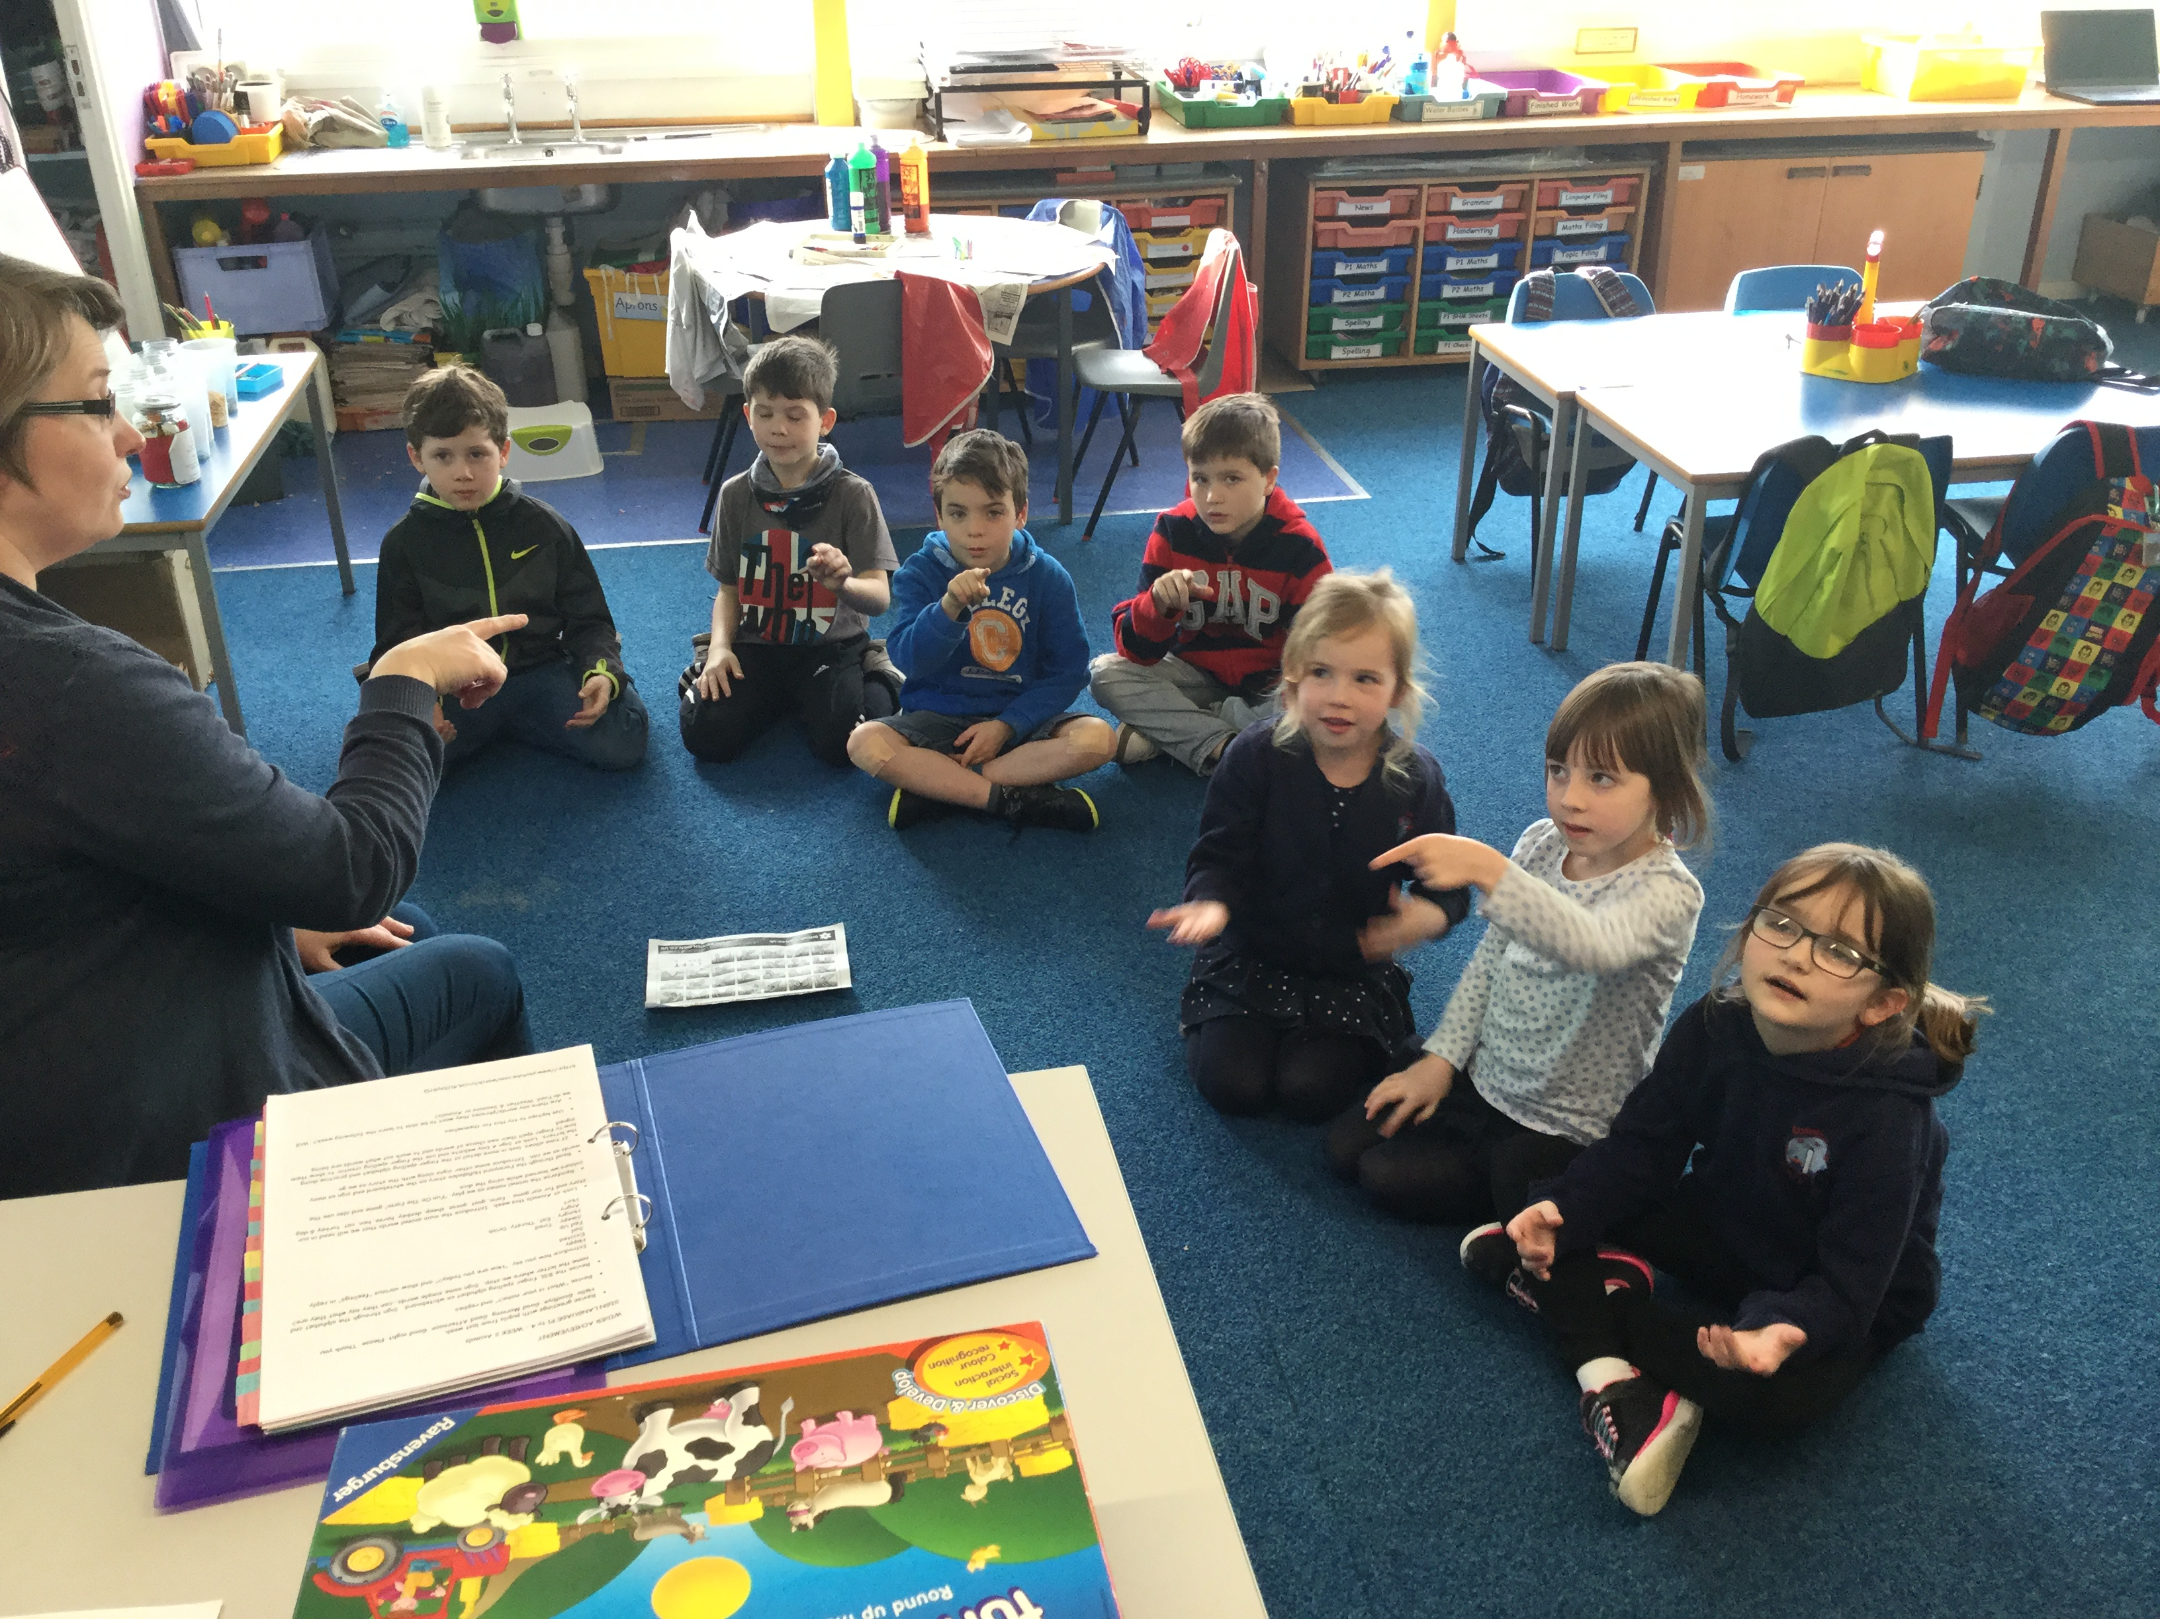
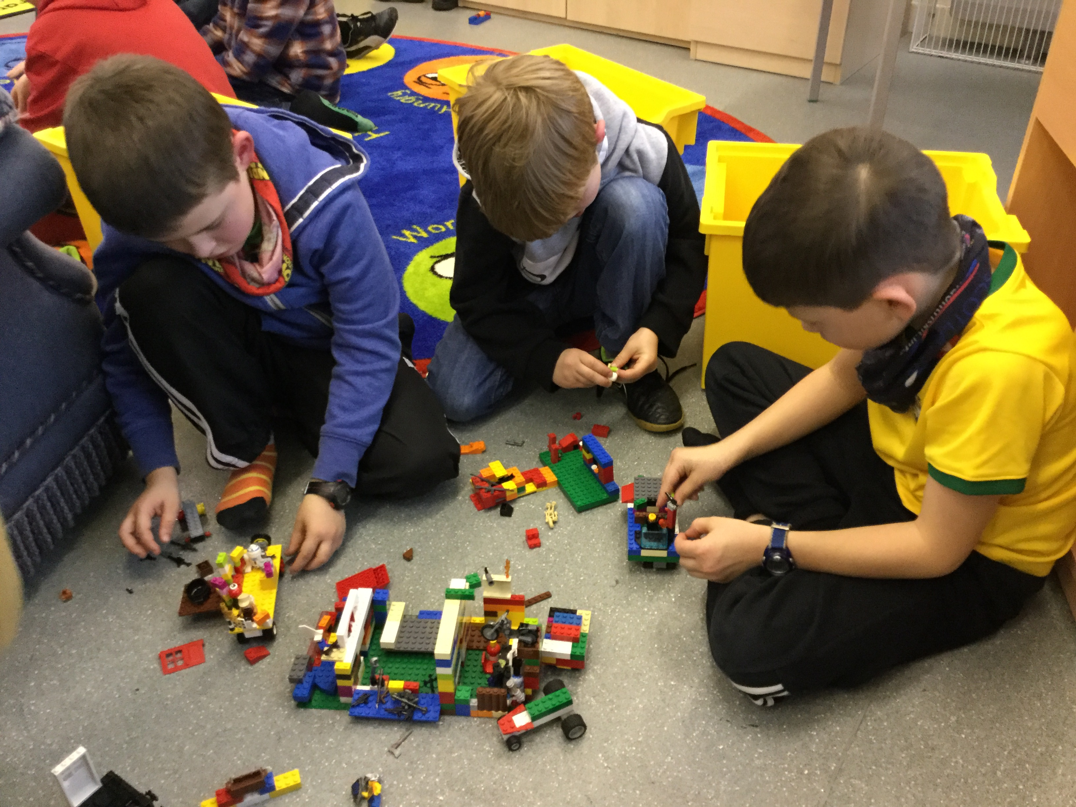

Lego Animations
Sign Language
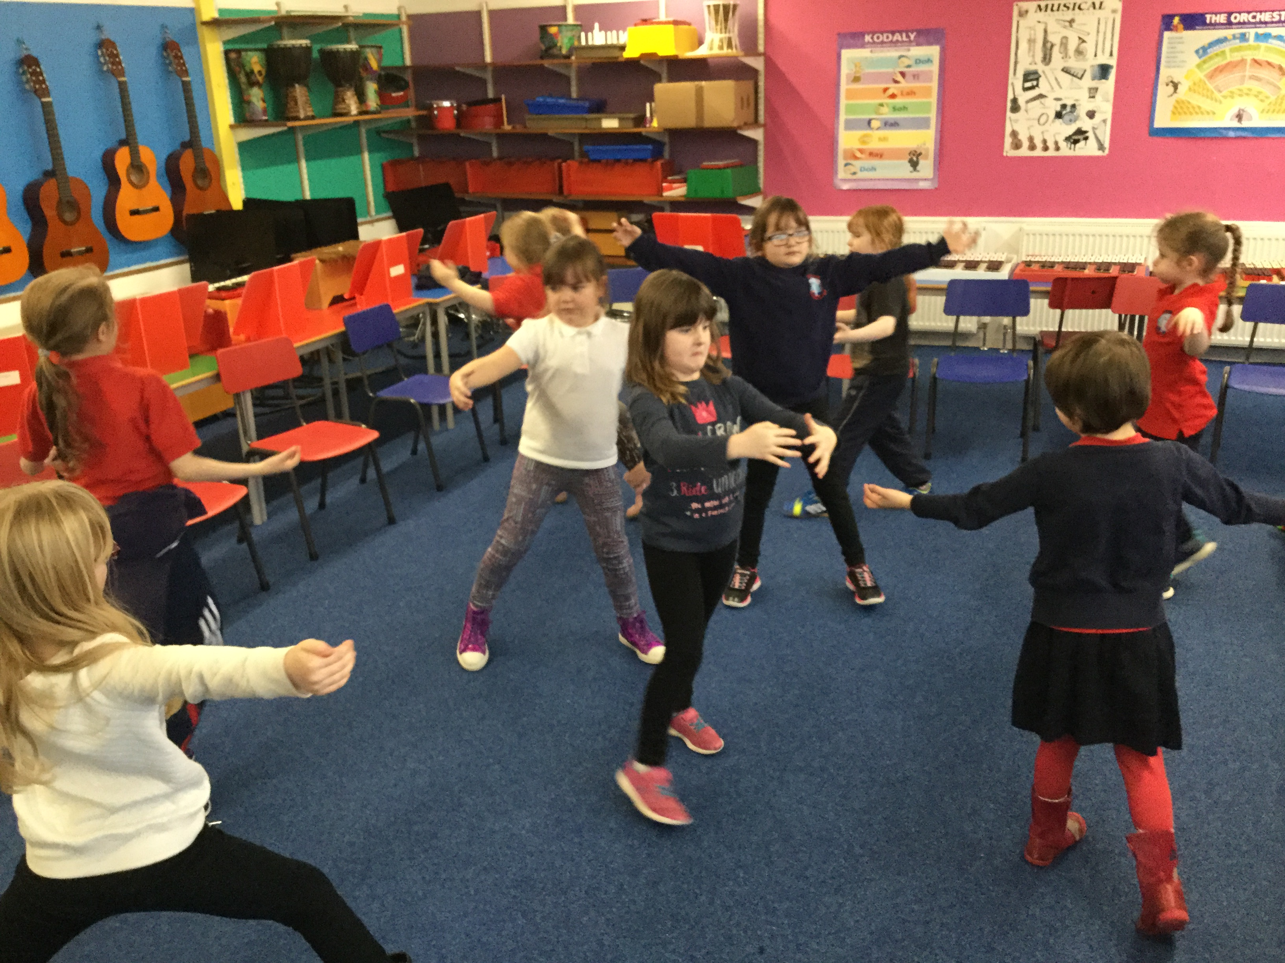
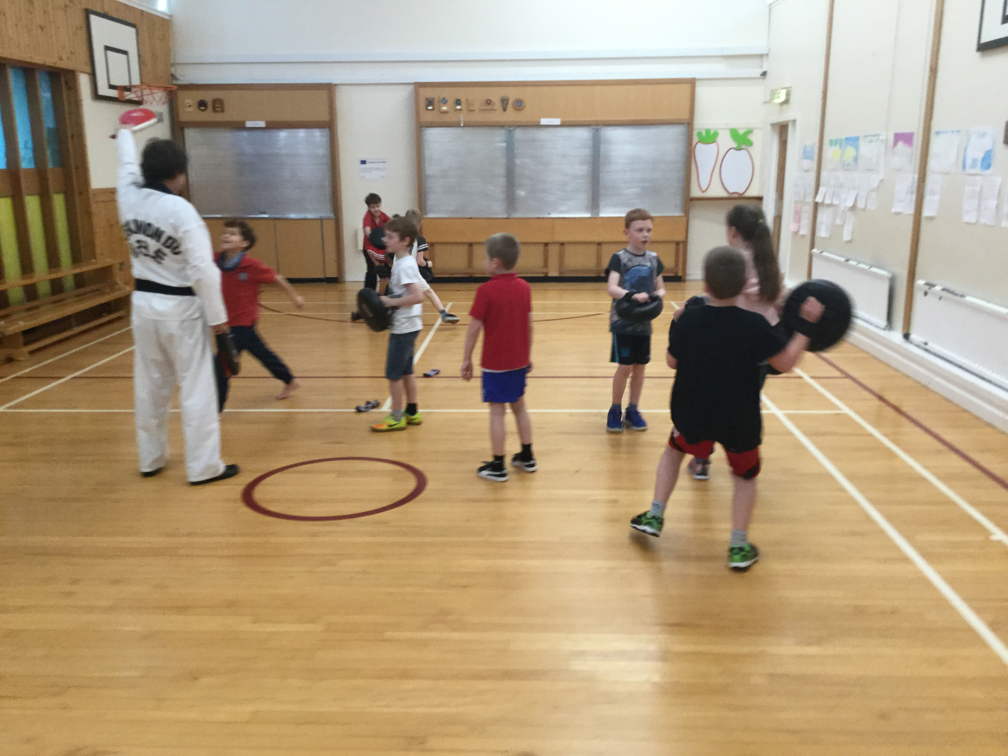
Taekwondo
Drama

The Curriculum for Excellence
This curriculum aims to develop four capacities for successful learning. These are:

Successful Learners
With:
- Enthusiasm and motivation for learning
- Determination to reach high standards of achievement
- Openness to new thinking and ideas.

Confident Individuals
With:
- Self-respect
- A sense of physical, mental and emotional well-being
- Secure values and beliefs
- Ambition.

Responsible Citizens
With:
- Respect for others
- Commitment to participate responsibly in political, economic, social and cultural life.

Effective Contributors
With:
- An enterprising attitude
- Resilience
- Self-reliance

As part of this development the boundaries between each of the stages of schooling have been blurred, helping to create a curriculum for all children from 3-18 years.

A child’s journey through Primary School is now organised under the following stages:

Early - In pre-school and in Primary 1
First - By end of P4, but earlier for some
Second - By end of P7, but earlier for some

These stages provide scope for challenge and depth. There is no pressure to speed through the levels but nor are there be any ceilings to learning. The focus is very much on individual progress and achievement with the child at the centre of their learning. Further information can be found at www.ltscotland.org.uk/curriculumforexcellence

At the very heart of our curriculum planning, lies the holistic development of children and their skills across the curriculum, building on their previous learning experiences, knowledge and skills. Children will learn through first-hand experiential activities within play-based situations. In their play, children practise and consolidate their learning, play with ideas, experiment, take risks, solve problems and make decisions individually and in small or large groups. The development of children’s self-image and feelings of self–worth and self–esteem are central to this process.

The curriculum within the Early Stages is progressive and aims to meet the needs of all children including those who are at an early stage of development and those who are more able and more independent. The curriculum will be appropriate to the individual child’s stage of learning rather than focussing solely on age related outcomes to be achieved. Children will be helped to move on to the next stage in their learning when they are developmentally ready, at their own pace.

In line with the Curriculum for Excellence, learning is organised under the following headings:

- Literacy and Language
- Numeracy and Mathematics
- Science
- Social Studies
- Health and Well-being
- Religious and Moral Education
- Expressive Arts
- Technologies

ICT (Information and Communication Technology) is embedded within all the above areas and is seen as an integral part of all the curriculum programmes as are aspects of learning such as citizenship and enterprise.

Much of the learning is planned using a cross-curricular approach to help ensure meaning and relevance and to give fun and enjoyment. This also opens up possibilities for personal learning and choice.

Numeracy and Mathematical Development
From the time your child joins us, they will experience a gentle approach to number recognition, building on knowledge already acquired. This will lead on to simple addition and subtraction. Work on simple shape, measurement and money is part of the curriculum and the children will be given opportunities for problem solving. There is less emphasis on the completion of workbooks and more on learning by doing – active learning. This means that there will be less written work than you may have seen in the past and there may be workbook pages that have not been completed as the children have learned the concepts involved through practical activities instead of repetitive examples. This is a major part of our curricular reform.

Literacy and Language Development
Literacy and Language involve the four skills of reading, writing, talking and listening. All four are essential skills and need to be taught at home and at school.

Using Jolly Phonics, the children are taught the main 42 sounds of English, not just the alphabet sounds. With this knowledge, they are taken through stages of blending sounds to form words and then to reading. This learning is paced to suit each pupil. Due to the importance of these early reading exercises, the children will not get a ‘reading book’ right away. They will, however, have the opportunity to choose books from the class and school library to take home to share with parents and guardians. There is a vast array of research showing the importance of reading to your child in the development of their language skills.

Preparation for reading is provided through the Oxford Reading Tree. This special purpose early reading scheme introduces children to whole words through a series of amusing family sketches. Reading scheme books will not be sent home until your child is ready to begin to read independently. There is further learning in this scheme – comprehension work. This is learning that goes with each story to build on the children’s understanding of texts, build their vocabulary and their understanding of grammar, spelling and punctuation. This is why one book will be given over a period of time instead of a book a night – there is more to reading than just reading!

The children are encouraged to build an enjoyment of stories and rhyme through a variety of books, songs and games.

Writing begins with talking and expressing views, opinions, passing on information and instructions and using our imaginations to make up stories, rhymes and role play. From this, we move onto mark making, expression through drawings and then onto using words. All children develop the skills involved with writing at different rates depending on a host of factors such as their vocabulary, their fine motor skills and finger muscle development, their ability to deconstruct words into sounds and then further down to the letters that represent these sounds. Children will be supported as they develop the skills and confidence to write independently.

Health and Wellbeing
The need for changes to lifestyles in Scotland to promote good health has meant this curricular area is now, like literacy and numeracy, the responsibility of all teaching staff in the school. This means it has great importance in our school and is promoted through our ethos, our values and through health promotion in the wider community. Health and Wellbeing includes aspects such as staying fit and healthy, healthy food choices, emotional and social health, taking responsibility and staying safe.

Learning, Teaching and Assessment
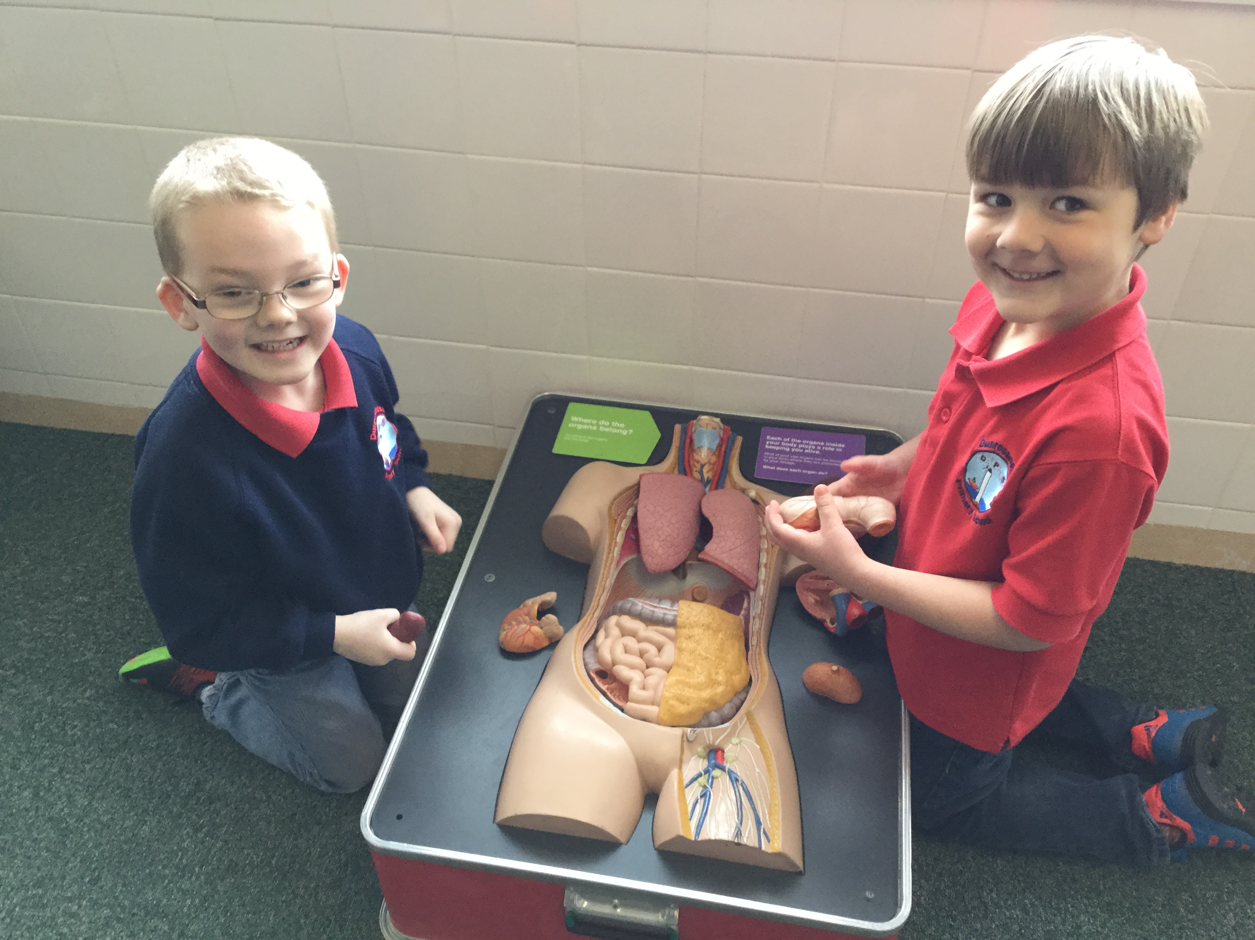
We apply a range of teaching and learning approaches in order to challenge and motivate learners to achieve their best. These include:
- Active learning
- Co-operative and collaborative learning
- Enterprising teaching and learning
- Outdoor learning
- Use of ICT

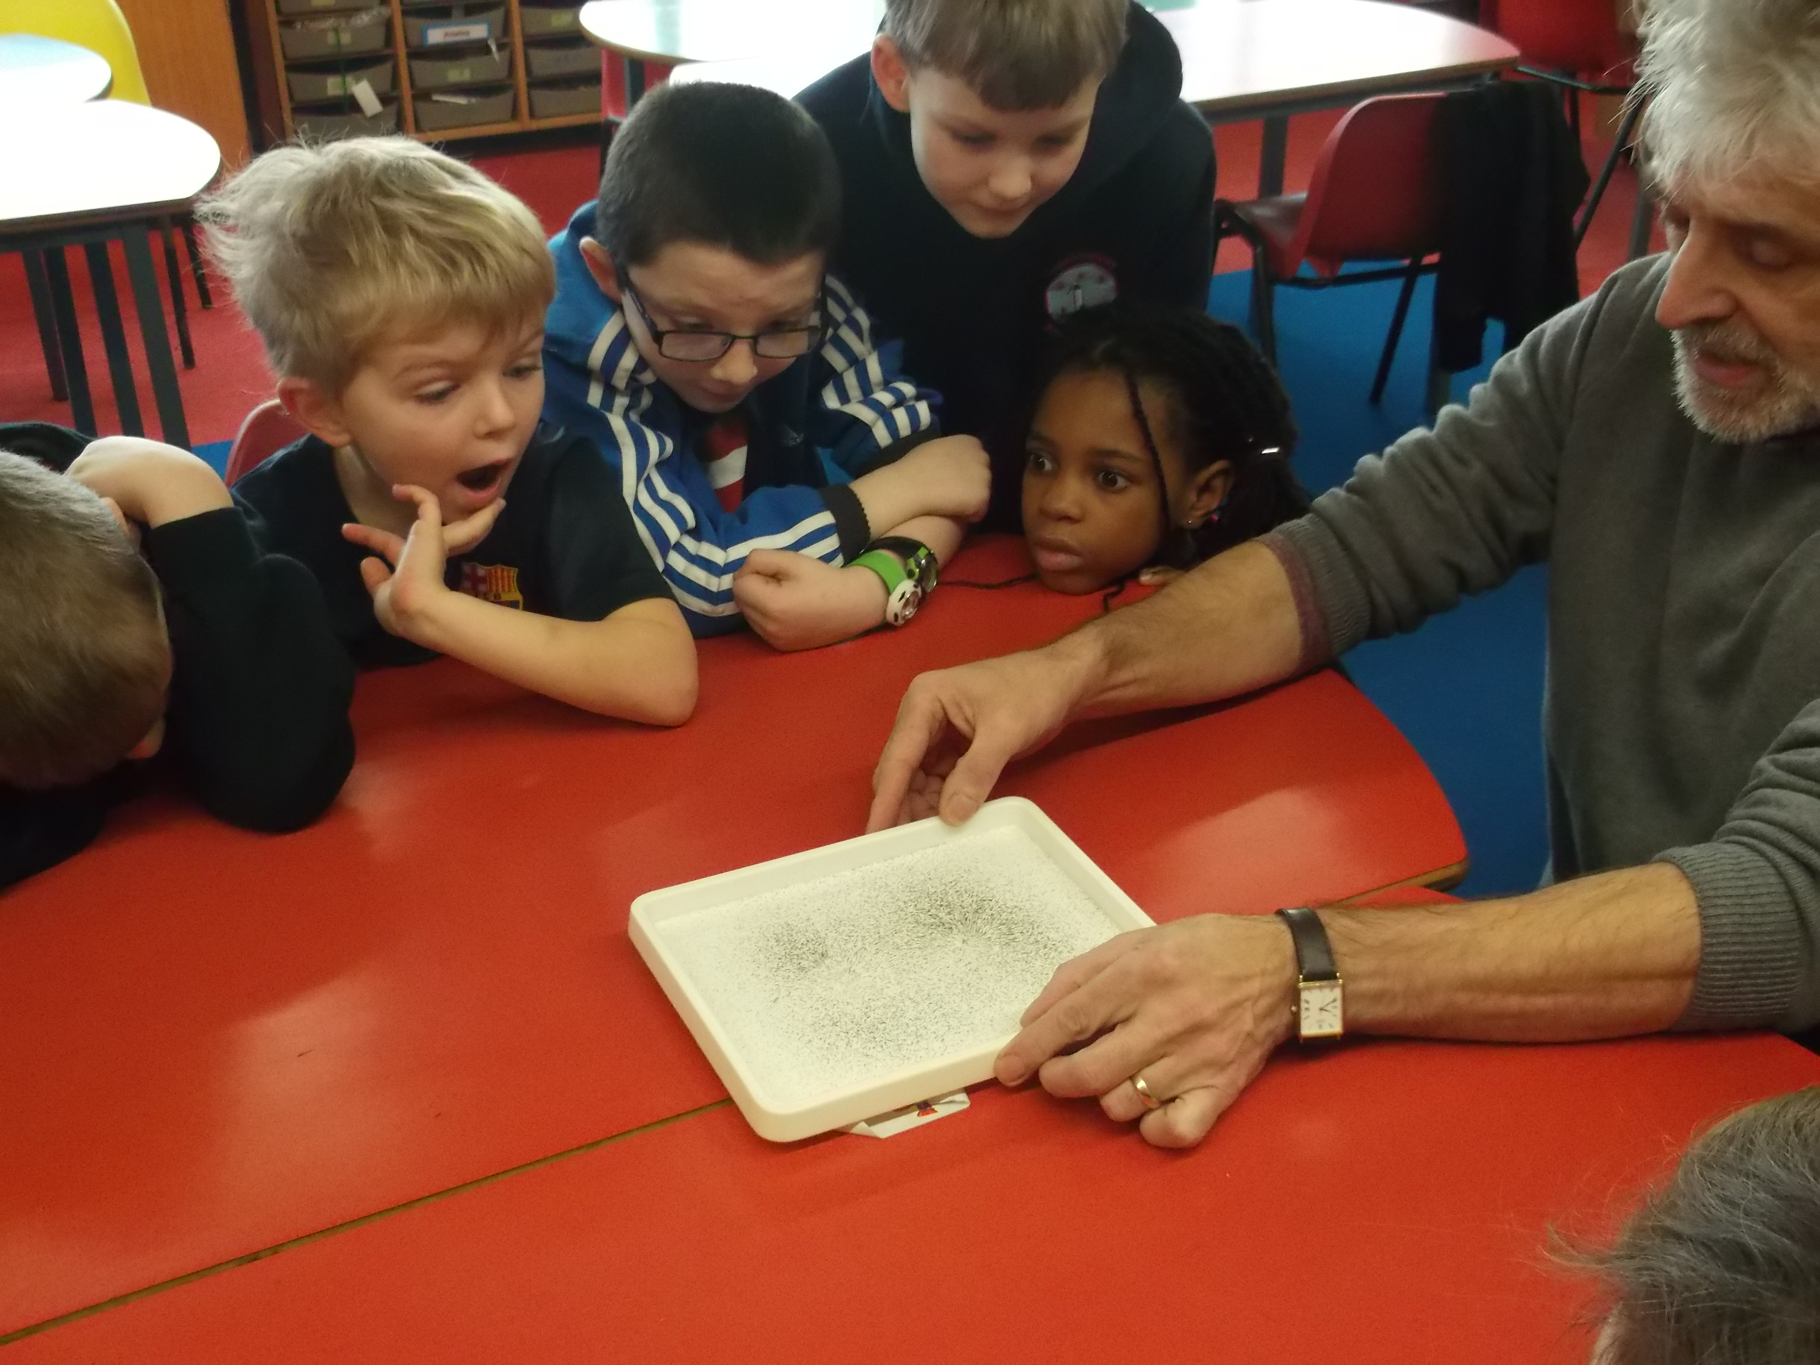
As a school we are developing opportunities for interdisciplinary learning, through which experiences and outcomes from within and across curriculum areas are grouped to provide coherent and relevant learning experiences and stimulating contexts to meet the needs of our children.

Our teaching staff involve children in deciding what and how they learn, ensuring a focus on personalisation and choice.

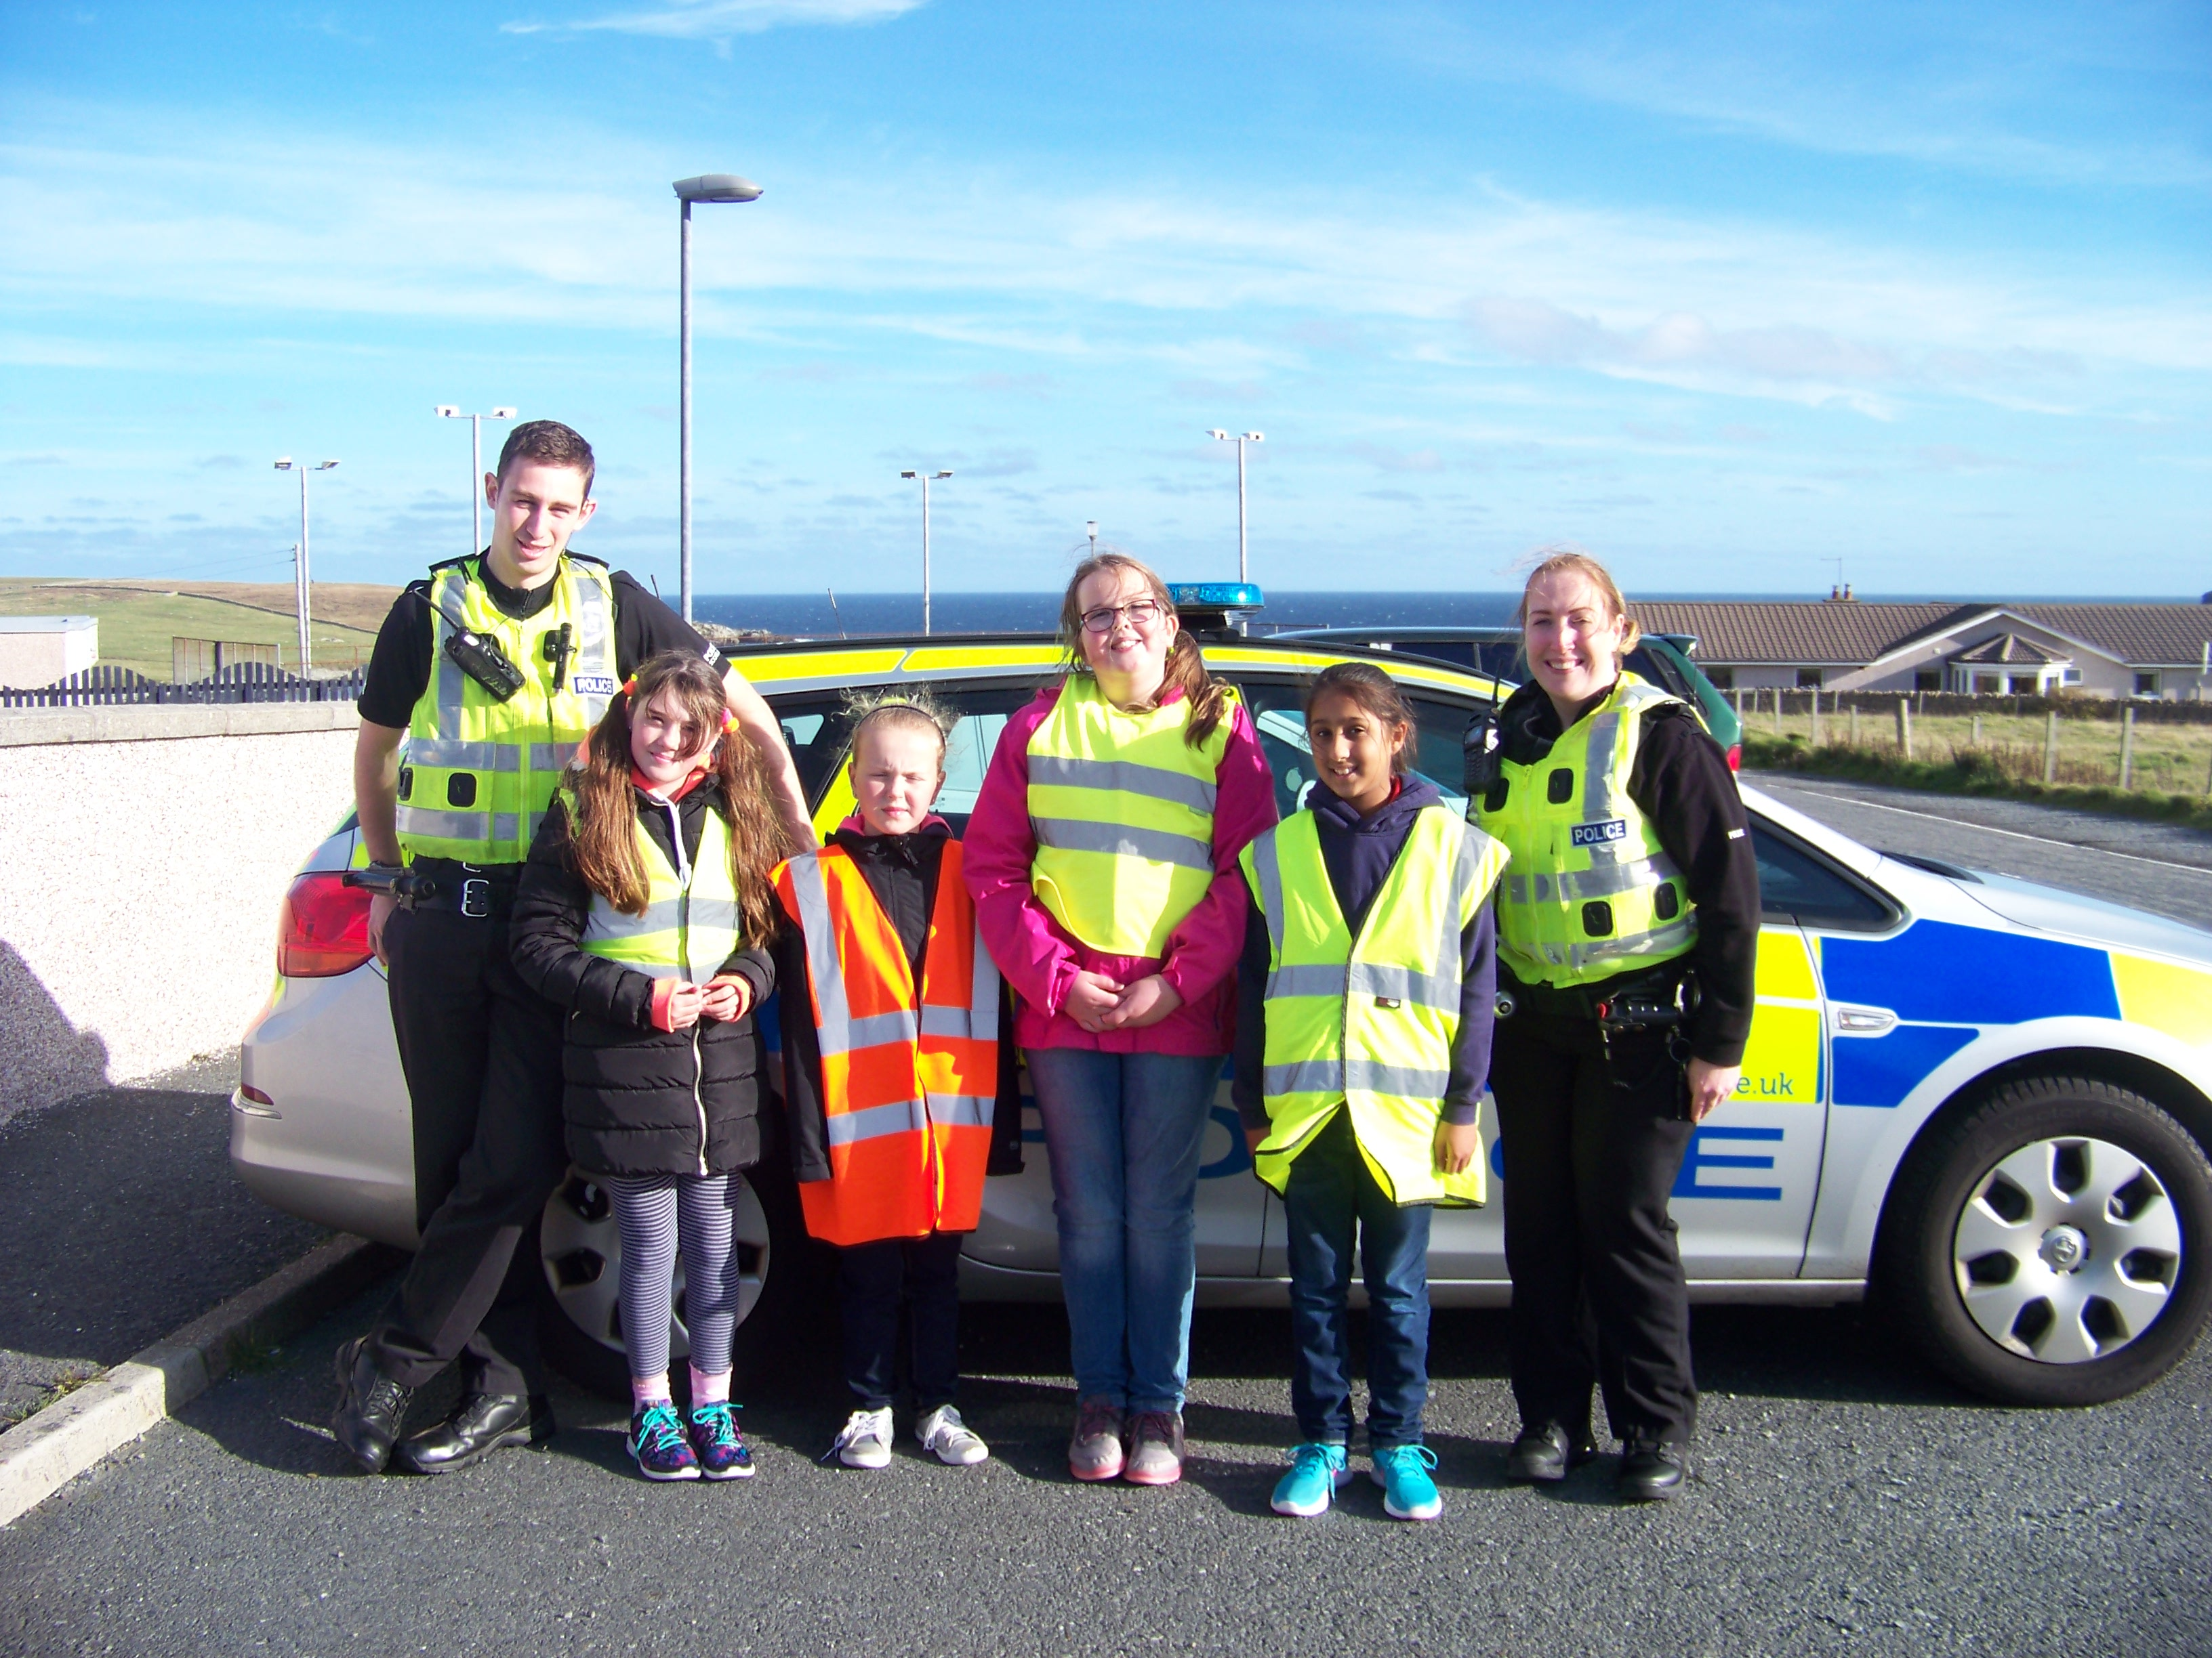
We carefully consider the totality of experiences provided for learners to help them develop important skills for learning, life and work. Our elected Pupil Council represents the views of the pupils in school decision making and play an important part in making positive improvements.

We develop relevant partnerships with people, groups and agencies to enhance learning. Active schools, the police, the fire service, health professionals, local ministers and local education officers, to name a few, all provide their expertise to enhance the quality of the education we provide.

A range of local organisations support and enhance the delivery of learning experiences out with the classroom. Relevant trips out to places like the Shetland Museum, Quendale Mill, the Shetland Croft House, the local shop, the Waste to Energy plant, local farms and many others offer our pupils real life learning experiences.

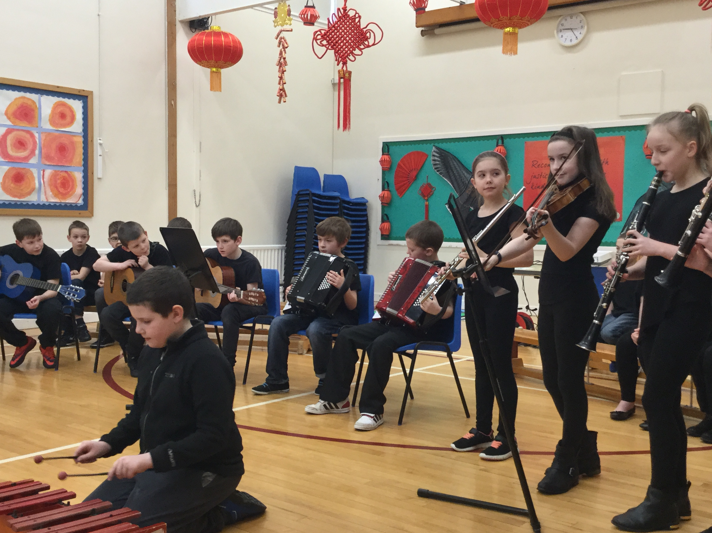
Our learners benefit from the expertise and skills of our visiting specialists for art and design, music and physical education, who encourage pupils to develop their skills beyond the school. We are proud of our longstanding instrumental achievements through a team of dedicated instrumental teachers. Our children get regular opportunity to show their talents at a range of different events.

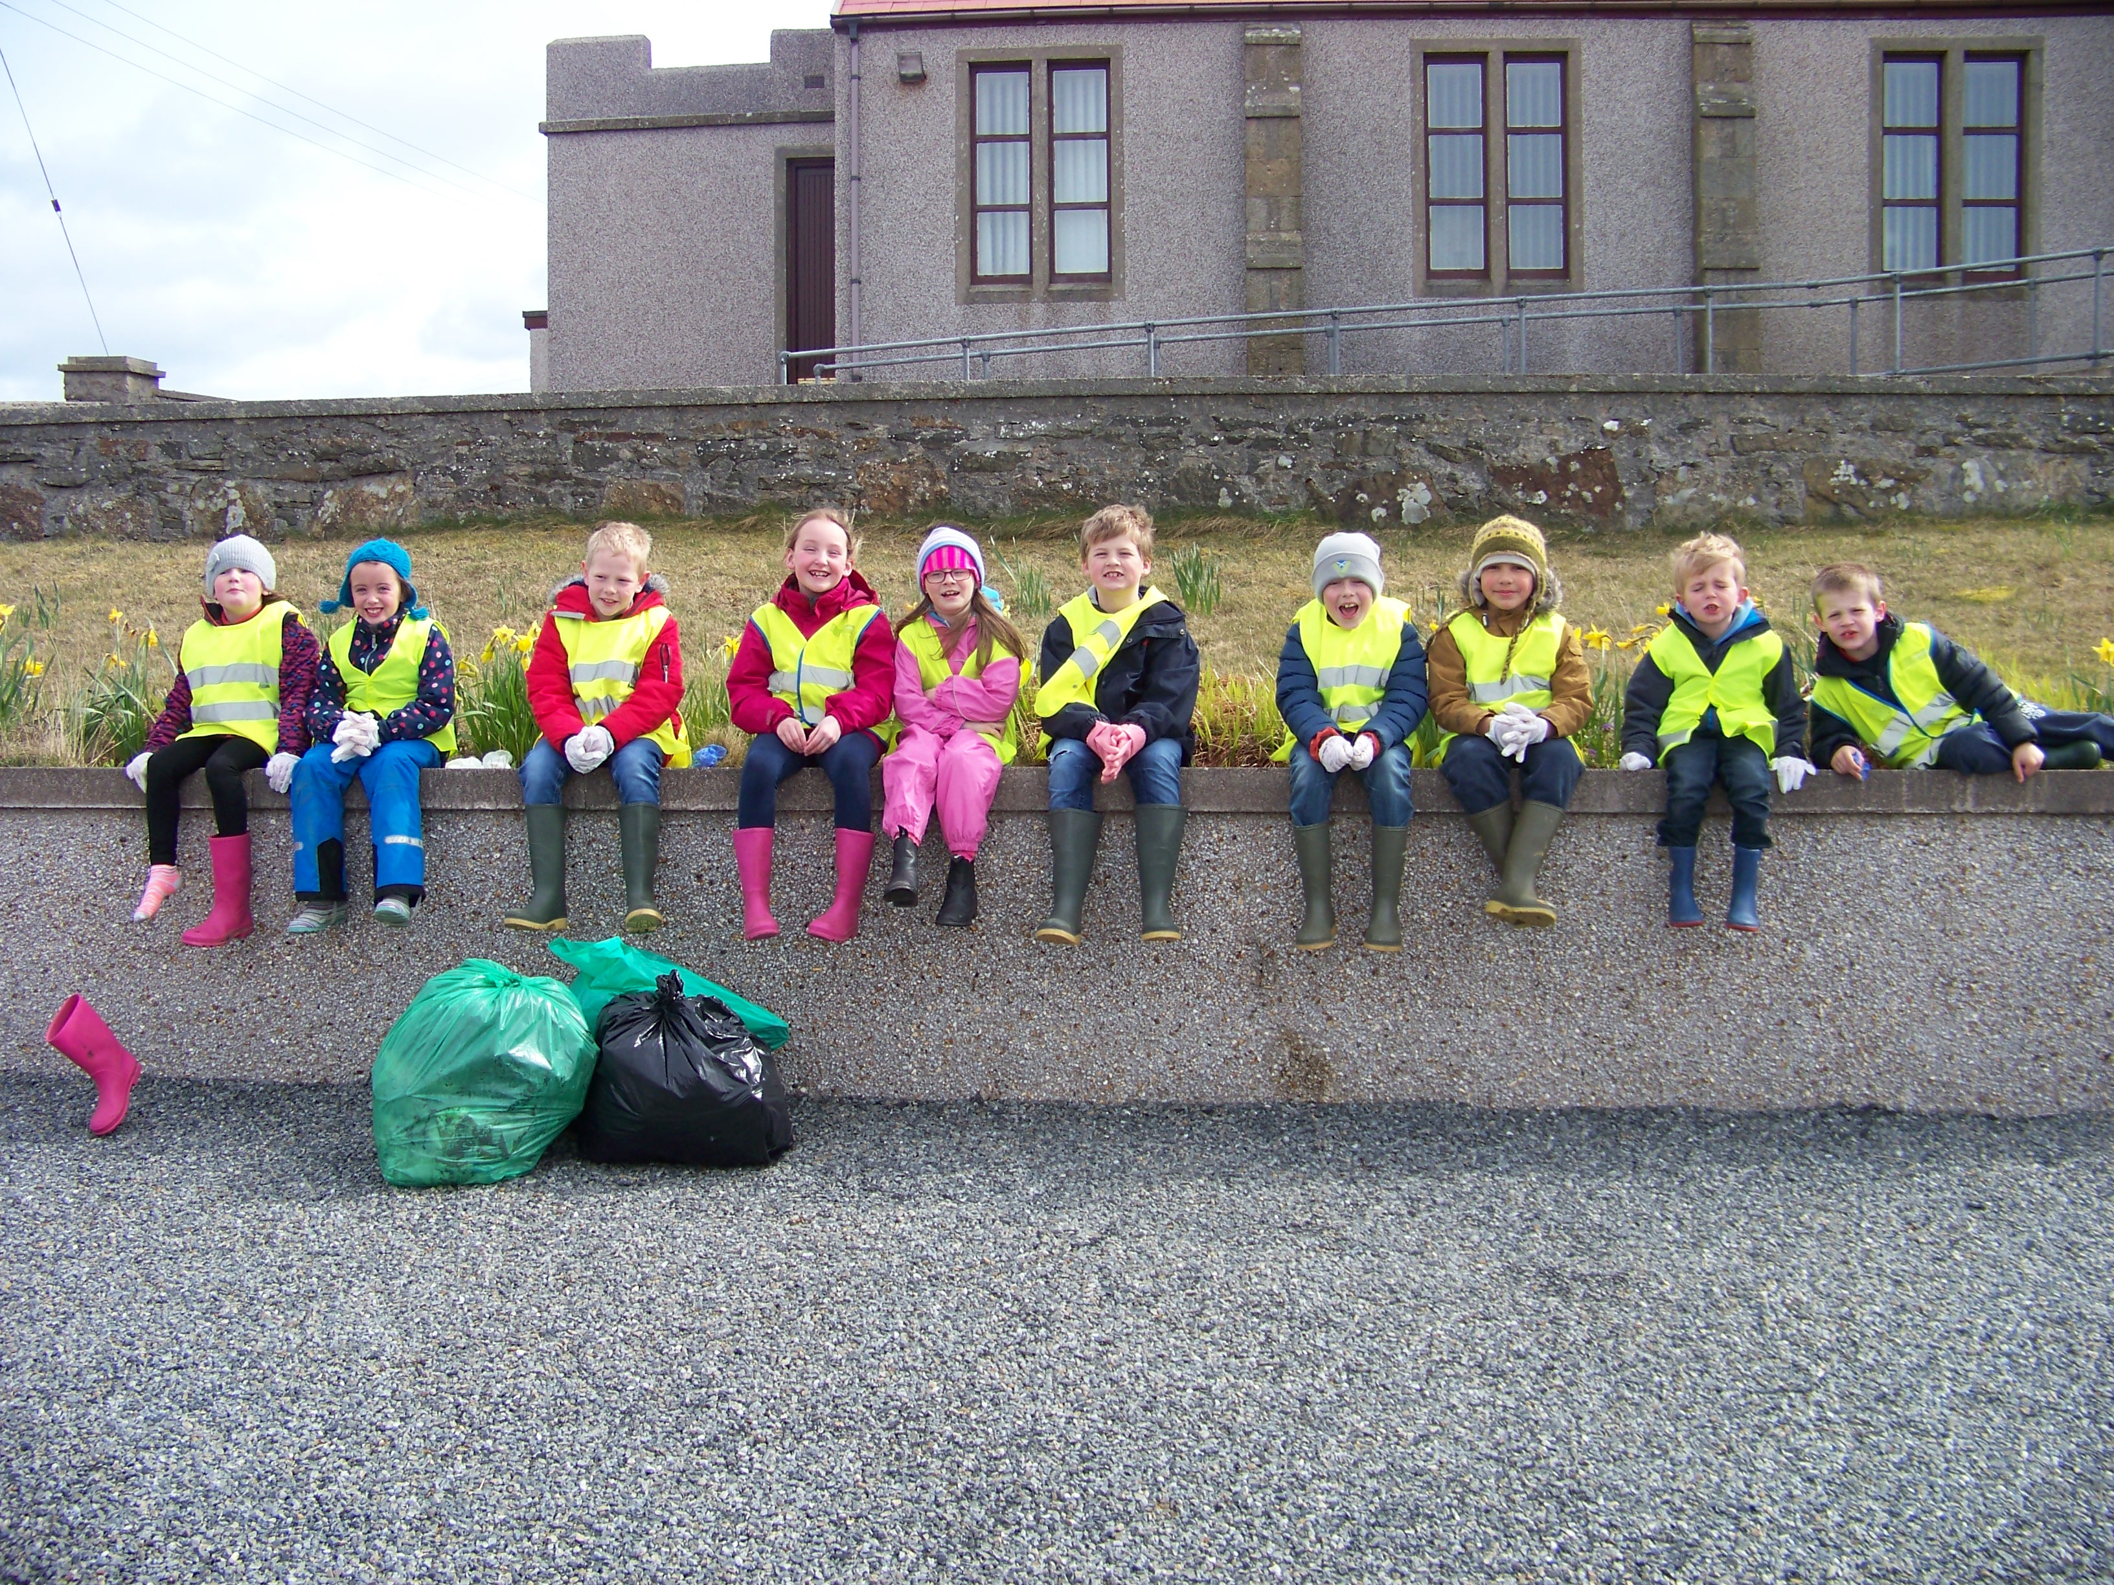
At Dunrossness School, citizenship and enterprise are embedded throughout our curriculum. Careful planning allows children experience a range of contexts to help them develop informed decision making and the ability to take thoughtful and responsible action both locally and globally. For example, at a local level the children participate in ‘Da Voar Redd Up’, the annual spring clean of Shetland’s beaches and roadsides. This helps children to realise the impact of litter on the local environment and to help them make informed choices about waste.

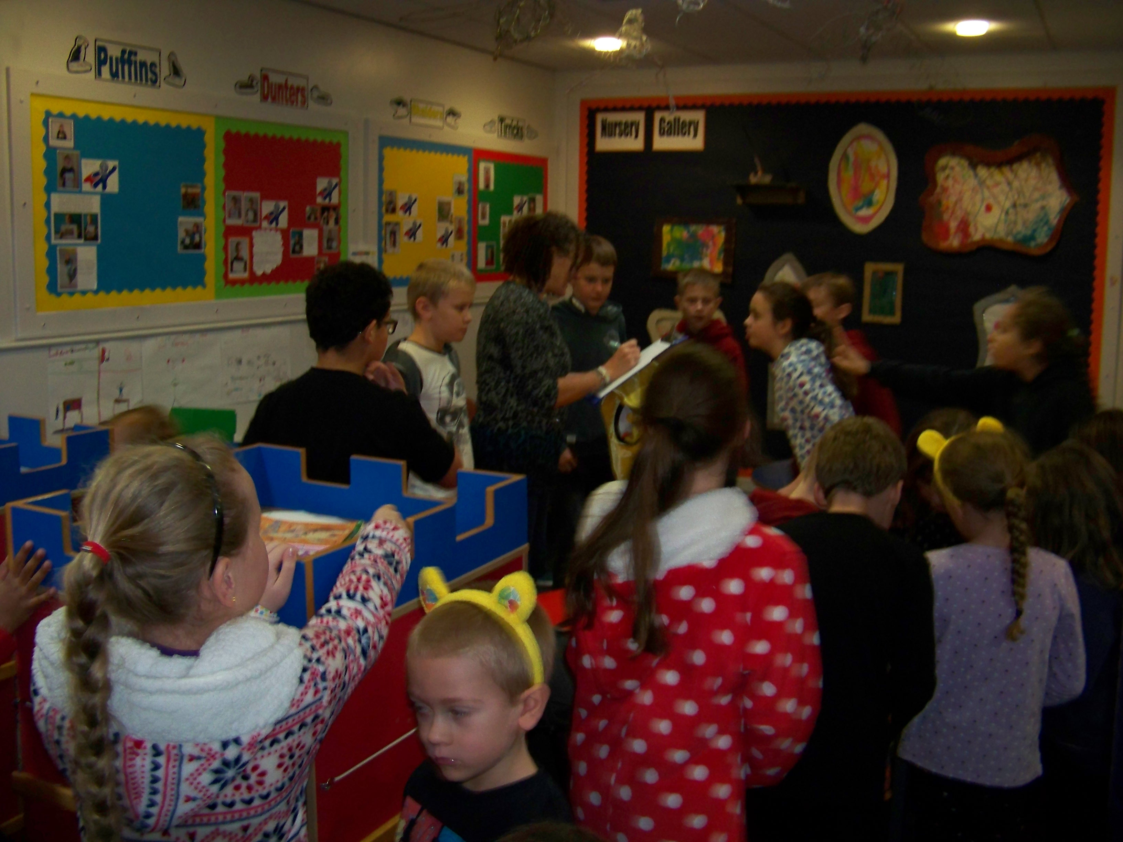
There are many events throughout the school year, such as Children in Need, Sport Relief and World Book Day. It is also a great way to raise money for great causes and an opportunity to get all the children and their families together!

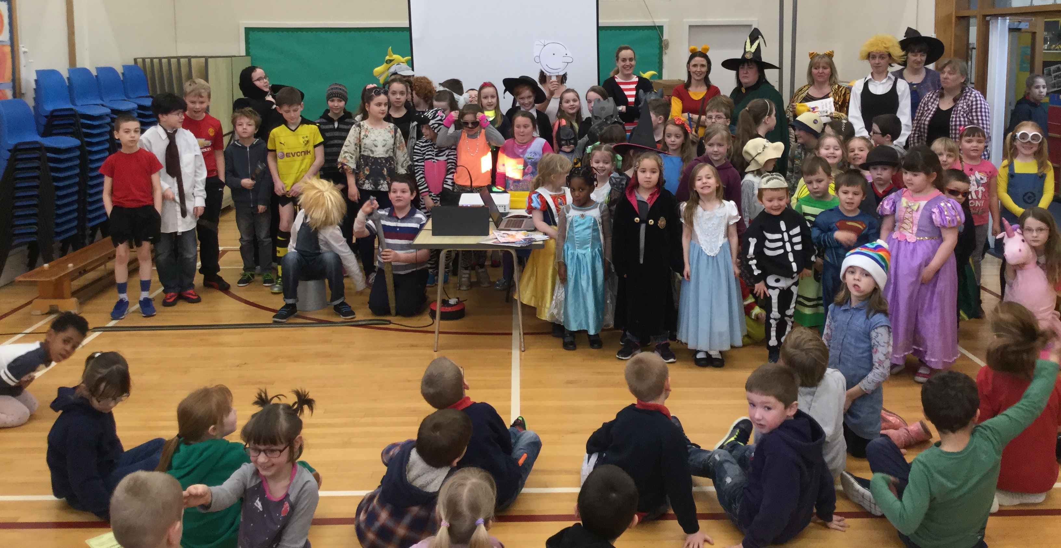
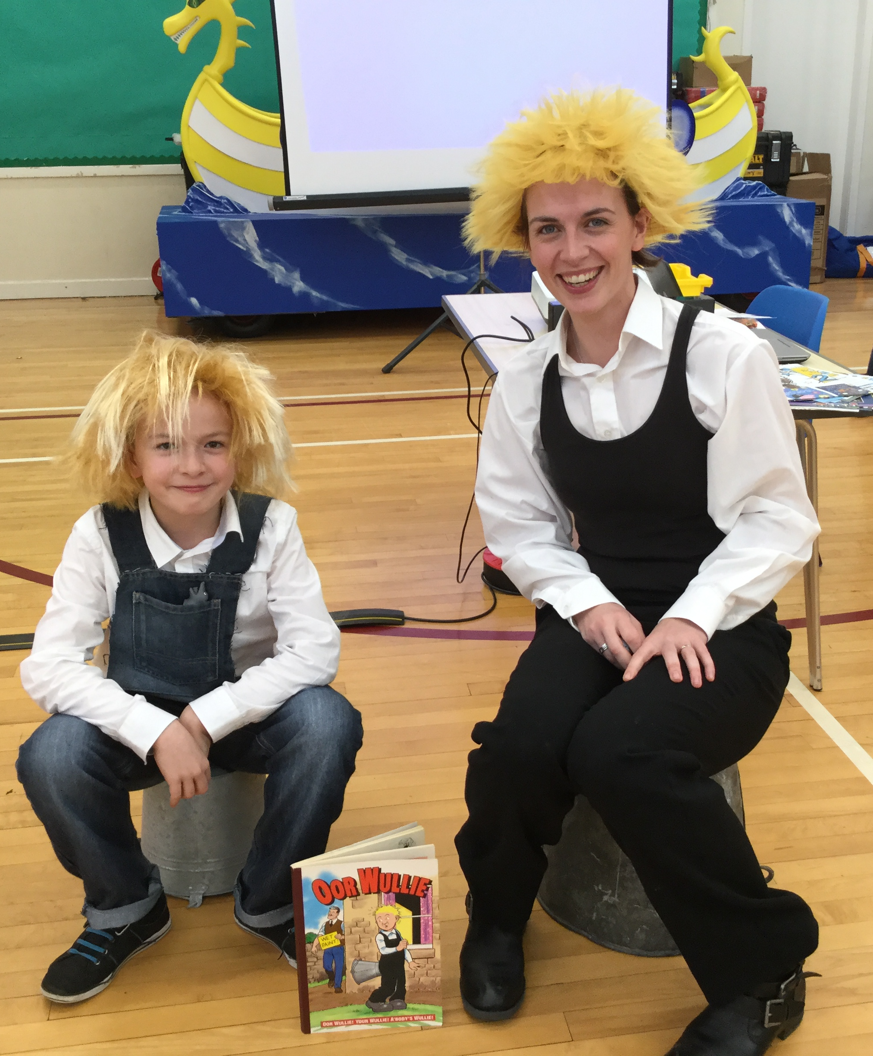
Assessment is an integral part of learning and teaching. We use a range of approaches to provide a clear picture of our pupil’s progress and achievement and to identify next steps in learning. We aim to engage our pupils in all aspects of assessment by sharing learning intentions and success criteria, providing opportunities for peer and self assessment, giving quality feedback to pupils about their progress and discussing next steps in learning.

Parents are also an integral part of the assessment process. We encourage parents to discuss their child’s progress with them. We have two official parents’ evenings, during which parents can discuss their child’s progress with the class teacher. Our homework diaries and open door policy, aim to ensure parents and teachers have regular, open lines of communication so that any issues or concerns can be discussed, and strategies implemented, at the earliest opportunity. A comprehensive report is sent home to parents annually.

Further information on achievement, reporting and profiling can be found on Education Scotland’s website. The direct link is:
https://education.gov.scot/parentzone/learning-in-scotland/assessment-and-achievement

Support for Pupils
92% of our pupils agreed that they get help when they need it.
Pupil Questionnaire, May 2016

Most pupils will be given the support they need to fully
access the curriculum in the general course of their
education. There will be times when some pupils will
need additional support. This could be on a long-term basis with the amount of support varying according to the needs of the pupil as progress is made through school or as a temporary support when a need arises.

Information on how pupils’ additional support needs (ASN) are identified and addressed can be found on Shetland Islands Council’s website. The website also provides information on mediation and dispute resolution services, links to the NHS and other agencies or organisations that can provide further support, information and advice about support and advocacy. The direct link is:
http://www.shetland.gov.uk/education/asn_home.asp

Dunrossness School has a dedicated ASN teacher, a learning support worker and a learning support assistant, who are responsible for ensuring that the relevant support is given. This may be in the form of extra resources, one to one or small group tutoring, helping a child in their own classroom, making classroom observations or taking the rest of the class to allow the class teacher time to work with the pupil. The ASN teacher will consult with the rest of the staff on support strategies and will liaise with other professionals in order to ensure the needs of the child are met. The ASN teacher work very closely with parents to identify and agree the level and type of support needed and will review needs on a regular basis. If you think that your child needs additional support or you would like further information or advice, you should contact Mrs Leslie. Contact details are at the start of the handbook. Other useful information and advice regarding additional support for learning can be found on Enquire’s website. The direct link is: http://enquire.org.uk/

Getting It Right For Every Child (GIRFEC)
In Shetland, we believe that children can be better supported by adults working closely together and sharing important information with each other. This process is known as GIRFEC: Getting It Right For Every Child. Before GIRFEC can be used, consent from the parent of the child and/or the child (depending on the age of the child) is required. The staff asking permission will explain more about what GIRFEC means. Detailed information about the process can be found on Shetland Islands Council’s website.
The direct link is: http://www.shetland.gov.uk/children_and_families/GIRFEC.asp

Child Protection
It is every child’s right to be cared for and protected from harm. It is every person’s responsibility to make sure that happens. The Shetland Child Protection Committee provides help when there is a need. Their website gives information on how to access that help. The direct link is: http://www.safershetland.com/

Shetland Islands Council’s website also provides information on our responsibilities towards children and includes where to find help and support. The direct link is: http://www.shetland.gov.uk/children_and_families/child_protection.asp

School Improvement

Dunrossness School is committed to self evaluation and continuous improvement. Each year the school produces a single document, called the ‘Standards and Quality Report and Development Plan’, which outlines the progress we have made each year along with the areas identified for future development. This document can be viewed using the following link:

Each year, the school fully self evaluates it’s practice and this, along with feedback from parents, pupils, staff and partners, is used to inform our Standards and Quality Report and Development Plan. Further information on our school improvement can be seen on the school improvement section of our website.
The direct link is: https://blogs.glowscotland.org.uk/sh/dunrossness/parent-council/school-improvement-plan-2/

Information about the school’s performance at national level can be found on the Scottish Government’s website and on the Education Scotland’s Scottish Schools Online website which also includes HMIe Inspection Reports.
Direct links are:
http://www.gov.scot/Topics/Statistics/Browse/School-Education

HMIe Inspection reports and School Consultation reports can be accessed directly on Education Scotland’s Reports webpage.
The direct link is: https://education.gov.scot/

Other useful websites
Information on the following websites may also be of interest to you:

Scottish Qualifications Authority
http://www.sqa.org.uk/sqa/41292.html

Scottish Credit and Qualifications Framework
http://scqf.org.uk/parents-carers/

Scottish Survey of Literacy and Numeracy
For general information on the survey:
https://education.gov.scot/parentzone/learning-in-scotland/assessment-and-achievement/Scottish%20Survey%20of%20Literacy%20and%20Numeracy

School Policies and Practical Information

Policies
A range of school policies support the work of the school. These can be accessed by contacting the office directly or by checking our website.

Policies applicable to all schools across Shetland can be found on Shetland Islands Council’s website. The policies include:
- healthy eating
- bullying
- exclusion
- school trips
- equality and diversity
- adverse weather.

The direct link is: http://www.shetland.gov.uk/education/policies_guidelines_and_forms.asp

Throughout the course of the year a wide range of opportunities are available for pupils to be involved in the school including sports and outdoor activities. This information will be distributed to parents, as required and is also accessible through the school website. The direct link is:

Shetland Island Council’s website provides information on instrument instruction along with other creative learning opportunities. The direct link is: http://www.shetland.gov.uk/education/creative_learning.asp

Religious Observance
Scotland is a society with a longstanding Christian tradition and we draw upon the rich resources of this tradition when planning religious observance as part of our assembly programme. Our school community also contains pupils and staff from other faiths and those with no faith commitment and therefore it is of central importance that all pupils and staff can participate with integrity in forms of religious observance without compromise to their personal faith. Alternative activities are organised for pupils whose parents wish to exercise their right to withdraw them from participation in religious observance. A list of our school assemblies is available on the school blog.

Concerns
Dunrossness School aims to ensure that any concerns parents voice about their child is dealt with in a sensitive and effective manner that brings about positive outcomes for the child. If you have any concerns, you should discuss it directly with the classroom teacher or head teacher in the first instance.

Complaints
Please direct a complaint to the Head Teacher in the first instance. The School Complaints Procedure can be found on Shetland Islands Council’s website. The direct link is:
http://www.shetland.gov.uk/education/hpc_complaints_procedure.asp

Absence/Sickness
If your child is ill or if you think it is necessary for your child to be absent from school for any other reason, please contact the school with the details, as soon as possible. The school office will contact parents if a child has not turned up for school and no information on that child’s absence has been provided. If your child is going to be absent for any other reason, you should contact the school office, who will provide a leave of absence form, which should be completed and returned to the school as soon as possible.
Please remember that no one should return to school until 48 hours after the final episode of sickness or diarrhoea
For further information on school attendance, a guide for parents can be found on the Scottish Government’s website. The direct link is: http://www.gov.scot/Publications/2009/12/04134640/0

If your child becomes unwell at school, the school will contact you to make arrangements for them to be taken home. If immediate medical treatment is required, the school will arrange for the pupil to be taken directly to the hospital and will contact you immediately. Please ensure that emergency contact numbers are kept up to date and emergency arrangements are in place.

If your child is suffering from an injury or illness which may affect their ability to participate in school activities, please inform the school as soon as possible. Where possible, medicines should be administered at home. However, in some circumstances it may be possible for medicines to be administered at school. If circumstances make it essential that your child should receive medicine in school, please contact the Head Teacher so that arrangements can be made to administer medicines. In these circumstances it would be expected that the dosage for that day only would be sent with the child. A medical consent form must be completed and signed by parents. These are available on the school website or from the school office. If you require suntan lotion to be applied to your child, please fill in an Administration of Medicines form and send to the school.

Family Holidays
Circular No 5/03 from the Scottish Government states that family holidays are to be classified as “unauthorised absence” from school, unless under exceptional circumstances.

Requests for Leave of Absence
All requests for leave of absence, other than for medical, dental or optician appointments (these are addressed to the class teacher) should be made in writing to the Head Teacher. There is a form available on the school website for you to download at home.

Collecting Your Child During School Hours
On arrival at the school, parents are asked to report to reception before collecting their child for an appointment. Parents should not be in school unaccompanied or without knowledge of the Head Teacher. Any children leaving school during school hours MUST be signed out by a known adult.

School Closure Information
In the event of school closure for severe weather, or any other reason such as loss of power, the school operates a “communication tree”. This allows information to be circulated quickly. Each family will be given a known point of contact, who will contact you with the details of the school closure. You should ensure that the school is kept updated on any changes to your contact numbers.

During periods of snow and ice, it is important to understand that buses cannot always operate on time, particularly in the morning, though bus operators will make every effort to keep to their schedule. The decision to send your child to school in adverse weather conditions rests with the parents, as they are best able to judge the weather conditions in their area. Parents must make arrangements for their child at all times, bearing in mind that in severe weather pupils may well be on their way home on the bus before they can be contacted.

School Day
The school day starts at 9.15am. Children not arriving by bus should be brought into the main entrance and encouraged to go through the school independently. Morning break is from 11.00am until 11.20am. Lunch starts at 12.20pm and our afternoon session runs from 1.30pm until 3.30pm. Children starting primary 1 will only attend mornings for the first four weeks. Information regarding this will be distributed separately.

Snack Time
Your child is encouraged to bring a healthy snack for playtime.
On Fridays, our Health Committee runs a healthy tuck shop, Fruity Friday. Children can buy healthy snacks costing from 30p to 50p such as fresh fruit salads, smoothies, rainbow platters, etc.
Water should only be carried to school in leak proof plastic containers, never in glass bottles. Bottles can be filled from the drinking fountain in school. Pupils are not permitted to drink directly from this fountain.
Milk is available before playtime each day, at a cost of 90p per week from August 2017. Milk is paid by the term and at the start of each term. Cheques are payable to the Shetland Islands Council.
Nursery Snack
Nursery snack will continue to cost 50p per day per child or 75p for those children having 2 snacks. This ensures each child has a healthy and nutritious snack provided each day in a family type setting. The social elements of eating together provide great stimuli for social communication and learning. This money can be paid directly to nursery staff termly or weekly by arrangement.

School Meals
Children have the chance to take a cooked school lunch. These are cooked on site and provide a healthy balanced meal from fresh ingredients. Meals cost £2.20 per day, payable on Friday of each week (the correct change in a sealed named envelope or a cheque made out to SIC would be much appreciated). Miss Bishop or Mrs Sandison will send out slips to record the amount of dinners and days on which these were taken. These slips should be sent in with the dinner money on Fridays to help with administration of this service. Application forms for free meals may be obtained from the school.

The Council has a “Food on Plate” policy. This means that all children are encouraged to take one choice from each food group on to their plate. No child is forced to eat food that they do not like or want.

Parents who wish their child to take packed lunches to school should inform the school in writing in advance so that provision can be made. Lunch boxes should be securely packed and non-breakable containers used. All meals are eaten in the school canteen. To change from packed lunch to school lunch and vice versa, we need a full week’s notice due to the ordering of foodstuffs.
To enable you to discuss choices with your child and to assist you with menu planning you will find the current menu on the school blog. https://blogs.glowscotland.org.uk/sh/dunrossness/

Allergies
It is vital that we are informed of any food or other allergies that your child may have. Please do this on the official registration form. For any medication needs with regard to allergy, please see Illness and Emergencies.

Equipment
Your child will be given a book bag for carrying their homework to and from school and a diary to aid home-school partnership. In addition to the equipment provided within school, we ask that you equip your child with the following:
- A school bag (large enough to hold an A4 size folder)
- P.E. kit: This should include t-shirt, shorts, and plimsolls to be kept in a drawstring bag on their peg.
- Swimming Kit: Costume, towel and goggles.
Please make sure that all clothing is clearly marked with your child’s name. This includes the towel and goggles in the swimming kit. Name tags can be ordered through the school. We strongly advise you do this as we have a large number of unclaimed and unnamed items of uniform left in Lost Property. Thank you!

Please do not bring expensive or very special toys, which may be lost or damaged, as the school cannot be responsible. Toys that children bring in should be able to be shared with others during play at the school otherwise they should be left at home. It is school policy that no toy guns or weapons are permitted.

School Fund
Funding for Christmas parties, special events, trips out and special items of equipment is raised through a variety of fundraising events and enterprises. This is supplemented by donations and funding from other miscellaneous sources. We will call on you from time to time to help out at these events and/or donate homebakes or items for raffles, tombolas, sales, etc. Your support is very much appreciated!

Any ideas you have for raising funds would be very welcome as we will need to self-fund more of our activities in the future as Council budgets are tightened.

How Can You Help to Prepare Your Child for School?
You will probably be doing many of these activities already as part of your daily routines. They all help with making your child’s transition into school easier and a less anxious for you and your child.

To Encourage Language Development
Talking and listening to your child is fundamental to their healthy development throughout childhood and into adulthood. The importance of this communication cannot be stressed enough.

Talk about:
- Things you do together and why you're doing them.
- What your child does at nursery or playgroup.
- What you see in the street, garden, countryside etc.
- The shops you go into and what you buy.
- Notices, street and road signs and what they mean.

Read Together:
  - Sharing storybooks is the best preparation for reading that your child could have.
  - Visit the local library.
  - Choose books and comics carefully.
  - Explain how to handle books (starting from the front, reading print left to
  - right etc).
  - Talk about what you are reading, ask questions and discuss pictures.
  - Reread favourite stories allowing your child to join in.
  - Don't forget Nursery Rhymes.

To Encourage Mathematical Awareness
- Discuss the size of things, big, small, tall, short.
- Use place words, in front of, behind, between.
- Use words such as heavy, light, more, less, many, few.
- Make sure they know the colour names.
- Say number rhymes and nursery rhymes.
- Count together.
- Set the table, one plate for each member of the family, etc.
- Share out e.g. sweets.
- Sort out buttons, counters, and beads.

To Encourage Writing Skills
It is probably best to leave the formal teaching of writing to the school as children may form incorrect writing habits that are often difficult to correct.
However, please do encourage your child to:
- Use pencils, crayons, chalk, and pens.
- Make patterns.
- Draw pictures.
- Colour in.
- Paint.
- Do 'dot to dot'.
All these activities help to develop the hand control necessary for flowing writing.

To Encourage Independence
- Encourage your child to do things for him/herself at home.
- Make sure your child knows how to use the toilet properly (flushing after use, then washing and drying hands).
- Make sure your child can use a tissue or handkerchief efficiently.
- Encourage your child to be tidy and put things away.
- Encourage your child to look after his/her belongings e.g. hats, toys, etc.

It will make life at school a lot easier for your child if they can do some of these things themselves. However, impress on your child that there is always an adult at school they can ask for help or speak to.

To Encourage Positive Relationships with Others
- Encourage good manners – a please and thank you make all the difference.
- Encourage your child to share toys, games etc.
- Talk about the importance of taking turns.
- Discuss why some things are right and other things are wrong.
- Explain why rules are needed for everyone's safety e.g. don’t throw stones, don't kick or punch others.
- Encourage your child to listen to others.

Calendar of Events 2017-18

August  September  October  November  December  January  February  March  April  May  June | Monday 14th  Tuesday 15th  Wednesday 16th  Tuesday 5th  Monday 11th  Monday 2nd  Tuesday 3 rd  Friday 6th  Monday 23rd  Tuesday 24th  Wednesday 25th  Saturday 4th  Thursday 14th  Friday 15th  Friday 22nd  Monday 8th  Tuesday 9th  Wednesday 31st  Friday 23rd  Monday 26th  Friday 30th  Friday 30th  Monday 16th  Tuesday 22nd  Friday 25th  Monday 28th  Tuesday 5th  Friday 22nd  Wednesday 27th  Friday 29th | STAFF ONLY In-service  STAFF ONLY In-service  School Commences for Pupils  Parent Council AGM  Primary 1 children commence full days  Parents Evening  Parents Evening  School closes at 3.30pm – October Holidays  STAFF ONLY In-service  STAFF ONLY In-service  School re-opens for pupils  School Coffee Morning  Christmas Concert Evening Performance  Christmas Concert Matinee Performance  School Closes 3.30pm – Christmas Holidays  STAFF ONLY In-service  School re-opens for pupils  School Closed – Up Helly Aa  School Closed – Occasional Holiday  School Closed – Occasional Holiday  Reports out to Parents  School Closes 3.30pm – Spring Holidays  School re-opens for pupils  Learner Led Event/Opt in Parents Evening  School Closed – Occasional Holiday  School Closed – Occasional Holiday  Sports Day (provisional)  Leavers’ Assembly  Nursery Graduation and nursery open morning  School Closes 3.30pm – Summer Holidays

New school year commences on Wednesday 22nd August 2018

Calendar of Events
Our calendar of events is updated on our school blog. This includes parents meetings, assemblies, services and events.

Financial Help for Parents
Grants are available for school meals and clothing. Guidance and an application form can be found on Shetland Islands Council’s website. The direct link is:
http://www.shetland.gov.uk/education/hpc_clothing_grants_and_free_school_meals.asp
Information on the provision and finance of transport can be found on Shetland Island Council’s website.
The direct link is: http://www.shetland.gov.uk/education/hpc_school_transport.asp

Online Protection
For information about online protection for your child, you may like to look at the Child Exploitation and Online Protection Centre’s website. The direct link is: https://www.thinkuknow.co.uk/

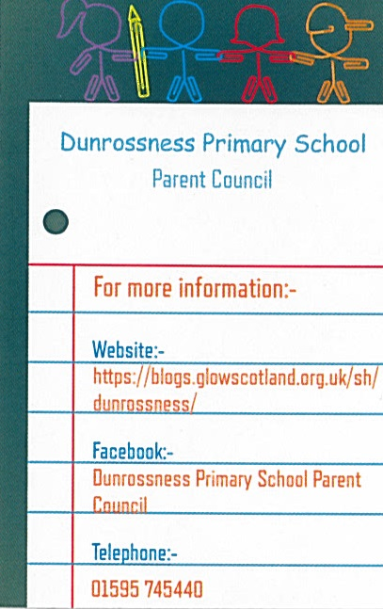
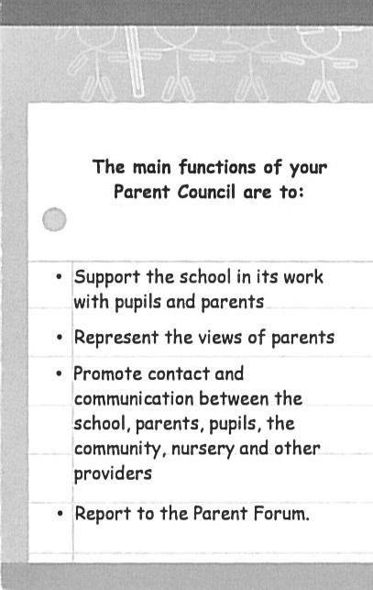
Parent Council Information

