Head Teacher: Ms Andrea Henderson Dunrossness Primary School
Dunrossness
Shetland ZE2 9JG
Telephone: 01595 745440
Fax: 01950 460803
E-mail: dunrossness@shetland.gov.uk
Website: www.dunrossness.shetland.sch.uk
Blog: https://blogs.glowscotland.org.uk/sh/dunrossness/
21st November 2017
Dear Parents/Carers,
Alternative Advent Calendar 2017

After the success of the Alternative Advent Calendar last year, we have decided to do it again this year and involve the whole school.

This Christmas for Advent, we would like to ask you to contribute to the Shetland Food Bank. Each day in Advent, instead of getting a chocolate each pupil will be asked to add one item to the class food bank box, meaning that each class should have between 20-25 items to donate. By doing this, we hope to help local people who are less fortunate than ourselves and hopefully make a difference to their Christmas.

All items must be non-perishable so that they will last until Christmas and will be donated to the Shetland Food Bank before the end of term. A list of items that are currently needed can be found on the Shetland Food Bank website, please see the link below:

https://shetland.foodbank.org.uk/give-help/donate-food/

Many thanks,

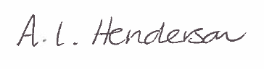

Andrea Henderson

