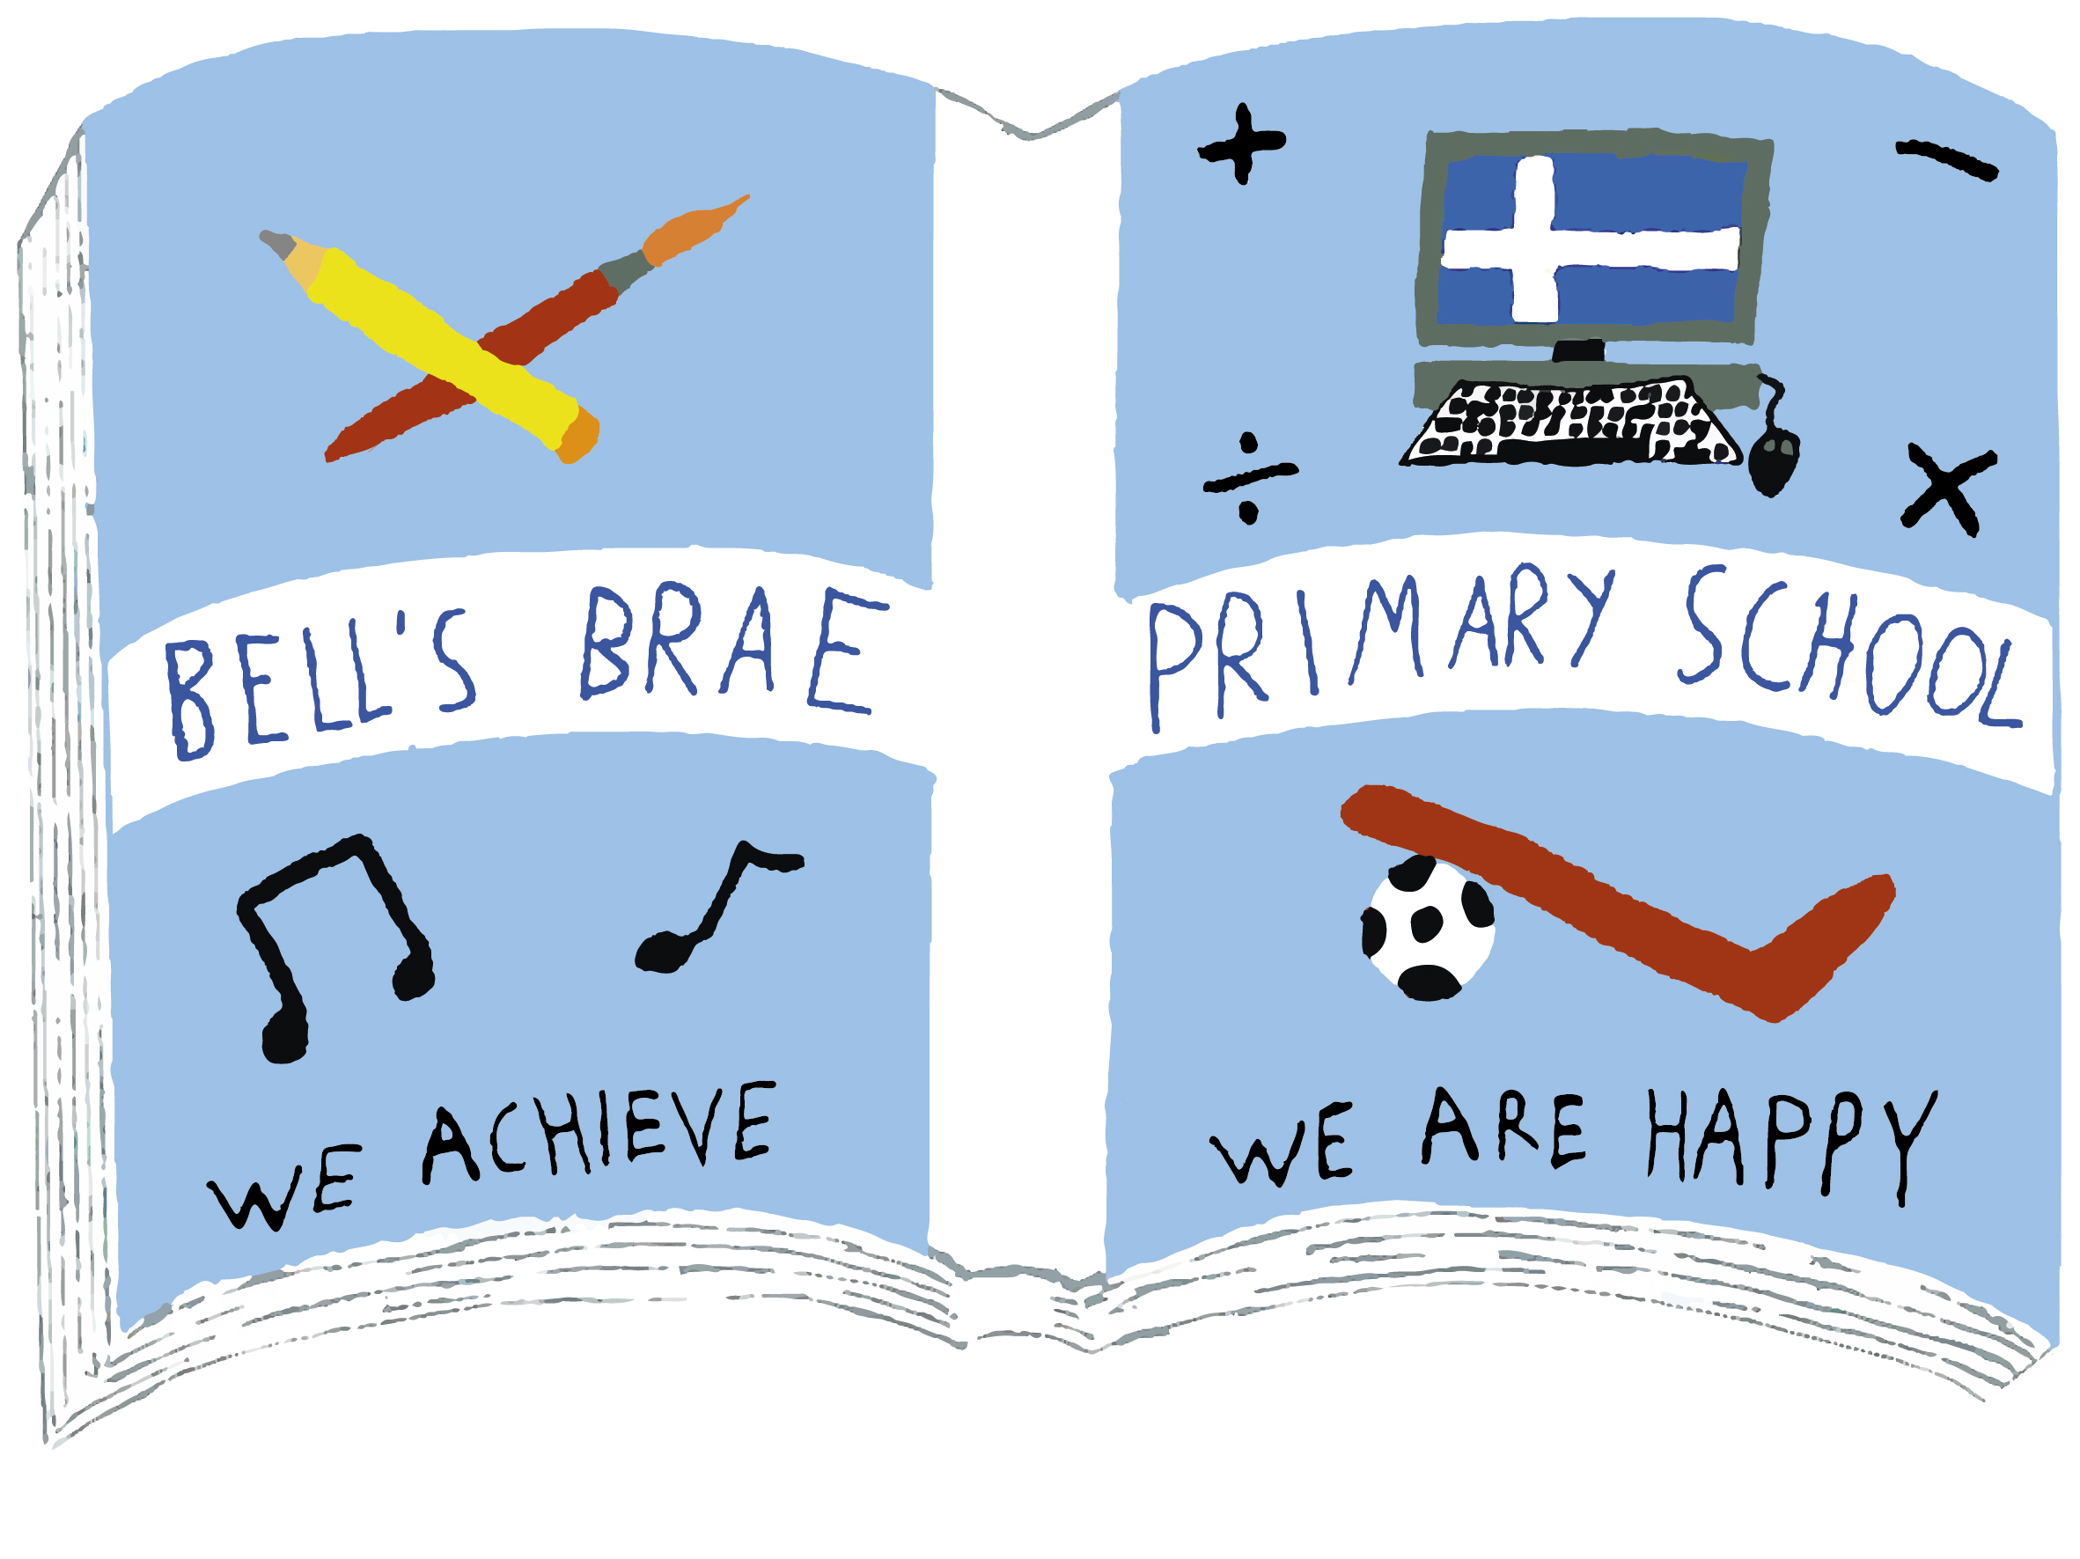
Bell’s Brae Primary School
Numeracy and Mathematics Summary for Parents and Carers
November 2019

Our Numeracy and Mathematics Statement
“Mathematics is important in our everyday life, allowing us to make sense of the world around us and to manage our lives. Using mathematics enables us to model real-life situations and make connections and informed predictions. It equips us with the skills we need to interpret and analyse information, simplify and solve problems, assess risk and make informed decisions.”
(Curriculum for Excellence, Principles and Practice)

In Bell’s Brae Primary School we have a commitment to ensuring that our learners are equipped with the numeracy skills which are required in the 21st century.

Aims
Our core aim is to ensure that all learners develop the numeracy and mathematics skills they need to achieve success in life, learning and work.
AIMS:
- support and enhance planning and assessment, based on skills, knowledge and understanding
- provide staff with a structured progression for learning and teaching
- enable the sharing of standards within schools, clusters and across, and between, authorities
- enable the development of skills for learning, life and work
- facilitate the process of monitoring learners’ progress and achievement.

Methodology
Numeracy and mathematical skills can be developed through careful planning of learning activities, questions and a range of assessments. As learners progress through Curriculum for Excellence levels, they should demonstrate increasing sophistication and independence in their ability to demonstrate, link, transfer and apply Numeracy skills in a range of contexts both in and out school.

At Bell’s Brae Primary School, our teachers use a variety of learning and teaching methodologies to stimulate the interest of our pupils in Numeracy, including:
- planned active learning which provides opportunities to observe, explore, investigate, experiment, play, discuss and reflect, modelling and scaffolding the development of mathematical thinking skills;
- learning collaboratively and independently; providing opportunities for discussion, communication and explanation of thinking;
- developing mental agility, problem-solving capabilities and critical thinking skills;
- building on the principles of Assessment is for Learning, ensuring that young people understand the purpose and relevance of what they are learning;
- frequently asking children to explain their thinking;
- use of relevant contexts and experiences, familiar to children and young people; and make frequent links across the curriculum, so that concepts and skills are developed further by being applied in different, relevant contexts;
- using technology in appropriate and effective ways

All recommended approaches are designed to develop understanding and progression for learners.
Knowledge and Strategy

Learning is a cycle, where knowledge provides the foundation for developing strategies, and use of strategies develops new knowledge.

Strategy describes the mental processes children use to estimate and solve problems. Knowledge describes what we want children to be able to recall without having to think about it. It is important for students to develop new items of knowledge and more advanced strategies for solving number problems at the same time.

Resources
Resources used in school include the following such:
- Scottish Heinemann Maths scheme 1-7 (correlation between this, progression pathways and benchmarks)
- NA N&M Progression pathways
- SEAL (Stages of Early Arithmetical Learning) materials
- Numicon
- Number Talks

Related links

Read, Write, Count - Tips, ideas and activities for you and your children to read, write and count together and promote home school partnerships.

Making Maths Count - This report encourages greater enthusiasm for maths amongst children, young people and parents.

BBC - Bitesize - First Level - Mathematics - Fun activities to help children at 1st Level in Scotland learn more about Mathematics.

BBC - Bitesize - Second Level - Mathematics - See how knowing about sums, averages, shapes, graphs and measurements can help with many tasks.

Fun to Save - This website is designed to be fun and allow children to learn about money and ways to save.

The Big Plus - The Big Plus encourages adults to improve their reading, writing and number skills.
www.thenumberrace.com (recommended for ages 4-8) is a free download which can help with maths in a number of ways

