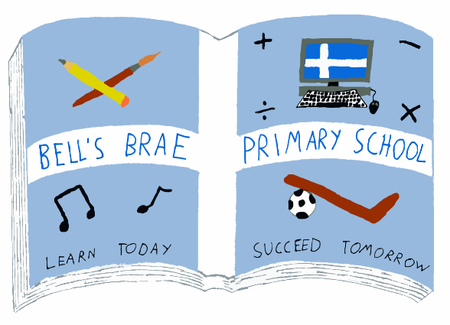

Mrs J Wadley  Head Teacher |  | BELL’S BRAE PRIMARY SCHOOL  LERWICK, SHETLAND, ZE1 0QJ  Tel Lerwick (01595) 743720  Fax Lerwick (01595) 807302  E.mail: bellsbrae@shetland.gov.uk  https://blogs.glowscotland.org.uk/sh/bellsbraeprimary/

24 January 2018

Dear Parents/Carers

Welcome back to school for 2018, we are now settled into the new term and are looking forward to the year ahead in Bell’s Brae. I would like to take the opportunity to introduce myself as Acting Depute Head Teacher (Early Years). I will be in the post for approximately 6 – 8 weeks and you can get in touch using the above information.

Students
Megan Leask and Rachel Baronet will continue their work placements in Rooms 1 and 2 respectively. These placements form part of their studies Shetland College (University of the Highlands and Islands) and will continue up until May.

Up Helly Aa
We will be looking for volunteers to provide additional supervision on Up Helly Aa day, just let someone know if you can help. We will be walking to the bottom of Harbour Street to see the galley and the Jarl Squad weather permitting.

Adverse weather
Just a reminder that information about school closures due to bad weather will be announced on local and national radio – Radio Shetland at 5.30pm, Radio Orkney at 7.30am and SIBC. Information is also available on the SIC internet homepage and parents/carers can also follow alerts on ‘twitter’. A direct link to this can be accessed through the Shetland Islands Council home page www.shetland.gov.uk click on twitter ‘follow@shetlslandsCll’ button at the top right corner of the page. However, parents/carers are responsible at all times for deciding whether to send their children to nursery.

Primary 1 Enrolment
Enrolment Week will take place from Monday 5 to Friday 9 February. During this time, enrolment forms will be available outside each EY room for parents/carers to complete for children eligible to start school in August 2018.

Appointments will be available for parents/carers of children in their pre-school year in the week beginning Monday 20 February. These will provide you with an opportunity to discuss your child’s progress and ask any questions you may have regarding their upcoming transition into Primary 1.

Please speak to a member of the EY team to let them know whether you would prefer a daytime or an evening appointment – this will allow you to arrange a time that is mutually convenient for yourselves and them. For your information, evening appointments will take place on Wednesday 21 February. A crèche will be available in the main school.

Dates for your diaries
Another reminder of some key dates for this term –

Tuesday 30 January – Up Helly Aa Day
Wednesday 31 January – Holiday
Monday 5 - Friday 9 February – Primary 1 Enrolment Week
Friday 23 February – Holiday
Monday 26 February – Holiday
Friday 30 March – Last day of term

As ever, if you have any questions about any of the above, or anything else, please ask a member of the Early Years team or contact myself.

Yours sincerely

Wendy Fraser
Acting Depute Head Teacher (Early Years)

