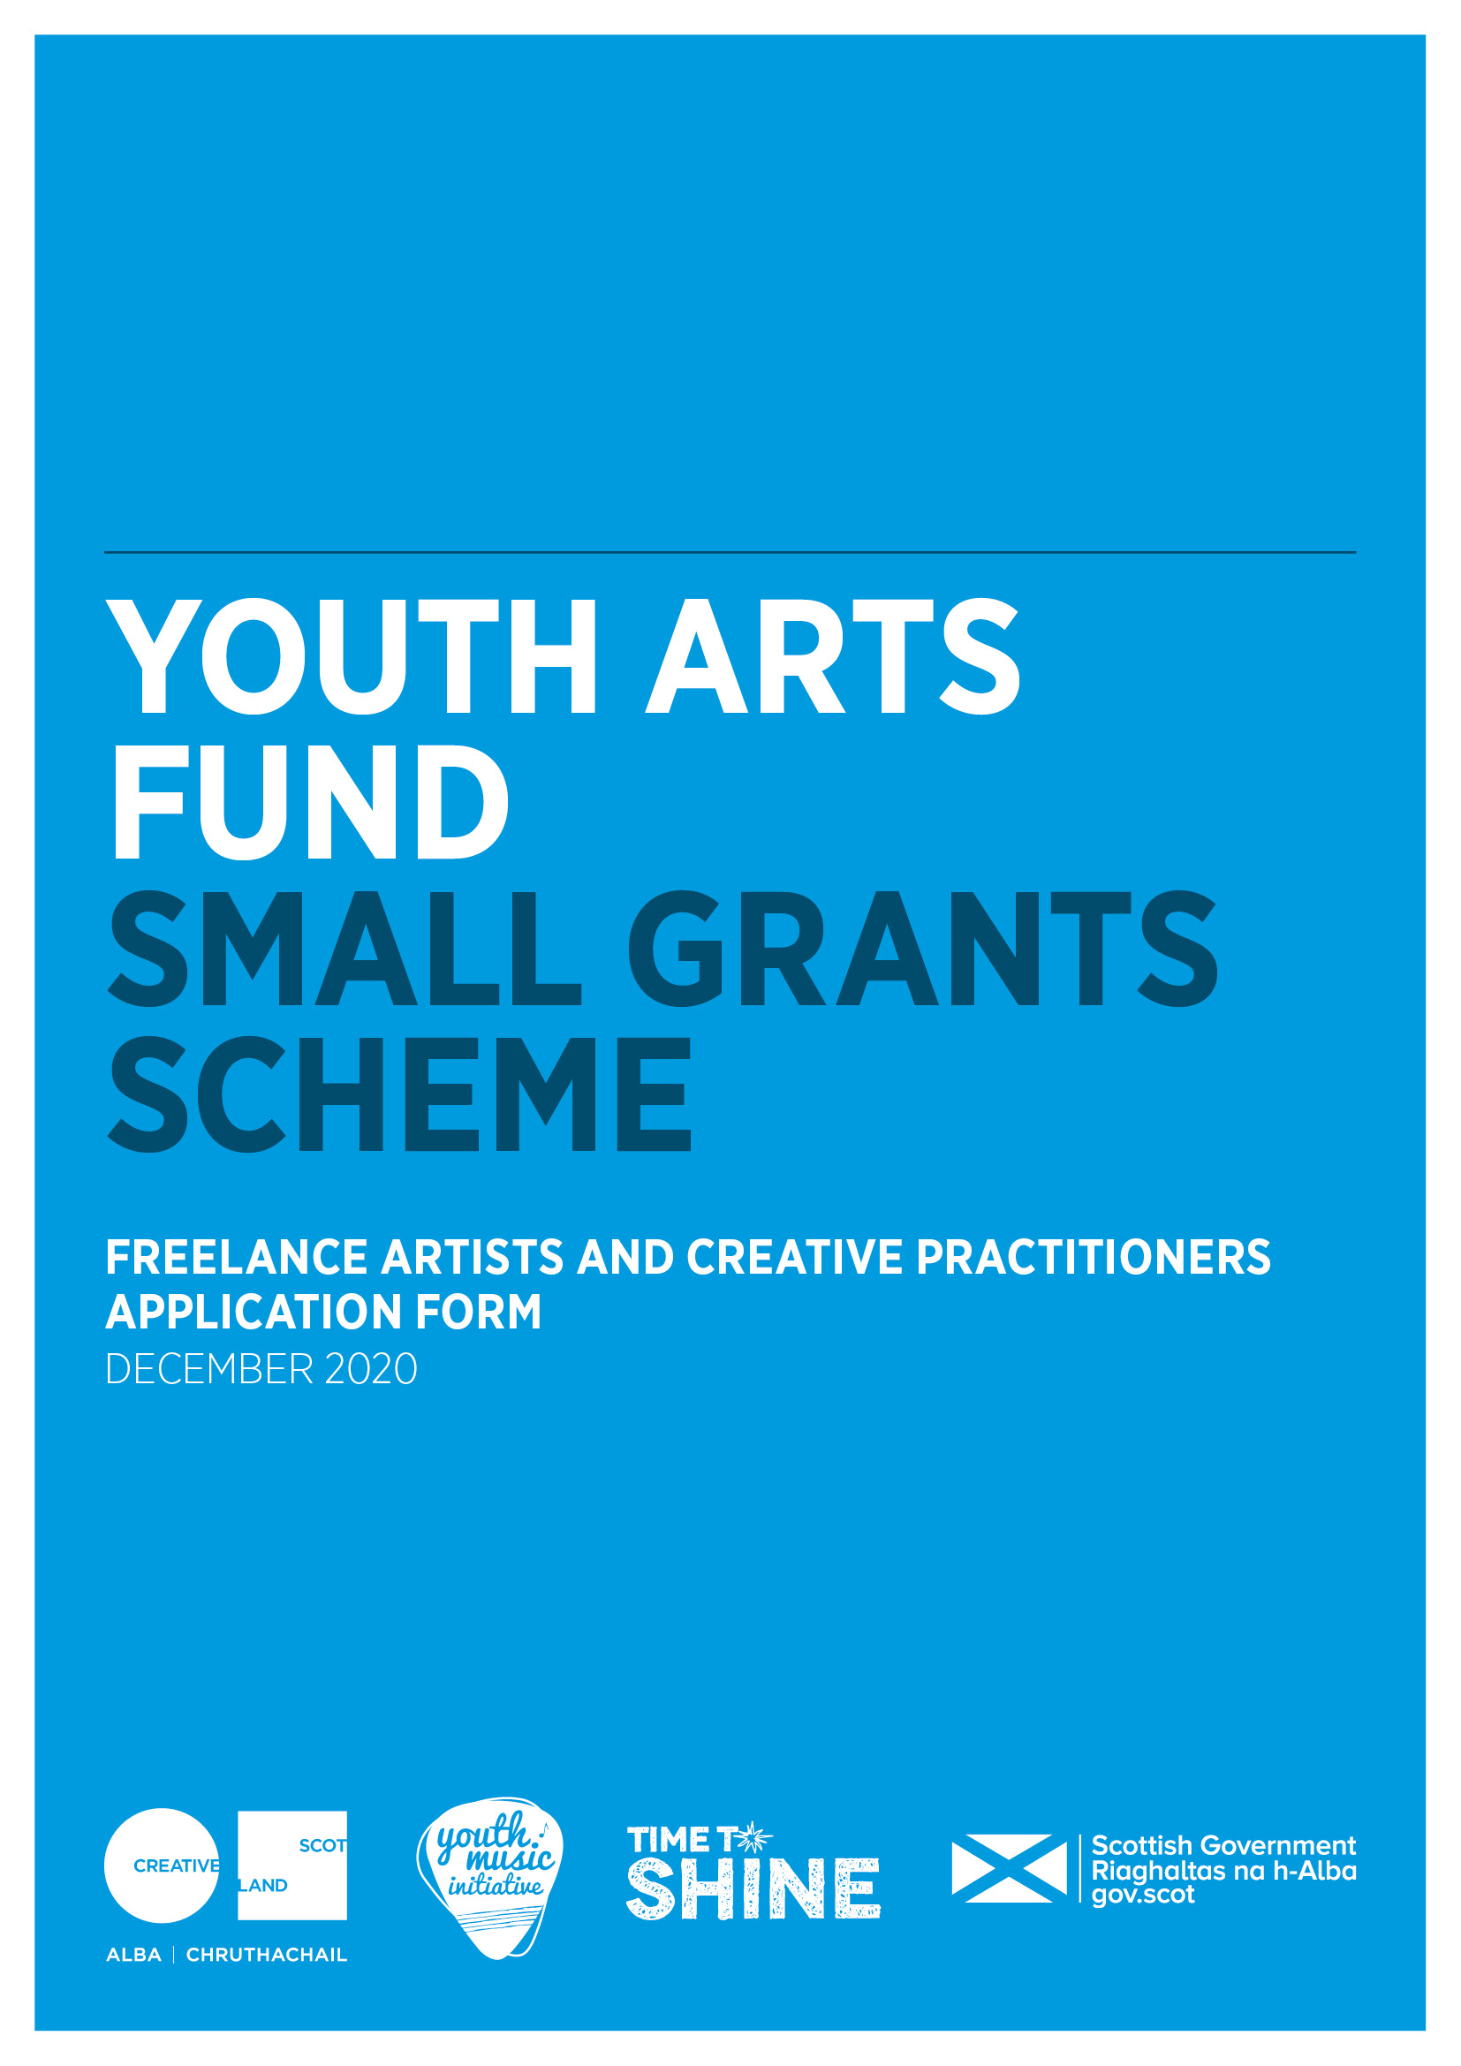

**  **

**Youth Arts Small Grants Scheme**

**Freelance artists and creative practitioners**

**Application form**

Please ensure that you have read the Small Grants Guidance for Freelance Artists and Creative Practitioners carefully before completing the form.

**Section A: Key Information**

|  |  |
| --- | --- |
| **Name** |  |
| **Address** |  |
| **Postcode** |  |
| **Contact telephone number(s)** |  |
| **Email** |  |
| **Website** |  |
| **Start date of your project** |  |
| **End date of your project** |  |
| **Amount of funding requested** |  |

|  |  |  |
| --- | --- | --- |
| **Names of any schools, youth, community groups and other organisations you are working in partnership with** |  | |
| **Number of children and young people you aim to work with** |  | |
| **Age range of children and young people you aim to work with** |  | |
| **Main artform you will work in**  please indicate the main artform you will work in by placing an X in the relevant box | **Music** | **Wider Arts (other than music)** |
|  |  |
| **Number of days work this project will support you to undertake** |  | |

**Section B: Supporting Information**

|  |  |
| --- | --- |
| **Supporting information** | **Submitted (please mark with an X)** |
| **Please submit a copy of your current CV**  This helps us to understand what you have achieved so far in your practice, your training and track record. You may also submit your artist statement if you have one. |  |
| **Please submit evidence of your PVG scheme membership** |  |
| **Please submit letters or emails of support from partners organisations** outlining support and their involvement in the project |  |

**Section C: Skills and Experience**

**Please tell us about your work as a youth arts practitioner**

What kind of work do you do with children and young people? What are your key skills and experience that mean you can do the work well? *300 words max*

|  |
| --- |
|  |

**Section D: Project Details**

**Please tell us about the project you want to apply for**

Please include:

* the need for the project
* how you see this project positively supporting and helping children and young people
* opportunities for children and young people to have their voices heard
* a description of the activities including number, content and duration of sessions

*400 words max*

Please note: all project activity must be provided free of charge to children and young people.

|  |
| --- |
|  |

**Please provide a project timeline**outlining key dates and milestones. Information can be presented in bullet point format.

|  |
| --- |
|  |

**Are you planning to work with children and young people in the following priority groups?** Please tick all groups that you plan to work with.

|  |  |
| --- | --- |
| **Priority group** | **Please tick** |
| **Those living in poverty or areas of social and economic deprivation.** For more information on the Scottish Index of Multiple Deprivation (SIMD) please visit the [**Scottish Government website**](https://www.gov.scot/collections/scottish-index-of-multiple-deprivation-2020/) |  |
| **Are experiencing or at risk of experiencing harm and neglect** |  |
| **Are looked after** (as defined by the Children (Scotland) Act 1995) and care leavers (as defined by the Children and Young People (Scotland) Act 2014). For more information, please visit the [**Scottish Government website**](https://www.gov.scot/policies/looked-after-children/) |  |
| **Are in the early years (0-5) of their life** |  |
| **Are from Black and/or Minority Ethnic backgrounds** |  |
| **Have a disability and/or additional support needs** |  |
| **Are at risk of offending or have previously offended** |  |
| **Are young carers** (as defined by the Carers (Scotland) Act 2016) and/or young parents |  |
| **Are experiencing or at risk of homelessness, or who have been homeless** |  |
| **Are experiencing mental ill health** |  |

**Please tell us how you are going to reach children and young people in these priority groups.** *300 words max*

|  |
| --- |
|  |

**Please tell us what barriers children and young people might experience to participating and how you will work with partners to make sure that young people can take up the opportunity.** *300 words max*

|  |
| --- |
|  |

**Please tell us about any partner organisations you will work with and how you have planned the project together.**

Name the organisation, planning meetings you have had and how you are going to work together and support children and young people. *200 words max.*

|  |  |
| --- | --- |
|  | |
| **Has/have the partner organisation/s said they are ready and able to work with you?** | Yes/ no |
| **Please provide further information below** | |
|  | |

**Please tell us how you will reflect on the work with the children and young people and partner organisations and how you will know if it has been successful?** *300 words max*

|  |
| --- |
|  |

**Section E: Budget**

Please provide a budget breakdown for your project, detailing the grant requested, your own financial contribution and any other sources of funding if applicable. Please indicate if these are cash or in-kind contributions and ensure in-kind is accounted for in both income and expenditure.

Please note, artists/creative practitioners must be paid at industry rates. You can find further information on the [Creative Scotland website](https://www.creativescotland.com/resources/our-publications/funding-documents/rates-of-pay-guidance).

|  |  |  |
| --- | --- | --- |
| **Expenditure** - breakdown of estimated project costs | | |
| **Item** | **Cost (£)** | **Cash or in-kind** |
|  |  |  |
|  |  |  |
|  |  |  |
|  |  |  |
|  |  |  |
|  |  |  |
|  |  |  |
| **Total cost of project** |  |  |

|  |  |  |
| --- | --- | --- |
| **Income** – total should equal your expenditure above | | |
|  | **£** | **Confirmed**  **Cash or in-kind** |
| **Grant request from Small Grants Scheme** |  |  |
| **Other sources of income, including in-kind**  **(if applicable)** |  |  |
| **Total estimated income for project** |  |  |

**Section F: Risk Assessment**

**Please tell us about project risks and how you will manage them**

**Please fill in risk level: *high, medium*** *or* ***low*** *before and after managing the risk*

|  |  |  |  |
| --- | --- | --- | --- |
| **What general risks you have identified?** | Risk level before managing risk | **How will you manage this risk?** | Risk level after managing risk |
| **General risks** | | | |
|  |  |  |  |
|  |  |  |  |
|  |  |  |  |
|  |  |  |  |
| **Covid-19 related risks** | | | |
|  |  |  |  |
|  |  |  |  |
|  |  |  |  |
|  |  |  |  |

**Use of Your Information**

Scottish Borders Council and YouthBorders have policies in place that store and treat all data as per the Data Protection Act. We will only use your data in relation to the delivery of this fund and the necessary communication.

We will promote the activities, through social, digital and traditional media.

I hereby confirm that the information in this application submission including the supporting documents is true and correct and I acknowledge that it is my responsibility to inform you immediately of any changes which could affect the interpretation or context of the application, and I confirm I will undertake to do this.

……………………………………………

Applicant signature

……………………………………………

Date

**Please submit your completed application to:**

Kevin Greenfield ~ Creative Learning Officer

(Borders Youth Music Initiative & Creative Learning Network)  
Children and Young People’s Services  
Scottish Borders Council

e:  [Kevin.Greenfield@scotborders.gov.uk](mailto:Kevin.Greenfield@scotborders.gov.uk)