A Recovery Curriculum Through Music
Maths and Numeracy – Rhymes and Songs
Beehive  This is a beehive (hand cupped)  Where are the bees?  Hidden away where nobody sees...  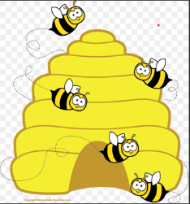  Now they come creeping out of the hive  One, two, three, four, five (extend fingers one  by one)  Five bees!  Bzzzzzzzzz! | Ten Little Raindrops  One little, two little, three little raindrops,  Four little, five little, six little raindrops,  Seven little, eight little, nine little raindrops,  Ten little raindrops falling down!  Falling, falling, falling raindrops,  Falling, falling, falling raindrops,  Falling, falling, falling raindrops,  Pitter-patter, pitter-patter, splash!
Weekly Rap  Monday, Monday Reach and run day.  Tuesday, Tuesday Tap your shoes day.  Wednesday, Wednesday Stretch and bend day.  Thursday, Thursday Twist and turn day.  Friday, Friday Jump up high day.  Saturday, Saturday Pat your body day.  Sunday, Sunday That’s the one-day we can rest and do nothing at all.  Then clap, clap, clap for the weekly rap.  Count to 7 and pick up speed!  (Repeat all --- pick up speed.)  (Repeat all & change last line to  Count to 7 and that’s the end!) |  | Five Little Seeds  Five little seeds, five little seeds.  Three will make flowers; two will make weeds.  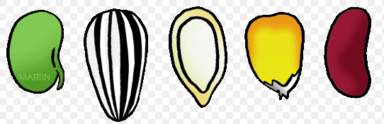  Under the leaves, and under the snow,  Five little seeds are waiting to grow.  Out comes the sun, down comes a shower.  And up come the three—pretty, pink flowers.  Out comes the sun that every plant needs.  And up come the two—silly old weeds.  (vary the numbers of flowers and weeds to  practice the combinations that make five or other numbers to 10)
Here’s a Green Leaf  Here’s a green leaf (show hand)  And here’s a green leaf, (show other hand)  That you see, makes two.  Here is a bud (Cup hands together)  That makes a flower;  Watch it bloom for you! (Open cupped hands  gradually) |  | 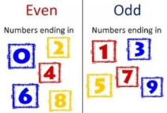  Odd and Even Number Rhymes  If you are an even number  You always have a pair  So if you look around  Your buddy will always be there  But ...  If you are an odd number  There's always a lonely one  He looks around to find his buddy  But he's the only one.
“To do is to be.” — Socrates
“To be is to do.” — Sartre
“Do be do be doo.” — Sinatra
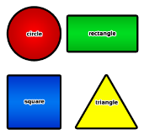  Shapes  Sung to: "Frere Jacques"  This is a square, this is a square,  How can you tell? How can you tell?  It has four sides, All the same size.  It's a Square, It's a Square.  This is a circle, this is a circle.  How can you tell? How can you tell?  It goes round and round, No end can be found.  It's a circle, It's a circle.  This is a triangle, this is a triangle.  How can you tell? How can you tell?  It only has three sides, That join to make three points.  It's a Triangle, It's a triangle.  This is a Rectangle, This is a rectangle.  How can you tell? How can you tell?  It has two short sides And it has two long sides. It's a rectangle, It's a rectangle. | Coin Song  Tune: First two lines of Twinkle, Twinkle Little Star  1p, 1p, easily spent  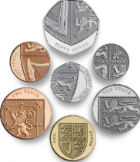  Copper brown and worth one pence.  2p, 2p, brown and round,  In your change it’s often found.  5p, 5p, silver and small,  The same as five 1ps in all.  10p, 10p, silver, and thin,  I remember, you're worth 10.  20p, 20p, with seven sides,  20p to buy some fries.  50p, 50p, big and bold,  You're worth 50 pence I'm told.  £1, £1, gold and fat,  You're worth 100 pence, I know that!
Over In the Meadow
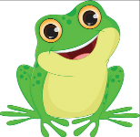
Assign sets of children to be the different animals in the song. Have them get up and move around appropriately when their verse is sung. Have children paint pictures to illustrate the song. Make up additional verses for the numerals 6-10. For example, “Over in the meadow in a home made of sticks lived an old mother rabbit and her little rabbits six…”

Over in the meadow in the sand and the sun
Lived an old mother froggie and her little froggie one. “Hop,” said the mother. “I hop,” said the one.
So they hopped and were glad in the sand and the sun.

Over in the meadow where the stream runs blue
Lived an old mother fishie and her little fishies two. “Swim,” said the mother. “We swim,” said the two.
So they swam and were glad where the stream runs blue.

Over in the meadow in the nest in the tree
Lived an old mother birdie and her little birdies three. “Fly,” said the mother. “We fly,” said the three.
So they flew and were glad in the nest in the tree.

Over in the meadow by the old apple core
Lived an old mother wormie and her little wormies four.
“Squirm,” said the mother. “We squirm,” said the four. So they squirmed and were glad by the old apple core.

Over in the meadow by the big bee hive
Lived an old mother bee and her baby bees five. “Buzz,” said the mother. “We buzz, “ said the five.
So they buzzed and were glad by the big bee hive.

