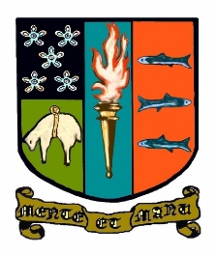**S3 Elective School of Rugby.**

**Physical Education.**

Following a broad and balanced Physical Education experience in S1 and S2 pupils have the option to follow a Physical Education elective alongside their core PE provision in S3. In this course pupils will focus on enhancing physical knowledge and improving practical ability through the sport of rugby.

Course Aims

1. To improve personal performance in rugby
2. To develop knowledge and understanding of factors which affect performance in rugby.
3. To complete a detailed personal project on rugby.
4. To learn the defensive and attacking strategies employed by teams in rugby and the need to have an appropriate game plan.
5. To explore the heritage of the game of rugby and its place in Borders Culture.
6. To learn the importance of nutrition, sleep patterns and strength and conditioning in preparing to play the game of rugby.

All pupils also participate in fitness testing and personal fitness planning throughout the course.  Their Training Programme will have a focus on the position they play in rugby and the specific weaknesses they will identify.

Pupils will produce a personal project demonstrating the knowledge gained on the course in the areas of skills and techniques, fitness and tactics in rugby.

**Progression.**

This course will lead onto National 4 or 5 Physical Education in S4 which can then lead to Higher and Advanced Higher Physical Education in S5 or S6.