**S3 Fashion & Textiles Technology**

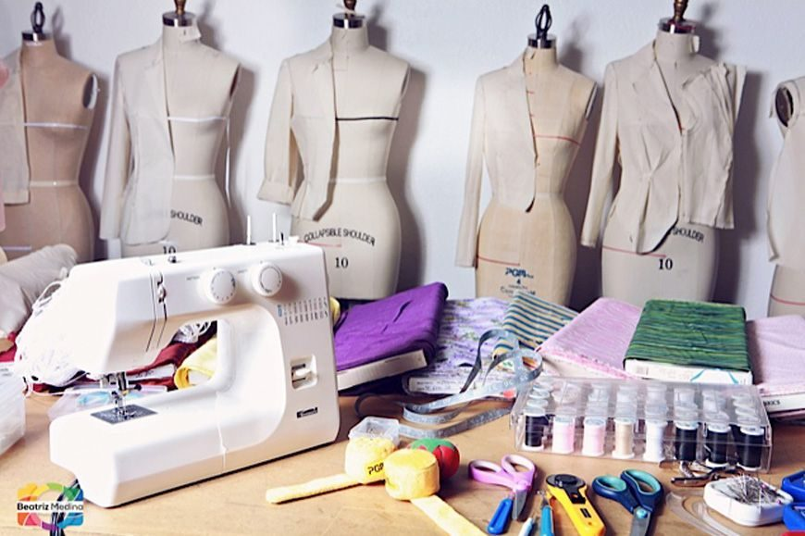

**Course Overview**

This course continues to build on fashion and textiles skills covered in S1 & 2. The main areas explored and developed in S3 are: Selection and use of sewing equipment, construction techniques, textile research techniques with emphasis on item development and acquiring knowledge of textile properties and characteristics.

Students will undertake 3 units which will involve both practical skills development and investigative study, which will develop their skills and knowledge in line with level 4 benchmarks in preparation for National 4/5 study if they choose.

Units will be delivered through both practical and theory-based study to ensure a thorough understanding of the properties of fabrics, product development processes and the possible employment opportunities in a changing Textile Industry.

**Projects and Products**

The projects and products made through the course are subject to change each year, in order to reflect the developing Textiles Industry and to allow for personalisation and choice. Previous items have included: home accessories, clothing, bags, soft toys and gift items.

**Course Key Skills**

Development of complex Hand and Machine sewing skills.

Production management and planning.

Creative thinking and problem solving.

Evaluation of the suitability, effectiveness and quality of products for the consumer.

Development of research and presentation skills

**Assessment**

Assessment is continuous throughout the course, with items of work retained as evidence of students having reached the required standard to undertake the National 4/5 Fashion and Textiles Technology course.

**Course Progression**

National 4/5 Fashion and Textile Technology Course

Higher Fashion and Textiles Technology Course

National Progression Awards in Fashion and Textiles related disciplines