S3 Introduction to Hospitality

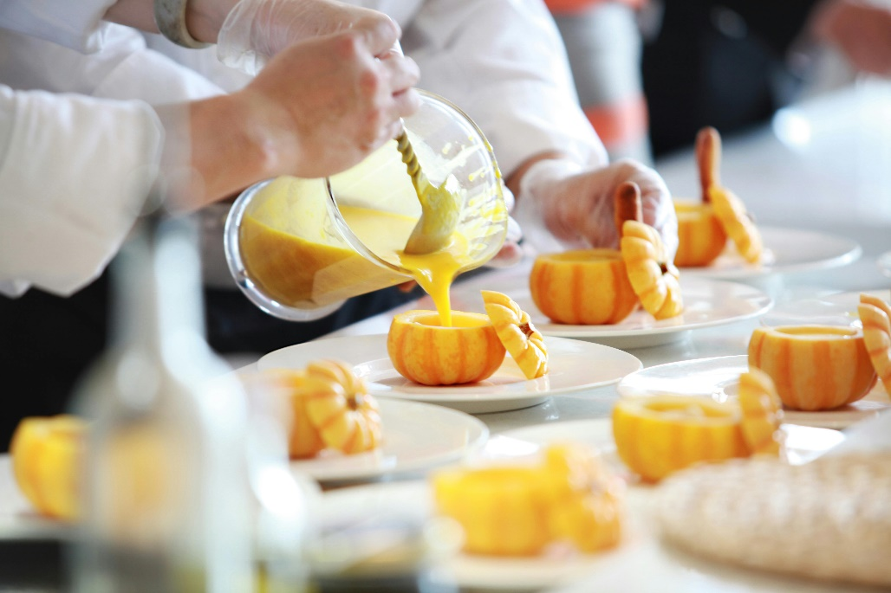**S3 Hospitality in Practice**

**Aims:**

* To develop a range of cookery skills, food preparation techniques and cookery processes involved in producing food products.
* To develop an understanding of the functions and characteristics of ingredients and their use.
* To gain an understanding of the food culture of other countries.
* To develop knowledge and understanding of the importance of safe and hygienic working practices.
* To gain insight into the wide range of career opportunities available within the Hospitality industry and the skills and attributes required for different career paths.
* To gain an understanding of the issues currently influencing the Hospitality industry.

**Course Content:**

Students interested in food, its preparation and presentation would be well suited to the Hospitality in Practice course. The course builds on the S2 Introduction to Hospitality skills and knowledge although the S2 course is not a prerequisite.

The course consists of both practical skill development and expansion of theoretical knowledge in equal proportions, on the topics of food preparation and contemporary food issues. It is important for students to understand that practical skills are not learnt in isolation, but in conjunction with theoretical knowledge/written tasks.

Units of study include:

* Professional Kitchen Operations and Hygiene
* Ingredients: Function and Sustainability
* Current Dietary Guidelines and Food Policy

In addition, all students are given the opportunity to complete the Royal Environmental Health Institute Scotland (REHIS) Elementary Food Hygiene certificate which is externally assessed and adds a valuable component to a CV for any student thinking about a future in hospitality.

Learning in this course is portfolio and project based, giving lead to student voice and input.

**Assessment:**

End of unit assessments will be undertaken at the conclusion of each unit and may consist of a written test, practical activity, extended project or evaluation of portfolio entries. A combination of these assessments may be used for each unit.

These assessments are designed to evaluate the students progress in the course and identify areas of improvement.

**Progression:**

Students who have demonstrated an appropriate level of practical skill, organisation and theoretical knowledge throughout the course may progress to:

* Skills for Work – Hospitality
* National 4/5 Practical Cookery

Students wishing to progress, are expected to have achieved a pass in the REHIS Elementary Food Hygiene course.

Students who would like to progress in this subject area, but who have not met the above requirements may progress to:

* National 3 Practical Cookery.
* National 2 Food Health & Wellbeing (entry to this course is on teacher recommendation)

­___________________________________________________________________