**S3 - COMPUTING SCIENCE**

**Course Content – what will I learn?**

The reason to learn this course is that Computing Science shapes the world in which we live and its future. This course brings together elements of technology, science and creative digital media, providing an insight into the challenge, excitement and reward to be found in these areas. In the S3 course we will

**Software Design and Development**

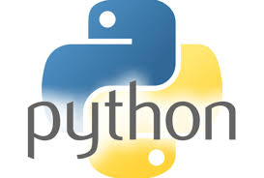

In this unit you will develop knowledge, understanding and practical problem-solving skills in coding, through a range of practical and investigative tasks using appropriate python programming language. This develops your programming and computational-thinking skills by implementing practical solutions and explaining how these programs work.

**Computer Systems**

Students will develop an understanding of how data and instructions are stored in binary form and basic computer architecture. They will gain an awareness of the environmental impact of the energy use of computing systems and security precautions that can be taken to protect computer systems.



**Database Design Development**

In this unit you will be analysing, designing and implementing and testing relational databases. You will apply this using a range of development tools such as SQL.

**Teaching Methods – What will I do?**



The course is both practical and theory based. The software that you will access is: -

* Python programming language
* Access database and SQL

All course materials, both practical and theory can be accessed through OneNote, SharePoint and Webpages. This course will allow you to work by yourself and in small groups to use problem solving skills to find digital solutions.

**Assessment and Homework**

N5 students will sit regular closed book assessments – written and practical – to track their progress and inform next steps for learning.

You will be expected to complete written homework assignments for each unit. These can be hand-written or prepared using ICT.

**Progression in the Senior Phase**

* National 4 Computing Science
* National 5 Computing Science