S2/3 Philosophy Elective

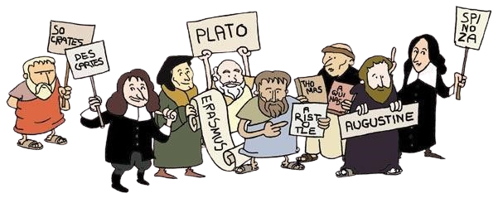
2 periods a week in S2 & S3 for pupils who choose this option

An elective class focusing on the philosophical aspect of RMPS. This course builds the skills required of certificated Philosophy courses that pupils can take in 4th, 5th, & 6th year.

S2

- The Mind – Rene Descartes and Dualism.

- Life and Death

- Reality – Plato’s Theory of the Forms.

- Morality – Moral Relativity, Religious Authority

- Creation – Creation Theory, the Big Bang, Evolution.

- Critical Thinking – Logic, Fallacies, Socrates.

- P4C – Interesting Questions.

S3

- Knowledge and Reality – Plato and The Cave.

- Ethics and Morality – Crime and Punishment.

- Debate and Discussion – Animal Rights.

- Engaging with Famous Philosophers – Confucius, Heidegger, Hobbs, Hume, Kierkegaard, Nietzsche.

- Critical Thinking – The study of arguments.

- Metaphysics – Arguments for and against the existence of God.
Learning and Teaching –

You will be expected to take part in many classroom discussions in the S2/3 Philosophy Elective course. If you are a confident speaker or wish to develop this skill then S2/3 Philosophy Elective is perfect for you!
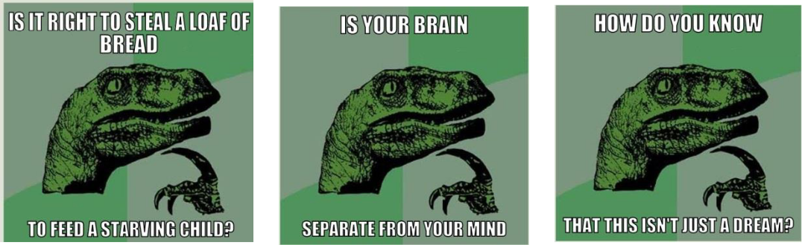

Homework –

Homework in the S2/ 3 Philosophy Elective usually takes the form of pupils having to think about a particular issue or question at home and be ready to discuss it in class.

Assessment –

The assessments used in the S2/ 3 Philosophy elective are designed to teach the skills required of the added value assignment task in National 5 Philosophy (and other subjects). You’ll be required to carry out research on philosophers and their theories and then present your findings in a number of ways including a class presentation, poster and an essay.

Progression in Senior School –

There will be opportunities for you to take your learning further at National 5 and Higher Philosophy in S4, 5& 6. The skills you will learn in the S2/3 Philosophy Elective will also be very useful in the study of RMPS which you can study in S4, 5& 6.

