National 5 Physical Education
Entry Level:
National 5 PE is designed to allow students to study the subject of Physical Education through both team and individual activities to achieve an SQA accredited award.
Students will need to have a very good participation/bringing kit record in S1-3 BGE PE, be able to work individually and as part of a team and have good communication skills.
The areas of study are similar for National 4 and 5, so all students will follow the same course and a decision about your final level will be made after completion of the first unit of study.
Course Content:
The course aims to:
- Develop and demonstrate understanding of the principles and factors which underpin and impact on performance.
- Explain factors which impact positively and negatively on both engagement and performance within physical activities.
- Build capacity to improve performance.
- Encourage students to examine and analyse performance to inform and influence personal improvement.
- Encourage the use of evaluation and feedback following performance.
Performance cycle of analysis
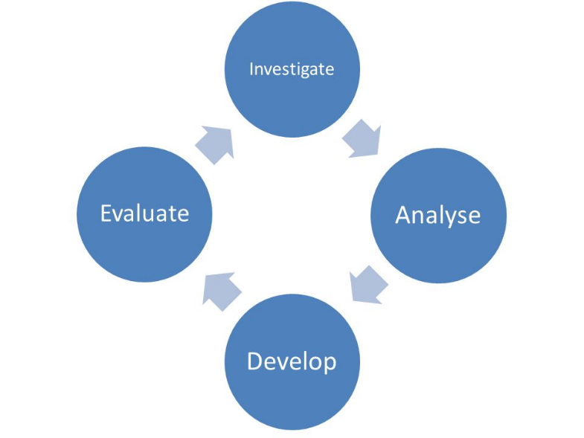

The course comprises of two areas of study.
- Practical performance
- Factors Impacting on Performance
Practical Performance
Through this unit students will work towards demonstrating a comprehensive range of movements and performance skills in physical activities. Students will develop their performance repertoire whilst maintaining control and fluency of skills across a range of activities.
The current options of practical activities in National 5 PE are:
Rugby, hockey, volleyball, basketball, badminton, football, American football, gymnastics, and netball.
This is subject to change depending on staffing, student choice and timetabling.
To be presented at National 5 level, students must demonstrate abilities of a National 5 standard as outlined by the SQA in at least 2 of these activities.
Factors Impacting on Performance
Through this unit students will be expected to:
- Demonstrate knowledge and understanding of the various factors (physical, emotional, mental, social) that impact on personal performance in physical activities.
- Develop performance through constructing a personalised training programme, focusing on specific sub-factors (i.e. physical – speed or CRE)
- Be able to test, monitor and retest performance, identifying and reviewing any improvements made.
- Evaluate the performance development process.
Course Assessment:
The National 5 course assessment is split into two components.
- “One-off” practical performance: This will be performed by the students and assessed internally at Peebles High School (50% of overall grade). Students will choose two activities from the course that they wish to be assessed on (30 marks for each activity) and graded on performance repertoire, control and fluency, decision making, tactics and rules/etiquette.
- Portfolio: This brings together work completed in a practical environment alongside the theory work covered in the factors impacting on performance unit. The portfolio is assessed externally by the SQA and is worth 60 marks (50% of overall grade).
There is no final SQA exam in National 5 PE.
Homework:
Homework will be set at regular intervals throughout the course to consolidate and extend knowledge and understanding.
Progression:
Students who achieve a pass at A or B grade for National 5 PE could progress to study Higher PE.

