NATIONAL 5 PRACTICAL COOKERY
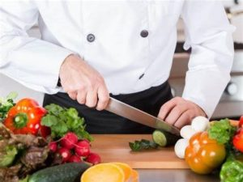
The course, which is practical and experiential in nature, develops a range of cookery skills and food preparation techniques, as well as planning, organisational and time management skills, in hospitality-related contexts. Through its emphasis on safety and hygiene, the course instils in students an understanding of the need to follow safe and hygienic practices.
Through studying this course students will develop skills and knowledge in the following areas:
- using food preparation techniques and cookery processes in the preparation of dishes
- understanding and demonstrating knowledge of the importance of food safety and hygiene and its application in the practical context
- selecting, weighing, measuring and using appropriate ingredients to prepare and garnish or decorate dishes
- understanding and demonstrating knowledge of the characteristics of a range of ingredients, and their function in a practical context
- understanding and demonstrating knowledge of the importance of sourcing sustainable ingredients
- understanding and demonstrating knowledge of current dietary advice relating to the use of ingredients
- following recipes in the preparation of dishes and carrying out an evaluation of the product
- planning, costing, organisational and time management skills in a cookery context
- producing, portioning and presenting dishes appropriately
Assessment
There are two components within the final assessment
Practical activity (70% of final mark)
This requires the candidate to prepare and serve a given three course meal within 2 hours 30 minutes.
The activity has two parts;
Planning for practical activity – Time-plan, Equipment requisition and service details. These are completed under exam conditions using unseen recipes. Marked by SQA
Practical Activity – Preparation and service of given dishes to restaurant standards.
Internally assessed & marks submitted to SQA.
This assessment takes place in February/March – check school calendar for dates.
Written examination (30% of final marks)
This will cover the theoretical aspects of the course content and is undertaken during the main SQA examination diet.

June -Oct | Oct- January | January | February
Cookery skills, Techniques and Processes & Organisation of Practical Skills | Understanding and using Ingredients | Prelims | Prep for final SQA Practical Exam and final written SQA assignment

March | April | May
Final SQA Practical Exams | Preparation & revision for written paper | Final SQA Examinations

