SUBJECT: Laboratory Science
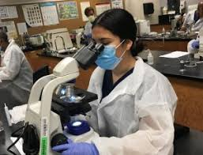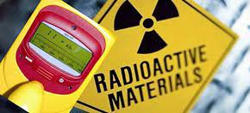

AWARD RECEIVED: N5

ENTRY LEVEL
There are not really any ‘entry requirements’ for this Course, other than having an interest in doing practical work similar to what you would expect to do in a Biology, Chemistry, Physics or Science class.
This Course is recommended for anyone who has an interest in learning more about a wide range of practical, experiment techniques and skills used in a wide range of Biology, Chemistry, Physics or Science experiments.
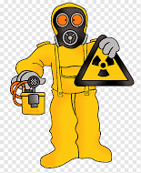
The Lab’ Science Skills Course would be very beneficial to anyone who would possibly like to have the option of working in a Lab’, in what would be a very wide range of jobs.
If you would like more information about this Course you could speak with Mr Reilly or your Science teacher.

COURSE CONTENT
This is a very ‘hands-on’, practical Course, which is split up into 4 Units, as outlined below :

Working in a Lab’ – in this Unit you will learn about basic Lab’ skills, including :
- handling and using chemicals
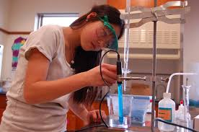
- preparing chemical solutions
- calculating and presenting results of your work
- maintaining health & safety when working in a Lab’
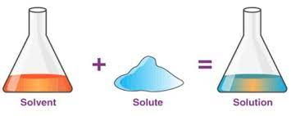
- following correct safety and security procedures
- doing Risk Assessments for practical Science work
- improving numeracy and communication skills

Practical Skills – in this Unit you will learn to develop the skills most commonly used in Lab’s,
including how to :
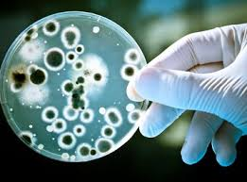
- work safely with potentially hazardous materials, such as micro-organisms
- measure radioactivity
- do calculations and present results of your work,
- improve your ability and skills in using Lab’ equipment
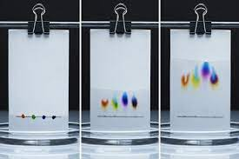
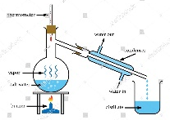
- perform a titration
- perform a chromatography
- perform a distillation

Practical Investigation – in this Unit you will develop the skills needed to do an Investigation that involves some practical, experimental work, including :
- produce a plan, including some practical experimental procedures, to investigate a Scientific topic
- devise methods that include practical, experimental procedures, to test the Aim of your Investigation
- carry out the practical, experimental work of your investigation, correctly and safely
- produce a, brief, Scientific Report, with your conclusion and evaluation of your Investigation

Careers using Lab’ Science Skills – in this Unit you will :
- learn about the wide range of jobs, industries and services that use Scientific knowledge and Lab’ skills
- learn how Science Lab’ skills are actually used in different jobs and industries
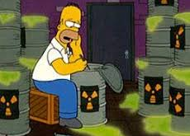
- investigate a range of career opportunities that use Lab’ Science skills
- investigate the skills, qualifications and experience needed for a job of
your own personal interest / choice, in the field of Lab’ Science
- produce your own Curriculum Vitae (CV) for a specific job in a Lab’ Science setting,
as a way to help you get prepared for employment or training or further education
- think about and evaluate your own employability skills and talents as you work through this Unit
This Course also allows students to develop a wide range of Employability Skills recognised by the SQA, including :
- ability to follow instructions
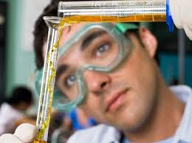
- awareness of health & safety in a Laboratory
- appropriate use of resources / equipment
- positive attitude in learning
- flexible approach to problem solving
- confidence to set goals, and to reflect and learn from experience
- time-management skills
- communication skills
- presentation skills
- numeracy skills
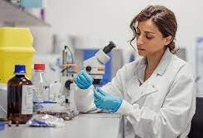
- basic practical skills of weighing, measuring and preparing solutions
- working co-operatively with others
- confidence to seek feedback
- review and self-evaluation skills
- working independently

All students will be encouraged to take as much advantage of the wide range of Lab’ Science opportunities that they will have access to during their time on the Course, to help give them experience of working in a real Lab’ Science environment. It is hoped that they will have the opportunity to spend time in a ‘real life’ Lab’ Science setting, through STEM and Developing the Young Workforce (DYW) links.
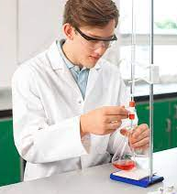
Science teachers and Technicians are usually always available either at lunchtimes and/or at the end of the day to give extra support if and when needed, throughout the year.

ASSESSMENT
There is no final, external SQA Exam for this Course.
To gain an overall Award for this Course, students need to pass each of the 4 Units, and those are all assessed internally within the Science Department in the school.
Students Pass the Units by successfully completing a combination of some practical activities, as outlined above, along with some written responses (e.g. a Report and a CV)
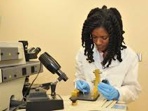

The Course Award is not graded, it is assessed on a Pass / Fail basis.

The internal assessments are verified by SQA.

HOMEWORK
Due to the nature of the Course, there is not so much requirement for frequent, ‘problem solving’ Homework exercises to be completed. However, there will be a need for students to do some research tasks as well as some analysing of their experimental results of the wide range of practical work they will be doing.
There is also a requirement for a Report and a CV to be written as part of their assessment.

The Science teachers are often available at lunchtimes and/or at the end of the day to give students help with their Homework.

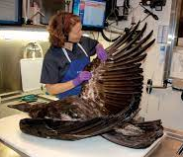
TRANSFERABLE SKILLS
There are many very useful and valuable transferable skills gained by studying
N5 Lab’ Science, including: the SQA recognised Employability Skills listed above.

PROGRESSION
There is very good progression from this Course on to other
applied science courses, or to N5 Biology, Chemistry or Physics.
It also provides excellent preparation for employment, or further training,
in the area of Lab’ Science work.

